
Sunday 24 August 2014

Live in the body
Year A - Pentecost 11 - 53A

The Mission of the Methodist Church of New Zealand | Our Church’s mission in Aotearoa / New Zealand is to reflect and proclaim the transforming love of God as revealed in Jesus Christ and declared in the Scriptures. We are empowered by the Holy Spirit to serve God in the world. The Treaty of Waitangi is the covenant establishing our nation on the basis of a power-sharing partnership and will guide how we undertake mission.
Links | Ctrl+Click on the links below to go directly to the text you require  Readings  Introduction  Preaching thoughts  Illustrations  Broader preparation  Creativity  Music  Prayers  Communal sharing  Children  PowerPoint  Gospel Bicentennial
Readings  Ctrl+Click to follow links  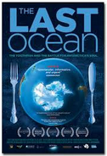     | Exodus 1.8-2.10 The Israelites, in bondage in Egypt, become so numerous that the Egyptians feel threatened. To control their numbers the king ordered that baby boys be killed. However, when Moses is born he is rescued by the king’s daughter.  Psalm 124 David praises God for protection from his enemies. “We escaped like birds from a hunter’s torn net.”  Romans 12.1-8 The most sensible way to serve God is to present our bodies to him as a living sacrifice. We have each been given gifts which we are to use well.  Matthew 16.13-20 Peter declares that Jesus is the Messiah, the Son of God. Jesus responds by talking about building the church.  If you are planning ahead, the Season of Creation commences next Sunday 29 August. Mission Resourcing has a few copies of a Faraday Institute DVD and study book called “Test of Faith” (2009) that are appropriate for this season and are available to borrow for use with a group in your church. They deal with the issue of science and faith which is important for all of us, but especially for young people in the secondary and tertiary age group.  There is also a copy of the DVD The Last Ocean (2012 – PG 88 mins). This is a documentary movie about the race to protect the earth’s last untouched ocean, the Ross Sea, Antarctica. These are available for free loan (provided you pay the postage) on request from nehu@missionresourcing.org.nz.  Youth Sunday  The third or fourth Sunday in August is the date that we recognise Youth Sunday. If you have an active youth group, you could hand the service over to them. Otherwise, try to involve as many young people as possible in the service.  Daffodil Day  This Sunday is the last before Daffodil Day (Friday 29 August). You may want to take a moment in your service to pray for those battling cancer, and for medical professionals and hospice workers supporting cancer sufferers and their families. It may be also appropriate to give thanks for the memory of those whose lives have been lost. You’ll find resources on the Cancer Society website and the Society will provide daffodils if you wish to take up an offering for them.
Introduction / Background  Ctrl+Click to follow links    CEV – Contemporary English Version of the Bible | Romans  We continue today our series through the second half of Paul’s letter to the Romans. Although in today’s passage Paul is no longer directly dealing with the place of Israel in God’s plan he no doubt is hoping that, as the Romans offer themselves to God and God changes the way they think (Romans 12.1-2), the Jew/ Gentile divide will be broken down. For a brief introduction to the letter see the 13 July ‘14 edition of “10 Minutes on a Tuesday”. An outline of the whole series is printed below:  Living as believers  13 July ‘14 Romans 8.1-11 Live in the Spirit 47A  20 July ‘14 Romans 8.12-25 Live with hope 48A  27 July ‘14 Romans 8.26-39 Live in God’s love 49A  3 August ‘14 Romans 9.1-5 Live for others 50A  10 August ‘14 Romans 10.5-15 Live to tell others 51A  17 August ‘14 Romans 11.1-2, 29-32 Live in God’s mercy 52A  24 August ‘14 Romans 12.1-8 Live in the body 53A  31 August ‘14 Romans 12.9-21 Live in harmony 54A  Be transformed  We are all familiar with the wonderful change that takes place when a caterpillar turns into a butterfly. It is called metamorphosis, which is a Greek word that is used in our reading from Romans today. It comes up in the Greek text when Paul tells us to be transformed (Romans 12.2).  The Bible says that we can be changed. Some say that people don’t change – that a bad person will always be bad. But the good news is that God can change us from the inside to the outside, just like chrysalis changes to a beautiful butterfly. He forgives us when we make mistakes and he can change us to make us better people. Nobody is out of reach of the love and changing power of God.  Spiritual gifts  From the time when the Spirit was first given to the church on the Day of Pentecost, the gift of the Spirit has also been associated with the gifts of the Spirit. You may have heard these referred to as “charismatic” gifts. We commonly use the word charismatic of someone who is inspirational. The word comes from the Greek root charis which means grace and, in the biblical sense, a charismatic gift is a gift of grace. These gifts don’t come as a result of our spiritual maturity, or because we deserve them but out of God’s grace, and his desire to equip us to encourage and build each other up.  In our reading this morning Paul says, “God has also given each of us different gifts (charismata) to use” (Romans 12.6 CEV). The word is often translated “spiritual gifts”. God loves variety. There are different kinds of spiritual gifts and different ways to serve the Lord.  There is a dimension to these gifts that makes them distinct from our natural talents and abilities. Of course, talents are gifts from God too – but the extra dimension of spiritual gifts is the divine dimension. According to Peter’s first letter (1 Peter 4.10-11) there are two types of spiritual gifts:  - Speaking gifts – in which we are dependent on getting words from God to speak  - Serving gifts – in which we are dependent on the strength that God supplies.  Dependence on God means that we are looking beyond ourselves to resources from God.  Matthew  For those who are following the gospel stream, the previous “10 Minutes on a Tuesday” resource for Year A can be found in the archived Refresh section of the New Zealand Methodist website. You will find there the following series through Matthew’s gospel:  Jesus: Parables, miracles and oracles  10 July ‘11 Matthew 13.1-9, 18-23 A story about a farmer 47A  17 July ‘11 Matthew 13.24-30, 36-43 Weeds in the wheat 48A  24 July ‘11 Matthew 13.31-33, 44-52 Parables of the Kingdom 49A  31 July ‘11 Matthew 14.13-21 Feeding 5000 50A  7 August ‘11 Matthew 14.22-33 Walking on water 51A  14 August ‘11 Matthew 15. 10-28 A woman’s faith 52A  21 August ‘11 Matthew 16.13-20 Who is Jesus? 53A  28 August ‘11 Matthew 16.21-28 Take up your cross 54A  Further lectionary based resources can be found on Bill Peddie’s blogsite.
Preaching thoughts and Questions  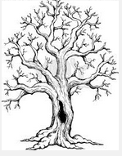  Scripture quotations are from the Contemporary English Version of the Bible    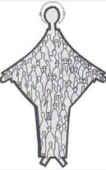  . | What’s your metaphor?  How do you understand your place in God’s plan?  I was in a church service where we were given pencils and paper and asked to draw what it meant to belong to the church. I remember a young mum, who was a new Christian, explaining her drawing. She had drawn a tree. There were lots and lots of little branches. “That’s us,” she said, “little branches spread all over the place. But we are all connected together – part of the same tree. Although some branches go out this way, and some go out the other way, all the branches are joined to the trunk of the tree. The trunk of the tree is Jesus. He is what we all have in common. And we are growing.”  For a new Christian I thought that her understanding of the nature of the church, and her place in it, was profound.  Futurist Leonard Sweet says, “Metaphors lodge truth in the imagination.” The images in our mind shape who we are and what we do. Images have the power to generate emotions. They cause us to feel something, and when we feel something we are more likely to do something.  What’s your metaphor?  How do you understand your place in God’s plan?  In the letter to the Romans, Paul has been seeking to explain to those in the church in Rome how they all fit into God’s plan. The Roman church consisted of a mixture of Jews and Gentiles, and there were some tensions between the two groups. In the chapters that we’ve been looking at over the last few weeks Paul has used the metaphor of a grafted branch to show how the Gentiles now belong to the people of God.  He moves on from that theme today with the use of two new metaphors. He begins by talking about our relationship with God and draws his metaphor from the Jewish sacrificial system. Instead of killing an animal on the altar of sacrifice he suggests that we offer ourselves as a living sacrifice.  He quickly moves on to our relationship with one another, because our relationship with God and our relationships with each other are closely connected. Now he draws on a new metaphor. We are all like different parts of a human body, each with its own function, and operating together we are the body of Christ serving each other and serving the world.  So Paul begs us to…  Offer our bodies  I beg you to offer your bodies to him as a living sacrifice, pure and pleasing. That’s the most sensible way to serve God. (Romans 12.1)  In the Christian understanding of persons the body, and what we do with it, is important. I am a living body – by offering my body to God I am offering to him everything about me.  Those of us who have been around church for a while tend to think of the offering as the bit in the church service when someone hands a plate around to receive our hard-earned cash. We can drop an envelope with money in it into the plate on a Sunday and think that our offering is done. But that would be like me pulling out a few dollars and giving them to my wife and children each week and saying, “That’s it from me.”  It’s not my money that my wife and children want. It’s me! (Although the teenagers are always ready to line up for some cash.) What they rightly expect of me is my time. My interest. My attention. My devotion. My love. This is the sense in which we are to offer ourselves to God.  We are to give ourselves as a sacrifice that is “pure”. The word is actually “holy” but the word “holy” has gone through some changes in the modern era and, especially when it is used of people, it is heard today as a negative rather than a positive – something akin to being sanctimonious (as in the terms holy Joe or holier than thou). So “pure” is a better translation at present… until it too loses its shine. The real meaning behind the word is separate. We are to be a separate people – separated in that we are dedicated to God for his use. The idea is encapsulated in the nineteenth century hymn by William Dunn Longstaff (see more on Longstaff below):  Take time to be holy, speak often with God;  Abide in him always, and feed on his word.  Make friends of God’s children, help those who are weak,  Forgetting in nothing his blessing to seek.  Take time to be holy, the world rushes on;  Spend much time in secret, with Jesus alone.  By looking to Jesus, like him you shall be;  Your friends in your conduct his likeness shall see.  That’s what it means to offer our bodies as a living sacrifice.  Then Paul changes the metaphor and tells us to…  Act as a body  There are many of us, but we each are part of the body of Christ, as well as part of one another. (Romans 12.5)  Just as a body has different parts so it is that we are all different, and have been given different gifts. Paul then goes on to list some examples (there is another list in 1 Corinthians 12 and there is a shorter list in Ephesians 4).  Because God wants us to act as body, we need to know what part we have to play. It’s important that for each of us to identify and use our gift. So let’s have a look at the ones we read this morning. Paul mentions that “God has also given each of us different gifts to use” (Romans 12.6). …  - Some can speak God’s message  - Some have a special gift of serving others  - or teaching  - or encouraging others  - or giving  - or exercising leadership  - or showing compassion  This list is certainly not comprehensive – but you can already see the variety there. There’s everything from exercising leadership to showing compassion. From speaking God’s message to giving. Because we are all different, we will each feel a natural inclination to some gifts, but not to others.  The challenge is to start acting in those areas to which we feel drawn, and consciously look for the strength stronger than ourselves or the word from God to speak. It’s not our self-sufficiency, but our dependence on God that makes a difference in the world.  So we need to find our gifts. And then use them to help one another. You sometimes hear people these days say, “Well, I’ve got my faith, but it’s a personal thing.” Paul makes absolute nonsense of such a claim. Faith is not a personal thing but a community thing. If we’ve got Christian faith, according to the passage we read, we are to be locked in to a local community of believers. We are joined in such a way that we depend on others, and others depend on us and the gifts we have. It’s like being a part of a body. We need each other.  For the church to be healthy we need everyone to be working at what they do. And we are to care for each other. In our daily experience of serving God the challenge is to:  - acknowledge our dependence on him  - and seek to find our gifts  - and then use them to help one another  looking to God for that divine dimension  - his words to speak  - and his strength to serve  By offering ourselves to him, and acting as a body, God forms us into a Christian community through which Christ is seen.
Illustrations /  Stories  Ctrl+Click to  follow link | William Dunn Longstaff (1822-1894)  William Longstaff was a wealthy English shipping magnate and was a friend of the British Methodist preacher William Booth who founded the Salvation Army.  When the American evangelical duo Ira Sankey and DL Moody visited Great Britain in 1875, Longstaff was one of the first to welcome them and became one of their financial sponsors. At their famous evangelistic meetings Sankey led the singing of rousing hymns before Moody preached. Large crowds were attracted to hear them.  In the 1880s Longstaff was inspired by the message of Griffith John, a missionary to China, who was preaching from the book of Leviticus. John’s text was, “Be holy for I am holy”. As a result of the message Longstaff wrote the hymn “Take time to be holy”. He gave the hymn to Ira Sankey who published it in a book of hymns in 1888.
Broader / Personal  Preparation  Ctrl+Click to  follow link | Casting Crowns is the name of a contemporary Christian band from Florida. They have a track that may be suitable for use in your worship service today and could be used to introduce the theme. The track is on their self-titled album (2003), which was their first studio album, and is called If we are the body. Read the lyrics and watch on YouTube.
Creativity /  Visual Aids  Ctrl+Click to  follow link   | What does it mean belong to the church?  Try repeating the exercise that I describe at the beginning of my preaching thoughts above. Distribute pencils and paper and ask people to draw what it means to them to belong to the church. When they have completed this, ask if two or three people would like to share what they have drawn and why.  Parts of a body  You could use a white board, black board or PowerPoint for this exercise.  Use a body diagram (like the on the left) that you can build up piece by piece. The idea is to recognise and encourage the people who function together in your congregation and who make it the body of Christ in your locality. This is an opportunity to focus especially on those who exercise unseen ministries.  - Start with the head – draw or project a head and then consider those who think about and plan the vision of the church – write beside the head the names of those who serve on Parish Council.  - Move on to the torso – think of those who are at the heartbeat of the congregation. Write the names of those who have a prayer ministry.  - The legs - think of those who take the good news out into the community. Write the names of those involved in social service and evangelism  - The arms – think of those who extend love and care to the members of the church. Write the names of the pastoral helpers.  That’s the basic idea – adapt it to your own situation. There’s always a danger that some people will feel left out so be careful to explain this is a representative list and everyone is important in the Body of Christ.  Finish by leading in a prayer, giving thanks for all who serve the church in so many different ways.
Music  AA: Alleluia Aotearoa  CMP: Complete Mission Praise  COC: Carol our Christmas  HIOS: Hope is our Song  FFS: Faith Forever Singing  MHB: Methodist Hymn Book  H&P: Hymns and Psalms  S1: The Source  S2: The Source 2  S3: The Source 3  S4: The Source 4  SIS: Scripture in Song  WHV: With heart and Voice  WOV: With One Voice  WOV = AHB | Hymns & Songs  All that I am (Cloninger & Moen) CMP 801; S2 623  All that I am (Wright) CMP 973  All to Jesus I surrender CMP 25; S1 15  Brother, sister let me serve you SIS 256; AA 8  Christ is made the sure foundation WOV 343; CMP 73; S2 654  Come let us use the grace divine MHB 749; H&P 649  For I’m building a people of power SIS 262; CMP 151; S1 109  How is Jesus present? AA 64  I give myself to you SIS 325 (Based on Romans 12.1)  I want the Spirit of power within MHB 280; H&P 291  I will offer up my life CMP 990; S1 265  Jesus put this song into our hearts CMP 376; S1 292  Jesus take me as I am SIS 318; CMP 382; S1 297  Let us all be one WOV 186  Lord make me an instrument SIS 349  Lord make me an instrument of your peace (Smith ) SIS 196  Make me a channel of your peace H&P 776; CMP 456; S1 348  Small things count, so Jesus said AA 123  Speak O Lord S4 2048  Take my life MHB 400; WOV 520; H&P 705; CMP 624; S1 468  Take time to be holy CMP 625  The church’s one foundation MHB 701; WOV 385; H&P 515; CMP 640; S1 477  Though I may speak with the language of angels S4 2100  We are children of God HIOS 142  We are many we are one FFS 67  When we walk with the Lord MHB 516; WOV 531; H&P 687; CMP 760
Prayers  Ctrl+Click to  follow link | Call to worship  The Lord made heaven and earth,  and he is the one  who sends us help.  Come, Let us worship him.  From Psalm 124.8  Collect  Merciful God,  grant that your Church,  being gathered by your Holy Spirit into one,  may reveal your glory among all peoples,  to the honour of your name;  through Jesus Christ our Lord. Amen.  © The Methodist Worship Book (Peterborough, England: Methodist Publishing House, 1999)  A prayer for servant leadership  O God of the suffering servant,  The tensions of life can tear me apart.  The drives of work pull me to earn,  the needs of relationship draw me for love,  The excitement of conquest attracts my competitive urge.  The sacred journey beckons my soul,  to satisfy my hunger of spirit.  Your leadership is not like the tyrant;  instead you call me to be a servant.  Like the climb towards the red crater,  may the breath of your creation,  resonate deep within me, Amen.  © John Howell – from Sighs too deep for Words (Taupo: St Paul’s Union Church, 2007) used with permission  Prayer of St Francis  Lord, make me an instrument of your peace.  Where there is hatred, let me sow love.  Where there is injury, pardon.  Where there is doubt, faith.  Where there is despair, hope.  Where there is darkness, light.  Where there is sadness, joy.  O Divine Master,  grant that I may not so much seek to be consoled, as to console;  to be understood, as to understand;  to be loved, as to love.  For it is in giving that we receive.  It is in pardoning that we are pardoned,  and it is in dying that we are born to Eternal Life.  Amen
Communal  Sharing  Ctrl+Click to follow links | Gift finding workshop  Have a gift finding workshop for your congregation. There are many different resources available for this:  - The Network Course - a course from the Willow Creek Association for discovering spiritual gifts and empowering people for ministry which runs over 6 sessions. Course material is available for free loan from Mission Resourcing. Contact nehu@missionresourcing.org.nz  - Finding your spiritual gifts – this link will take you to an American Lutheran questionnaire designed for a one session workshop.  - Email me for a questionnaire that I have adapted for use in New Zealand andrew@missionresourcing.org.nz
Children  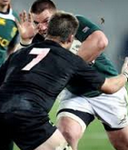  Richie McCaw No 7 | Openside Flanker  It was the beginning of the season and Coach George got together all the boys who had volunteered to play rugby for the Parkvale Midgets. He counted those present. There were twenty. It gave George a team with five players to spare. There would always be boys that were sick or away, so that was a good number.  Coach George thought he should start by seeing which boys would be best for which positions.  “Who wants to play in the backs?” he asked.  Nobody responded.  “Don’t be shy. Who wants to play in the backs?”  Still nobody responded.  “Okay. Who wants to play in the forwards?”  Immediately twenty hands went up and all the boys responded together “Me!!”  “Well, we can’t all be forwards. However, we’ll start with the forwards. Who thinks they’d be good in the front row?”  Nobody responded.  “No volunteers? Which of you burly boys would like to be locks?”  Coach George looked directly at a couple of the biggest boys, but they just looked away.  “All that is left is the loose forwards. I guess no-one wants to do that either?”  “Yes we do!” all the boys cried out, “We want to be number 7”  ‘What?” said Coach George, “you all want to be openside flankers? That’s crazy! You can’t all be openside flankers. Why would you want to be anyway?”  The boys explained, “Richie McCaw is number 7. We like Richie and we want to play in the position that Richie plays.”  The coach sat all the boys down and explained to them that a team requires different people, with different skills, who do different things. It’s not about being like someone else. It’s about finding out what you are good at, then practising so you can do it better. Some boys are big and strong and they will be good forwards. They will be able to push hard in the scrums and reach high in the lineouts. Some are very fast runners and they will be very good out in the backs as centre or on the wing. Others are very agile and they will make great halves.  If that is true of a rugby team, it is also true of the church. Our Bible reading today says, “God has also given each of us different gifts to use.” (Romans 12.6 CEV). When someone sings a lovely song in church we might think, ”I’d like to sing like that.” But God has given us all different gifts to use:  - Some people are good at singing  - some are good at speaking  - some are good at organising things  - some are good at being kind and looking after people who are needy or  unwell  - some are good at being encouragers.  All the different gifts are necessary to make up the church. God wants each of us to find out what we are good at, and use our gifts to help other people.  Prayer  Lord God  Thank you that we are all different  and that we don’t have to copy what someone is doing.  Help us to use our gifts to serve you  and to help others.  Amen.  More resources for children from sermons4kids.com (scroll down for a worship bulletin in MS Word)
PowerPoint  Ctrl+Click to  follow links | Images  Living sacrifice  Living sacrifice 2  Cartoons from reverendfun.com  Body of the church  Living sacrifice
Gospel  Bicentennial  Ctrl+Click to  follow links  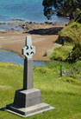  Marsden Cross  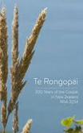 | Official commemorative services at Rangihoua in the Bay of Islands  Those planning on being in the Bay of Islands for these events will need to plan to be present well before the announced start times. Lack of parking at the site will necessitate arrival by bus. Visit the official website.  - Civic service, Sunday 21 December. This service will be held at 10.30am at the Interpretive Centre (Rore Kahu) at the top of the park. The Governor General will be present and the programme will include the official opening of Rangihoua Heritage Park and the Marsden Cross track.  - Churches service, Thursday 25 December. An ecumenical Christmas Day service of thanksgiving is planned for 11.00am at Marsden Cross, Rangihoua to celebrate the birth of Christ at the birth place of Christianity in Aotearoa New Zealand.  The Hope Project  The aim of the Hope Project is to commemorate the Gospel Bicentennial by means of a multi-media project which is to commence in October. Included will be two weeks of television advertisements, one booklet delivered by a national postal company to every New Zealand household, and a gospel website. The booklet will tell the story of the arrival of gospel in New Zealand, as well as how the gospel is still at work in people’s lives today. It is hoped that the booklets and ads will create conversational opportunities for ordinary Christians to talk about their faith. Churches wishing to partner with the project can do so on the Hope Project website.  Te Rongapai DVD  This five part documentary DVD tells the story of the gospel in New Zealand from Samuel Marsden forwards. Every New Zealander should know this story and every New Zealand church should own this DVD.  The five chapters are:  - Christian beginnings 16 mins  - Breakthrough 18 mins  - Christianity and the Treaty 5 mins  - Christianity and colonial complications 9 mins  - To the present 16 mins  As a build up to the gospel bi-centenary some churches are screening this chapter by chapter in their Sunday worship services. The DVD is available for purchase at $20 (GST incl.) per copy, plus $5 P+P from the New Zealand Christian Network website (where you can also watch a trailer.) Mission Resourcing has one copy available for free loan. Contact: nehu@missionresourcing.org.nz

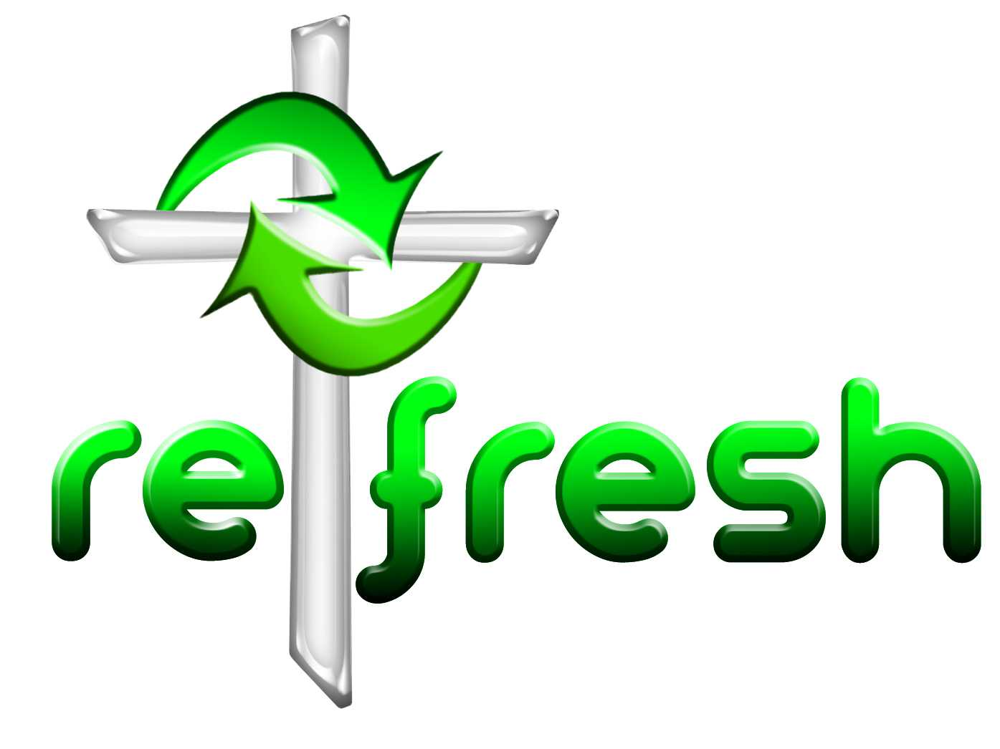
© 10 minutes on a Tuesday is a Refresh Resource. Unless otherwise acknowledged all material is prepared by Andrew Gamman. While every effort has been made to acknowledge source material, if you believe unacknowledged work has been quoted, contact the email address below to request that it be acknowledged or removed. Material included here may be freely used and reproduced for the immediate purpose of worship. Permission must be sought to republish in any form, or to reproduce for commercial gain. If you wish to share the content with others you may do so by linking through the NZ Methodist website. For more information on this and other resources, contact andrew@missionresourcing.org.nz or 09 525 4179 (w)


Mission Resourcing: Inspiring and resourcing our communities for a journey with Christ that enriches lives and relationships

