
Sunday 18 May 2014

We are chosen
Year A - Easter 5 - 35A

The Mission of the Methodist Church of New Zealand | Our Church’s mission in Aotearoa / New Zealand is to reflect and proclaim the transforming love of God as revealed in Jesus Christ and declared in the Scriptures. We are empowered by the Holy Spirit to serve God in the world. The Treaty of Waitangi is the covenant establishing our nation on the basis of a power-sharing partnership and will guide how we undertake mission.
Links | Ctrl+Click on the links below to go directly to the text you require  Readings  Introduction  NZ music month  Preaching thoughts and illustrations  Broader preparation  Creativity  Music  Prayers  Communal sharing  Children  PowerPoint
Readings  Ctrl+Click to follow links    Fairtrade  Fortnight  3-18 May 2013  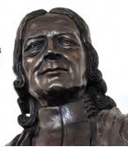  John Wesley  1703-1791  “Catch on fire with enthusiasm and people will come for miles to watch you burn.” | Acts 7.55-60 Stephen becomes the first Christian martyr. After he defends his faith before the Jewish Council they have him stoned to death.  Psalm 31.1-5, 15-16 David prays to the Lord for protection. “You, Lord God,  are my mighty rock and my fortress.”  1 Peter 2.2-10 Peter encourages Christians by reminding them of their high calling. Even though their Lord was rejected he says, “you are God's chosen and special people…. Now you must tell all the wonderful things that he has done.”  John 14.1-14 Jesus explains that he is the way to the Father. "I am the way, the truth, and the life!"  Fairtrade Fortnight 3-18 May 2014  Today brings us to the end of Fairtrade fortnight. This year’s theme is “The Power of You.” Those churches that haven’t already changed, could consider a swap to serving only Fairtrade coffee, tea and drinking chocolate. Your swap to Fairtrade products is an easy and effective way to ensure that producers and growers in the developing world get a fair price for their goods so they can work their way out of poverty. It makes a life-changing difference to the lives of millions of developing country farmers, workers and artisans as well as their families and communities. Not only does Fairtrade provide them with security and stability to plan for their future through fair and stable prices - it also provides additional funds through the Fairtrade Premium for investment in social, environmental and economic development.  Why not display a large range of Fairtrade products in your church foyer during this fortnight? Suggest that people should look for the Fairtade logo (left) on products when they are doing their grocery shopping.  Wesley Day  A range of Wesley Day resources is available from the New Zealand Methodist website. This includes readings, background notes, hymns, children’s resources and a Eucharistic prayer.  Methodists in other counties celebrate this as Aldersgate Sunday or Heritage Sunday. It is the Sunday preceding May 24, which was the date that John Wesley's had his life-changing experience at a meeting on Aldersgate Street, London, in 1738.  He wrote in his journal:  "In the evening I went very unwillingly to a society in Aldersgate Street, where one was reading Luther's Preface to the Epistle to the Romans. About a quarter before nine, while he was describing the change which God works in the heart through faith in Christ, I felt my heart strangely warmed. I felt I did trust in Christ, Christ alone for salvation, and an assurance was given to me that he had taken away my sins, even mine, and saved me from the law of sin and death."  This is also the day that Methodists seek to celebrate the Anglican Methodist Covenant . The covenant was signed on 24 May 2009 at Lotafala’ia, the Tongan Methodist Church in Mangere, South Auckland and Te Karaiti Te Pou Herenga Waka, the Maori Anglican marae/church. In Auckland the 5th Anniversary Service of the signing of the Anglican Methodist Covenant is to be held at 5.00pm this Sunday (18 May) at Holy Trinity Cathedral Parnell.  Alternative suggested readings:  Isaiah 12.1-6; Psalm 130; 2 Peter 1.1-11; Matthew 9.35-10.16  In the archived Refresh section of the New Zealand Methodist website you will find a previous “10 Minutes on a Tuesday” resource with a complete service for Wesley Day, Year B – Easter 7 – 38B (20 May 2012).
Introduction / Background  Ctrl+Click to follow links | Being God’s people  We continue today our series through the first letter written by the apostle Peter. The whole series is outlined below:  Being God’s people  27 April We have hope 1 Peter 1.3-9  4 May We have been rescued 1 Peter 1.17-23  11 May We suffer 1 Peter 2.19-25  18 May We are chosen 1 Peter 2.2-10  25 May We have a ready answer 1 Peter 3.13-22  1 June We are tested 1 Peter 4.12-14; 5.6-11  Cornerstone  1 Peter 2.6 is quoting Isaiah 28.16 and changing the application of the “precious cornerstone” to Christ. This is the stone is at the extreme angle of an edifice and is used to bind it together into a unity. The symbol represents the unity Christ brings to believers in his body, the church. The stone referred to in the following verse (1 Peter 2.7 – which quotes Psalm 118.22) is the probably same one, this time it is a stone over which people who refuse to follow Christ undervalue and trip over.  However, Christ is also the foundation stone, the one on whom the church is built and is dependant for its strength. No doubt in writing this Peter would have had in mind that Christ had named him the rock on which the church was to be built.  Priesthood of all believers  “You are a group of royal priests.” The idea that all believers can act as priests is implied in several New Testament scriptures and is made explicit in 1 Peter 2.9-10. The priest has access to God and the role of a priest is to mediate between God and people, bringing the offer of forgiveness, redemption and the message of grace. To interpret the term “the priesthood of all believers” as meaning that no priests are necessary is to misunderstand this passage. The point is not that there are no priests, but that all Christians have access to God and are to act as priests by carrying the message of grace to others. This was one of the principles on which the reformers broke from the Roman Catholic Church in the 16th Century European Reformation.  In the archived Refresh section of the New Zealand Methodist website you will find a previous “10 Minutes on a Tuesday” resource for today’s passages which follows the reading from the book of Acts, Year A – Easter 5 – 35A (22 May 2011).  Further lectionary based resources can be also found on Bill Peddie’s blogsite.
NZ Music Month  Ctrl+Click to follow links          FFS: Faith Forever Singing  HIOS: Hope is our Song  SIS: Scripture in Song | NZ Music Month  New Zealand Music Month is a 31-day nationwide celebration of home-grown talent and the diversity of our unique musical culture. Through the whole of this month we are especially recommending Kiwi music to use in your worship services.  New Zealand hymn suggestions from John Thornley, NZ Hymnbook Trust  The following songs are all found in Hope is our Song, published in 2009 by the NZ Hymnbook Trust. They are selected chronologically. They have been chosen as songs that have quickly found a place in worship, both for their strong texts and singability. As is the custom in the Pasifika worship tradition, you might like to try a mix of spoken and sung texts – one or more verses read aloud, followed by these same verses sung. Or, as an alternative, the whole text read in English, and then sung.  The CD that goes with the book includes a total of 27 songs from Hope is our Song. ‘CD’ in brackets will indicate those songs found on the CD recording. The CD includes half of the selection given. The recordings are a guide to helping introduce new songs, as well as giving pleasure to the individual and family - in the family home, rest home and other institutional settings. This CD includes a booklet with all words – something not given with earlier CDs.  Enjoy and be energised for the faith journey!  No. 68 I sing the grace of God within you  No. 81 Jumping Jesus  No. 87 Let our earth be peaceful  No. 98 Look in wonder (CD)  No. 95 Love is your way  Other New Zealand song suggestions  For you are a chosen people SIS 348 (An excellent choice to match today’s theme)  God comes to us as one unheard HIOS 42  It all depends on where I’m going FFS 39  (For foreign song suggestions see the Music section below)
Preaching thoughts, questions and illustrations  CEV = Contemporary English Version of the Bible  * 1 Peter 1.2 needs to be read in the context of the previous verses that speak of the word of God and of our attitudes.  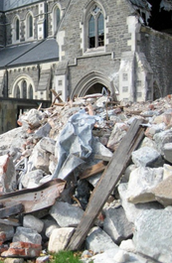  Christchurch Cathedral | Who are you?  Andrew Gamman  Who are you?  Husband of Caroline  Who are you?  Father of Micah, Tamar, Sarah and Caleb  Who are you?  Son of the late Margaret and Albert Gamman  Who are you?  A Methodist minister  Who are you?  Lover of sports  Who are you?  I am an introvert, basically a shy person who can at times act in an out-  going manner  …The tenor of these questions comes from the initial session of a therapy group I was involved in when I was studying psychology at University. It’s a psychological game – and the aim of the game is self-understanding.  Who am I?  The question has inspired books on the meaning of persons. Of course, we are more than one sort of person. Typically, during teenage years, we play a series of roles to try to discover where we fit: The scholar, the rebel, the socialite, the anarchist… before we enter adult years when we usually play more long-term and settled roles.  The assumption of the T-Group, or therapy group, is that we derive our sense of meaning and purpose from knowing who we are. And the trouble with the question is that it is introspective and self-centred. A truer sense of meaning and purpose comes, not from looking inward – but from looking outward, at our relationships – how we fit with other people and with God. The bigger and better question is, “Who does God say that I am?”  Here we turn our attention from ourselves to God. Our reading this morning was written to a group of people who had come to Jesus but were in difficult circumstances and struggling for survival. What Peter tells them is true for all Christians  “…you are God’s chosen and special people… Once you were nobody. Now you are God’s people.” (1 Peter 2.9-10 CEV)  We are chosen…  Chosen to grow up  “Be like newborn babies who are thirsty for the pure spiritual milk that will help you grow and be saved. You have already found out how good the Lord really is.”  (1 Peter 2.2-3 CEV)  One of a new mum’s first concerns is whether her baby is feeding properly. This is essential for the life and health of the baby. Likewise, when we come to Christ, we must have a hunger for God’s word and begin to feed and grow*. In this respect, no matter how old we are, we are to be like newborn babies. Like them we are to be free from jealousy and cruelty and to realise our total dependence on God.  Christians are called to grow. There is no sense in which the gospel can become “old hat”. Cynical Christians who think they have heard it all before have missed the opportunity to keep on growing. There is always more to learn and the purpose of our growth is to stretch to reach our full potential in serving Christ.  We are chosen…  Chosen to grow together  “And now you are living stones that are being used to build a spiritual house.”  (1 Peter 2.5a CEV)  As I write this I have just returned from a trip to Christchurch. I have been there on several occasions since the deadly 22 February 2011 earthquake, but that didn’t stop my eyes filling with tears at the sight of the centre city more than three years on from the quake (not to mention some of the suburban devastation). There are still piles of rubble everywhere. Demolition is still the most notable activity, construction hard to find.  (Of course, there were signs of hope too: the cardboard cathedral is a wonderful monument to the resilience of Christchurch and crowds were still gathering at the nearby white chair memorial created by Pete Majendie.)  The apostle Peter describes the church as a spiritual house being built of living stones. We are those stones. Our individualistic way of viewing life has meant that churches sometimes look more like a pile of rubble than blocks that are built into one another. A stone built into a church wall cannot drift in and out at will. It is dependent on the stones around it and they are dependent on it. And as we get built in to the structure we do have to get some of the rough edges knocked off, as do those alongside of us. It’s a bit painful at times but that is the only way we can fit in and become part of the structure.  We find our true place of belonging in community when we are dependent on one another. And just in case we feel that the metaphor of a temple is a static thing, we note that we are called to be living stones part of a living, healthy and growing church community.  We are chosen…  Chosen to be royal priests  “But you are God’s chosen and special people. You are a group of royal priests and a holy nation. God has brought you out of darkness into his marvellous light. Now you must tell all the wonderful things that he has done.” (1 Peter 2.9 CEV)  God has given us a new status. This is the Cinderella story – God has taken each of us from being nobody and made us into the princess at the ball. We are now royals. Our authority is hereditary. We are children of the King of kings. And like all royals we are to live in such a way that presents an example that leads and guides others. Like some royals, sometimes we don’t do this very well!  But more than that, we are priests. In the First Testament the priests met with God on behalf of the people. Their role was to mediate between God and people, bringing to people Gods’ offer of forgiveness, redemption and the message of grace. In Christ all God’s people now have access to him and we all are charged with the task of telling about the acts of Christ.  “Now you must tell all the wonderful things that he has done” says Peter. This is not just the task of the minister. In the places where we go, we are to chat about the things that Christ has done for us. We can all tell our own story of finding the grace of God. We are God’s chosen and special possession and this is what we are chosen to do.
Broader / Personal  Preparation  Ctrl+Click to follow links | A couple of music tracks that match today’s theme:  - Angela Millar sings an original song on American Idol last year about how God comes to us and sets us free. This would be suitable for playing as part of your service. Watch on GodTube  - What is life? by George Harrison released as a single off his 1970 triple album All things must pass Read the lyrics Listen on YouTube
Creativity /  Visual Aids   | Who am I?  Buy little packets of tiny craft mirrors from the $2 shop. Give one to each person. (Or you could also set up mirrors around the church.)  Get everyone to look in a mirror.  Pause.  Then ask…”What went through my head?  What judgments do I make about myself?  Do I think I have…  Grey hair?  A large nose?  A freckly or spotty face?  A tired look?  Are these comparative statements? Compared to what?  …Or am I proud of what I saw?  Is there a balance to be achieved somewhere between self-acceptance and pride?”  To conclude (maybe after the message) get people to look in the mirror again. Ask everyone to look beyond the image reflected back. Who does God say I am?  I am chosen by God  I am royal  I am a holy priest  I am special  Together we are God’s people  (These are all titles from today’s reading in 1 Peter 2)  Lead in a prayer…  “Lord, rather than trust in what I look like,  in what I do,  or in what I have,  I trust instead in your in your grace.  and what you say about me.  Thank you that I am chosen by you.  Help us to live as your special people  and to tell all the wonderful things that you have done.  Amen”
Music  AA: Alleluia Aotearoa  CMP: Complete Mission Praise  COC = Carol our Christmas  HIOS: Hope is our Song  FFS: Faith Forever Singing  MHB: Methodist Hymn Book  H&P: Hymns and Psalms  S1: The Source  S2: The Source 2  S3: The Source 3  S4: The Source 4  SIS: Scripture in Song  WHV: With heart and Voice  WOV: With One Voice  WOV = AHB  Ctrl+Click to follow links | Hymns & Songs  All that is within me S2 624  A safe stronghold our God is still MHB 494; H&P 661; CMP 2  Christ is made the sure foundation WOV 343; H&P 485; CMP 73  Christ is our corner-stone MHB 702; WOV 344  Christ is the foundation MHB 981  For I’m building a people of power SIS 262; CMP 151  God builds a house with living stone Words (scroll down) Tune: Duke Street (WOV 43)  God of grace and God of glory WOV 543; H&P 712; CMP 192  I come with joy to meet my Lord WOV 452; H&P 610  Jesus the very thought of you MHB 108; WOV 126; H&P 265; CMP 386  Jesus, you’re my firm foundation CMP 999; S1 302  Lord, you have founded WOV 403  One offer of salvation S3 1464  Praise the name of Jesus SIS 111; CMP 566  Rise up you champions S4 2034  Rock of ages cleft for me MHB 498; WOV 157; H&P 273; CMP 582; S1 950  The building block This song is a must to include in a service based on1 Peter 2. It was written by Noel  Paul Stookey who was the “Paul” in the American folk group Peter Paul and Mary. (The old folks will  remember them). They actually performed together right up until Mary’s death in 2009. His work outside of the  famous trio has mainly centred on his strong Christian faith and on social issues. This song does not appear  in any of the usual songbooks although the words seem to be in public domain and you can pick up the simple  tune on YouTube.  The church’s one foundation MHB 701; WOV 385; H&P 515; CMP 640; S1 477  We are his children CMP 955; S1 537  What shall we offer MHB 784; WOV 362; H&P 807  You are my rock S1 587
Prayers | Collect  Loving and eternal God,  through the resurrection of your Son,  help us to face the future  with courage and assurance,  knowing that nothing in life or death  can ever part us from your love for us  in Jesus Christ our Saviour;  who is alive and reigns with you,  in the unity of the Holy Spirit,  one God now and for ever. Amen.  © The Methodist Worship Book (Peterborough, England: Methodist Publishing House, 1999)  Psalm 31 (selection)  I come to you, Lord, for protection;  never let me be defeated.  You are a righteous God;  save me, I pray!  Hear me! Save me now!  Be my refuge to protect me;  my defense to save me.  You are my refuge and defense;  guide me and lead me as you have promised.  Keep me safe from the trap that has been set for me;  shelter me from danger.  I place myself in your care.  You will save me, Lord;  you are a faithful God.  Be merciful to me, Lord,  for I am in trouble;  my eyes are tired from so much crying;  I am completely worn out.  I am exhausted by sorrow,  and weeping has shortened my life.  But my trust is in you, O Lord;  you are my God.  I am always in your care;  Look on your servant with kindness;  save me in your constant love.  How wonderful are the good things  you keep for those who honour you!  Everyone knows how good you are,  how securely you protect those who trust you.  You hide them in the safety of your presence.  Praise the Lord!  Good News Translation (GNT) Copyright © 1992 by American Bible Society  A prayer in the cleft of the rock  Hidden God,  You pass by while we are sheltering in the cleft of the rock,  but we cannot see your face.  If we look forward we can see your back,  leading us, guiding us, beckoning us with anticipation,  into a future land of promise.  Suffering Christ,  You experienced the cruelty of rejection,  knowing the human condition,  with our hopes and failures  and our dreams and doubts.  Loving Spirit,  You are like a parent to us,  nurturing us, warming us to the journey,  laughing and crying with us,  inviting us to find grace.  O God whose name we hesitate to speak,  we must walk the chaos of exodus,  before listening to your sacred wisdom from the holy mountain,  and the music of Easter.  Give me courage to let you journey with me.  Amen.  © John Howell from Sighs too Deep for Words (Taupo: St Paul’s Union Church, 2007) used with permission  We come knowing that we are loved  We come knowing that we are loved  Not just by others  But by you who gave us – gives us – breath  We come wishing for better health  Not just for ourselves, but for those whom we love  We come here aware that in some areas our joy is not all that we might hope  We see things that are not how they are meant to be  We come in the knowledge that we have been called and equipped to make a difference in this your world:  And we pray that this morning, you will begin with us  © Alan K Webster (used with permission)
Communal  Sharing   | Birthdays  Do you have a custom of acknowledging birthdays in your church? It can be really significant for children to have their birthdays acknowledged by the worshipping community. It is also a good idea to celebrate with, and pray for, those who are having special birthdays: 21 or the beginning of a new decade.  In a smaller church why not acknowledge all birthdays. Ask, “Has anyone had a birthday in the past week?” If some people are embarrassed by the question they won’t say anything… but there will also be people who like others to know.  Some churches have a basket filled with a combination of mini candy bars and knickknacks from the Christian Bookshop (bookmarks, pencils, mini pads etc – you’ll be surprised what you’ll find for a few cents) and get each of the birthday people to help themselves to a small gift.
Children  Ctrl+Click to  follow links    CEV = Contemporary English Version of the Bible | Building blocks  Bring along a set of wooden building blocks. Set the children the task of building a house.  When they have finished point to a block at the bottom of the house and ask one of the children to see if they can take it out. (In the unlikely event of the house still remaining standing, get another block taken out.)  Read from the Bible  Come to Jesus Christ. He is the living stone that people have rejected, but which God has chosen and highly honored. And now you are living stones that are being used to build a spiritual house. 1 Peter 2.4-5 (CEV)  The Bible says that the people in the church are like building blocks that are being made into a house. Every block is important. We depend on others to help us and we help other people. Just like the building block we tried to take out of our building, we are of most value when we join in with other people.  Prayer  Lord Jesus  Thank you that you have chosen us  Make us helpful people,  ready to lend a hand to others  and able to receive the help of others.  Amen  You will find more lectionary based resources for children from sermons4kids.com Scroll down for a children’s worship bulletin in MS Word.
PowerPoint  Ctrl+Click to  follow links  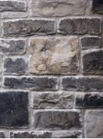 | 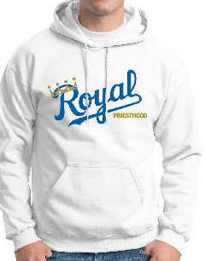  Google images for  - Stone masonry  - Royal priesthood - (you can even buy the hoodie to the right!)  Chosen graphic from St John’s Lutheran School, Napa California  Cartoons from reverendfun  - Act more priestly  - Building blocks  Cartoon from churchfail.wordpress.com  - Priesthood of all believers

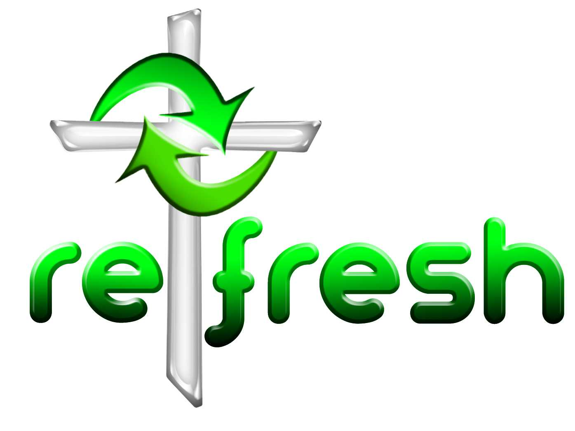
© 10 minutes on a Tuesday is a Refresh Resource. Unless otherwise acknowledged all material is prepared by Andrew Gamman. While every effort has been made to acknowledge source material, if you believe unacknowledged work has been quoted, contact the email address below to request that it be acknowledged or removed. Material included here may be freely used and reproduced for the immediate purpose of worship. Permission must be sought to republish in any form, or to reproduce for commercial gain. If you wish to share the content with others you may do so by linking through the NZ Methodist website. For more information on this and other resources, contact andrew@missionresourcing.org.nz or 09 525 4179 (w)


Mission Resourcing: Inspiring and resourcing our communities for a journey with Christ that enriches lives and relationships

