
Sunday 15 September 2013

Season of Creation – Storm Sunday
Year C – Pentecost 17 – 56C

The Mission of the Methodist Church of New Zealand | Our Church’s mission in Aotearoa / New Zealand is to reflect and proclaim the transforming love of God as revealed in Jesus Christ and declared in the Scriptures. We are empowered by the Holy Spirit to serve God in the world. The Treaty of Waitangi is the covenant establishing our nation on the basis of a power-sharing partnership and will guide how we undertake mission.
Links | Ctrl+Click on the links below to go directly to the text you require  Readings  Introduction  Preaching thoughts  Illustrations  Broader preparation  Creativity  Music  Prayers  Communal sharing  Children  PowerPoint
Readings  Ctrl+Click to follow links | Readings for the Season of Creation  Job 28.20-27 Wisdom is known only to God. It is hidden from human eyes. In the act of creation God determined truth and defined wisdom  Psalm 29 The voice of the Lord is heard in the storm. “The voice of the Lord makes lightning flash and the desert tremble.”  1 Corinthians 1.21-31 The wise of this world do not understand the message of the crucified Christ. “But God chose the foolish things of this world to put the wise to shame.”  Luke 8.22-25 When Jesus and the disciples were struck by a windstorm on the lake their boat started to sink. The wind and waves obeyed Jesus when he ordered them to stop.  Readings from the Revised Common Lectionary  Jeremiah 4.11-12, 22-28 Jeremiah has a vision of the disaster to come: “The earth was barren... the sun moon and stars had disappeared.” Jeremiah 4.23  Psalm 14 It is foolish to ignore God. He is constantly watching us and takes sides with those who are obedient and humble.  1 Timothy 1.12-17 Paul expresses gratitude and praise to God for the undeserved kindness God shows to him. It is an example for others who will also believe and have eternal life.  Luke 15.1-10 Jesus responds to the accusation that he is too friendly with sinners by telling the stories of the lost sheep and the lost coin.
Introduction / Background  Ctrl+Click to follow links  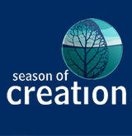 | Season of Creation  Through the month of September “10 Minutes on a Tuesday” is following the readings and themes for the Season of Creation. The observance of a Season of Creation began in the Lutheran Church in Australia in 2000 as a response to the environmental crisis. Since then this opportunity for the church to examine creation-based themes has spread to many different denominations and around the world. The series is outlined below:  1 September Ocean Sunday  8 September Flora and fauna Sunday  15 September Storm Sunday  22 September Social justice Sunday  29 September Blessing of the animals  There is an enormous amount of detailed on-line resource material to help with your services through this season:  - The Australian Season of Creation website provides resources for a full service each Sunday in MS Word  - The American Let all Creation Praise website has much additional material and adapts the Australian material for US use in a pdf format.  - The Methodist General Board of Discipleship website has weekly worship planning helps  - The textweek website has range of resources for each week of the season  - The World Council of Churches website has additional information including Resources for the WCC 10th Assembly, and a host of other links… the rest of this list comes from there  - Sermon notes, intercessions, group study and harvest festival ideas by Churches Together in Britain and Ireland (in English with Welsh and Irish translations).  - Outline of a prayer service on the theme of creation held at the Ecumenical Centre on 22 April 2013  - Resources collected by the Anglican Communion Environmental Network  - Resources including a set of worship service outlines by the United Church of Canada  - Exegetical and liturgical resources collected by the Network of Earthkeeping Christian Communities in South Africa (in English and Afrikaans)  - Prayers, blessings and meditations collected by the European Christian Environmental Network (in a variety of languages). See also their Time for Creation dossier.  - Additional Season of Creation resources on the Seasons of the Spirit website  - Season of Creation resources by the Mid North Coast Uniting ecoministry in Australia  - Worship, teaching and prayer material by the Uniting Earthweb  - Prayers and liturgies, preaching and educational resources by the Canadian Green Church project (in English and French)  - Resource pack "The Life of Trees and the Tree of Life" by the Christian conservation organization A Rocha.  - See also the Ecumenical Water Network's reflections and resources from the Seven Weeks for Water.  In addition New Zealand Methodist Mission Resourcing has a few copies of a Faraday Institute DVD and study book called “Test of Faith” that are appropriate for this season and are available to borrow for use with a group in your church. Request a DVD and one study book for the group leader from nehu@missionresourcing.org.nz  In the archived Refresh section of the New Zealand Methodist website you will find a previous “10 Minutes on a Tuesday” resource that focuses on today’s gospel passage, Year C - Pentecost 16 - 56C (12 September 2010). Bill Peddie’s blogsite also follows the gospel reading.
Preaching thoughts and Questions  Ctrl+Click to follow links  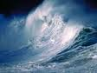 | As I write this Typhoon Trami is battering Southern China. After wreaking havoc in the Philippines, where the storm killed 18 people, it has now caused a tidal bore up the Qiantang River that generated a 20 metre wave. Flooding around China has already left 250 dead or missing in this last week.  It seems that hardly a week goes by without one part of the globe or another being hit by a storm. It does make us wonder. We ask: Are storms just part of nature? Does God cause the storms? … And why do we have a “Storm Sunday” in our Season of Creation? Could it be that anthropogenic climate change is changing the frequency and intensity of storms?  Current research is not conclusive, but the New Zealand Chief Science Advisor does suggest the rising CO2 levels mean that sub-tropical cyclones are expected to track south to New Zealand more frequently. Also, according to the Intergovernmental Panel on Climate Change (IPCC), an increase in the number of extreme storm events is predicted. So it does seem that human behaviour has a part to play today even in the storms that batter us. The theme therefore belongs with the ecological crisis and the other topics that we have touched on in this Season of Creation.  This week’s gospel reading (Luke 8.22-25) is about a storm. The disciples, those chosen and faithful followers of Jesus, were all together in a boat. At Jesus’ suggestion they headed across Lake Galilee. Out of nowhere came a windstorm, so great that their boat started sinking.  The disciples feared for their lives… but Jesus was sound asleep! They woke him up shouting, “Master, Master! We are about to drown!”  Jesus got up. He spoke to the wind and the waves and ordered them to stop. They did… and everything was calm. Then he said to his disciples, “Don’t you have any faith?”  Jesus challenged their fear and lack of faith.  He does the same to us.  The disciples were frightened and amazed and said to each other, “Who is this? He can give orders to the wind and the waves, and they obey him!”  The implied answer is that Jesus was God present with them. In Jesus, God’s power was present with them to help.  Jesus is also God present with us. God’s power is present with us to help. Is it possible that he can bring us the peace and reassurance we need here and now? The story presents us with a challenge to…  Find Christ in the middle of our storms  Storms blow up in our lives. They come when they are not expected - Just like the storm on the Lake Galilee, and like Typhoon Trami sweeping into Southern China. Sometimes they just seem to come out of nowhere. It’s all plain sailing then…a loved one dies; a relationship ends; there’s a terrible accident; an investment sours; an illness is diagnosed; or a redundancy looms.  The storm has come.  And when we are in the middle of an emotional storm that has overcome us, we also wonder in this situation: Are storms just part of nature? Has God caused the storm? Have I done something to cause this storm?  When the wind and the waves threaten to overwhelm us, we are afraid. And we do sometimes fear that in the end they may sink us.  Even the strongest and most assured of Christians will call out, at one time or another, “Master! I am about to drown!”  When the stormy winds of sorrow and grief blow, we do well to seek the calm and comfort of the presence of Jesus Christ. As we acknowledge our need, he hears our cries for help and comes to our aid. There is yet peace and security to be found in the presence of Christ. The knowledge that his love is stronger than the winds and waves, brings us reassurance. His purposes for us will not be blown away by the storm. His presence rebukes our fear.  If it is in the nature of things that storms arise... it is also in the nature of things that the storms pass.  Yes we will pass though the storm.  Yes, Christ is in the boat with us.
Illustrations /  Stories | God stills Barclay’s storm  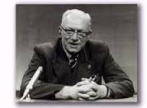  “…some years ago our twenty-one year old daughter and the lad to whom she would one day have been married were both drowned in a yachting accident… God did not stop that accident at sea, but he did still the storm in my own heart, so that somehow my wife and I came through that terrible time still on our own two feet.”  William Barclay, William Barclay: A Spiritual Autobiography (Grand Rapid, Michigan: Eerdmans, 1975) p52  William Barclay,  Scottish theologian  Author, radio and television presenter  1907-1978
Broader / Personal  Preparation  Ctrl+Click to  follow links | Movies with an ecological theme for the Season of Creation  - An inconvenient truth (2006 - PG) An Academy Award winning documentary movie about former US Vice-President Al Gore’s campaign to educate the world about climate change.  - Avatar (2009 - M) Directed and written by James Cameron, this visually extravagant movie is based on a science fiction plot in which humans rape the resources of the planet Pandora. The entertainment value and box office success was due more to the visual effects (for which it won Oscars) than the storyline with its clumsy ecological message. Trekkies will tell you that Star Trek IV - The Voyage Home (1986 - G) also attempted to combine sc-fi with an ecological message with a similarly clumsy result.  - The Lorax (2012 - PG) This is an animated movie adaptation of a Dr Seuss book. It tells the story of a grumpy yet endearing creature who seeks to protect the earth from environmental disaster caused by greed. Featured are the voices of Danny DeVito (as the Lorax) Zac Efron and Taylor Swift. In the words of the Lorax, “Unless someone like you cares a whole awful lot, nothing is going to get better. It’s not.”  - Yogi Bear (2010 - G) With a bit of a push you could say that the movie is about how the lives of species are threatened by their diminishing natural environment. All good fun – filmed in New Zealand.  - Erin Brockovich (2000 - M) starring Julia Roberts is based on a true story and tells of a legal assistant’s persistence to achieve justice after a big power company pollutes the city’s water supply.  Plus a couple of movies, both with a Kiwi connection, from which you can get good clips of a storm:  - King Kong (2005 - M) directed by Peter Jackson and starring Naomi Watts and Jack Black.  - The Truman Show (1998 - PG) written by Andrew Niccol and starring Jim Carrey and Ed Harris.  Music tracks to introduce today’s theme:  - Anchor me off Don McGlashan’s Kiwi band The Mutton Birds’ second album Salty (1993). Watch on YouTube. Read the lyrics.  - Shelter – the title song off the second album (1986) by American country rockers Lone Justice. Watch on YouTube. Read the lyrics.  - Storm – by LA band Lifehouse off their 2007 album Who we are. Watch on YouTube. Read the lyrics
Creativity /  Visual Aids  Ctrl+Click to  follow link | 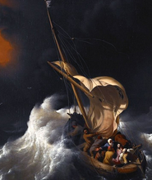  Christian art  This activity could be used as a “station” set up in the foyer for your congregation to interact with following the service. In this case you would print off the painting and leave instructions, pencils and note paper. Alternatively, you could project the painting and ask the questions as a meditation to either wrap up your service or introduce your theme.  Look at the painting Christ in the storm of the Sea of Galilee done by Ludolf Backhuysen in 1695.  How could Christ sleep though a storm like this?  Do you know people that are relaxed in stormy situations?  Detail from Backhuysen’s painting  Is it because of their personality or their faith?  Do you think that the orange tones in the sky are meant to represent a coming break in the storm?  Think of a “stormy” situation that you, or someone you love, is facing right now.  (If set up as a station get people to write or draw this situation)  Pray that Christ will be present in the storm and bring his calm.
Music  AA: Alleluia Aotearoa  CMP: Complete Mission Praise  COC = Carol our Christmas  HIOS: Hope is our Song  FFS: Faith Forever Singing  MHB: Methodist Hymn Book  H&P: Hymns and Psalms  S1: The Source  S2: The Source 2  S3: The Source 3  S4: The Source 4  SIS: Scripture in Song  WHV: With heart and Voice  WOV: With One Voice  WOV = AHB  Ctrl+Click to follow links | Hymns & Songs  A safe stronghold our God is still MHB 494; H&P 661; CMP 2  All creation is a song S4 1703  All things praise you, Lord most high MHB 29; H&P 331; CMP 24  Be still for the presence of the Lord CMP 50; S1 47  Christ is our peace (words and music on the WCC 2013 website)  Fierce raged the tempest MHB 167; H&P 144  God moves in a mysterious way MHB 503; WOV 54; H&P 65; CMP 193; S2 700  How wonderful this world of thine H&P 336  In Christ alone S3 1311  In heavenly love abiding MHB 528; WOV 504; H&P 678; CMP 331; S2 782  I sing the Almighty power of God MHB 46; WOV 40; H&P 334; CMP 293  Jesus calls us! O’er the tumult MHB 157; WOV 505; H&P 141; CMP 359  Jesus is Lord, creation’s voice proclaims it SIS 360: CMP 367  Jesus lover of my soul (Wesley) MHB 110; WOV 139; H&P 528; CMP 372;  S2 838  Lead us heavenly father lead us MHB 611; WOV 492; H&P 68; CMP 400; S1 311  O Lord my God, when I in awesome wonder CMP 506; S1 396  O the Spirit she moves on the water AA109  Out of the storms FFS 53  Praise him, praise him God of creation SIS 131  The God of heaven thunders AA135  These hills FFS  Sing a happy alleluia! AA 118  Will your anchor hold in the storms of life MHB 634; H&P 689; CMP 770  Who then is this S1 1069  When the storm winds blow AA 152  A word search of “storm” on www.hymnry.org will give you 1398 hymns on the theme!
Prayers  Ctrl+Click to follow link | Collect  Christ you come as a companion.  I seek you to secure my feet in the quake,  be my anchor in the storm,  a shelter from the tornado.  In the haven of friends,  bring calm to my soul,  joy in my heart  and resilience in my backbone,  Amen.  © John Howell (used with permission)  Praise to be you  Praise to be you, O God,  the maker of the universe,  by whose wisdom we are created and sustained.  Praise to be you, O God,  the Father of our Lord Jesus Christ,  by whose love we are redeemed and forgiven.  Praise to be you, O God,  the source of all holiness,  by whose Spirit we are made whole  and brought to perfection.  Praise to be you, O God,  Source of all being,  Eternal Word and Holy Spirit  As it was in the beginning, is now  And shall be forever. Amen.  © The Methodist Worship Book (Peterborough, England: Methodist Publishing House, 1999)  The voice of the Lord in a storm - Psalm 29 (selection)  All of you angels in heaven,  honor the glory and power  of the Lord!  Honor the wonderful name  of the Lord,  and worship the Lord  most holy and glorious.  The voice of the Lord  echoes over the oceans.  The glorious Lord God  thunders  above the roar  of the raging sea,  and his voice is mighty  and marvelous.  The voice of the Lord  destroys the cedar trees;  the Lord shatters cedars  on Mount Lebanon.  God makes Mount Lebanon  skip like a calf  and Mount Hermon  jump like a wild ox.  The voice of the Lord  makes lightning flash  and the desert tremble.  The Lord rules on his throne,  king of the flood forever.  Pray that our Lord  will make us strong  and give us peace.  Contemporary English Version (CEV) Copyright © 1995 by American Bible Society  Reading the sky  My soul is troubled. And what should I say – ‘Father save me from this hour’? John 12.27  The temperature falls to signal  the warm fine day is changing.  The wind races black clouds  like the A1GP event  and the storm flags its start.  We cannot bypass the downpour,  only experience it and wait.  The Holy One whose soul is troubled  reads the sky over Jerusalem.  Does every generation need to experience  war, greed or exploitation  before learning how to live with neighbour and planet?  God, I will lift my eyes to the One who draws all to him.  May we see a new way of living on the horizon. Amen.  © John Howell, Sighs to deep for words: Prayers and images from Taupo (Taupo: St Paul’s Union Church, 2007) Used with permission  Benediction  The peace of God which passes all understanding,  keep your hearts and minds in the knowledge of the love of God,  and of his Son Jesus Christ our Lord;  and the blessing of God almighty,  the Father, Son and Holy Spirit,  be upon you and remain with you always.  Amen.  Based on Philippians 4.7
Communal  Sharing | Is there someone in your congregation who has been through a major storm, or a storm at sea? Arrange for them to tell about their experience in the service today as an introduction to your theme.
Children  Ctrl+Click to  follow links | Conservation    Talk to the children about the importance of caring for God’s world and protecting New Zealand’s natural heritage. Make a kea face mask from this pattern on the Department of Conservation website or use one of their other fun activities suggested for children.  More resources for children from sermons4kids.com - scroll down to the bottom of the page for a printable Children’s bulletin in MS Word.
PowerPoint  Ctrl+Click to  follow links | YouTube clip – Jesus calms the storm BBC 1 min 7 sec  Storm cartoons from reverendfun.com: sacrilegious in a thunderstorm; snooze on the cruise.  Google images for storm and storm at sea.

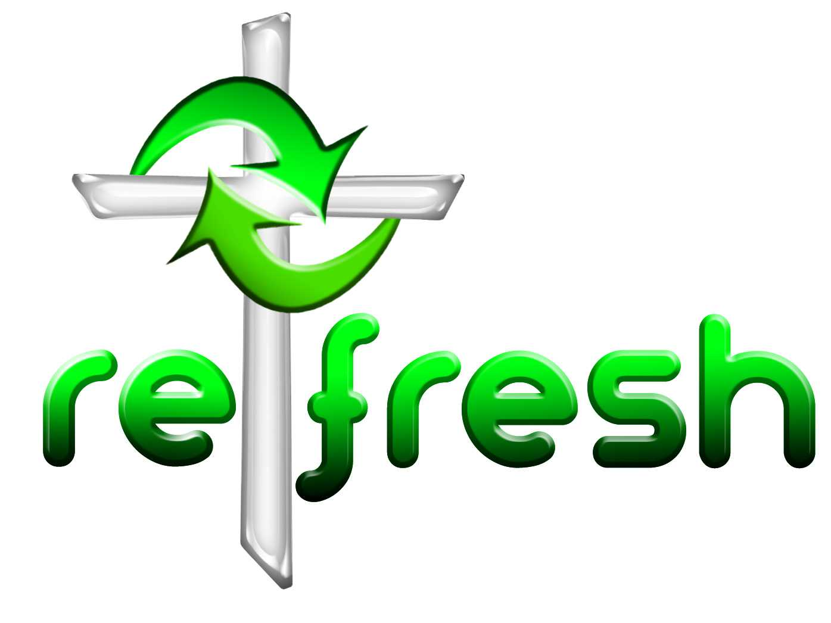
© 10 minutes on a Tuesday is a Refresh Resource. Unless otherwise acknowledged all material is prepared by Andrew Gamman. While every effort has been made to acknowledge source material, if you believe unacknowledged work has been quoted, contact the email address below to request that it be acknowledged or removed. Material included here may be freely used and reproduced for the immediate purpose of worship. Permission must be sought to republish in any form, or to reproduce for commercial gain. If you wish to share the content with others you may do so by linking through the NZ Methodist website. For more information on this and other resources, contact andrew@missionresourcing.org.nz or 09 525 4179 (w)


Mission Resourcing: Inspiring and resourcing our communities for a journey with Christ that enriches lives and relationships

