
Sunday 19 May 2013

Last words: 4. You will do even greater things Year C - Pentecost - 39C

The Mission of the Methodist Church of New Zealand | Our Church’s mission in Aotearoa / New Zealand is to reflect and proclaim the transforming love of God as revealed in Jesus Christ and declared in the Scriptures. We are empowered by the Holy Spirit to serve God in the world. The Treaty of Waitangi is the covenant establishing our nation on the basis of a power-sharing partnership and will guide how we undertake mission.
Links | Ctrl+Click on the links below to go directly to the text you require  Readings  Introduction  Preaching thoughts  Illustrations  Broader preparation  Creativity  NZ music month  Music  Prayers  Communal sharing  Children  PowerPoint
Readings  Ctrl+Click to follow links  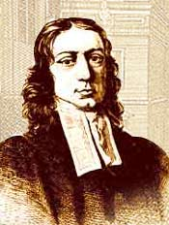  John Wesley  1703-1791    5-20 May 2013 | Psalm 104:24-35 A song of praise to the Lord who has created all living creatures. “You created all of them by your Spirit, and you give new life to the earth.”  Genesis 11:1-9 When the people of Babel tried to build a tower that reached to the sky, God confused their languages so they couldn’t understand each other.  Acts 2:1-21 During the Pentecost Feast the Holy Spirit came on the believers. Visiting pilgrims from many nations heard them declaring the wonders of God in their own languages.  John 14:8-17 In response to Philip, Jesus explains that he is one with the Father. To have seen Jesus is to have seen the Father. He then promises to send the Spirit to be with the disciples and help them.  Wesley Day  Being the Sunday preceding 24 May, today is celebrated as Wesley Day, also known as Aldersgate Sunday or Heritage Sunday. 24 May was the date that John Wesley, the founder of the Methodist movement, had his life-changing experience at a meeting on Aldersgate Street, London, in 1738. He wrote in his journal:  "In the evening I went very unwillingly to a society in Aldersgate Street, where one was reading Luther's Preface to the Epistle to the Romans. About a quarter before nine, while he was describing the change which God works in the heart through faith in Christ, I felt my heart strangely warmed. I felt I did trust in Christ, Christ alone for salvation, and an assurance was given to me that he had taken away my sins, even mine, and saved me from the law of sin and death."  This is also the day that Methodists seek to celebrate the Anglican Methodist Covenant . The covenant was signed on 24 May 2009 at Lotafala’ia, the Tongan Methodist Church in Mangere, South Auckland and Te Karaiti Te Pou Herenga Waka, the Maori Anglican marae/church.  On this day plan to be involved in local and/or regional combined Anglican -Methodist worship services and social gatherings. The Annual Auckland Anglican Methodist Covenant Service will be held at 5.00pm Sunday 19 May at Pitt St Methodist Church. It will be an opportunity to celebrate our joint heritage in the Wesleys and share together in some great singing and liturgy.  Alternative Readings for Wesley Day:  Isaiah 12.1-6  Psalm 130  2 Peter 1.1-11  Matthew 9.35-10.16  In the archived Refresh section of the New Zealand Methodist website you will find a previous “10 Minutes on a Tuesday” resource with a complete service for Wesley Day, Year B – Easter 7 – 38B (20 May 2012).  Fair Trade fortnight 5-20 May 2013  This Sunday brings us to the end of Fair Trade fortnight. Register as a Fairtrade church - There are just two easy steps to becoming a Fairtrade church: use Fairtrade Certified products and promote fair trade. Your swap to Fairtrade makes a life-changing difference to the lives of millions of developing country farmers, workers and artisans as well as their families and communities. Not only does Fairtrade provide them with security and stability to plan for their future through fair and stable prices - it also provides additional funds through the Fairtrade Premium for investment in social, environmental and economic development.  Week of Prayer for Christian Unity 12-19 May  The theme this year is “What does God require of us?” and the resource material was prepared by the Student Christian Movement of India. The Biblical text is Micah 6.6-8, so it also fits in nicely with the global Micah Challenge.  In the archived Refresh section of the New Zealand Methodist website you will find a previous “10 Minutes on a Tuesday” resource for today’s Pentecost passages, Year C - Pentecost - 39C (23 May 2010).
Introduction / Background | Jesus’ upper room discourses  Our current series of gospel passages from John takes us to Jesus’ upper room discourses (John 13.31 - 17.25). In these Jesus prepares his disciples for his departure. They are his important last words before his death. We have been following these lectionary readings over a five Sunday series under the heading “Last Words”:  28 April Love one another John 13.31-35  5 May Keep my word John 14.23-29  12 May Be one John 17.20-26  19 May You will do even greater things John 14.8-17  My usual method is to follow one of the lectionary readings rather than to jump from text to text. However, I am departing from this today to include thoughts provoked by the Genesis and Acts readings as well as the gospel passage. More than one preacher has seen the miracle of Pentecost as being a reversal of the story of Babel, and those who selected the lectionary readings have brought these together this year for Pentecost Sunday. Towers and tongues add some rich symbolism to Jesus’ last words from John’s gospel.  The series comes to its conclusion next Sunday 26 May, which is Trinity Sunday, when we look at John 16.12-15.  Aetiologies in Genesis  An aetiological story is one that is used to explain the cause or origin of something, be it a custom, an event, or an object. The book of Genesis is full of them. Being a book of beginnings, it includes aetiological stories for a variety of things including: creation, the Sabbath, marriage, rainbows and, in today’s passage, different languages.
Preaching thoughts and Questions  Ctrl+Click to follow link  See another approach to today’s reading in the 19 May 2013 sermon on Bill Peddie’s website    Artists impression of the Kingdom Tower (under construction)  * After the New Zealand government established “native schools” in 1867 the situation was reversed and it wasn’t uncommon for Maori children to be strapped for speaking their own language at school. | Let’s build a tower  “Let’s build a tower that reaches to the sky… we’ll become famous.” Genesis 11.3-4  My one is bigger, better, flasher and taller than yours!  It’s hardly a new game. However, for the sake of pride, nations continue to plough no end of resources into showing off their financial and engineering prowess by building towers.  Completed in 1997, the Sky Tower in Auckland stands at 328 metres… which dwarfs the Eiffel Tower (234 metres) and, more important, it’s bigger than Australia’s tallest tower, the one in Sydney, which is a mere 309 metres. It’s even higher than Australia’s tallest building. (Q1 on the Gold Coast which is 322 metres). There’s also a tower in Canberra but it rises only to a trifling 195 metres.  But before our Kiwi hearts swell with pride… look to Moscow where you’ll find the Ostankino Tower standing at a proud height of 540 metres. It was the world’s tallest building… was… but not for long… line honours today go to the Kalifa Tower in Dubai which reaches to a whopping 828 metres. That’s nearly three times the height of Auckland’s Sky Tower! It can be seen from a distance of 100 kilometres! It’s elevators travel at 64kph! It is unrivalled in both its height and plushness… At present… Construction started in March this year on Saudi Arabia’s 1,000 metre high Kingdom Tower which is due to open in 2018. It was originally planned as the “mile high tower” (1.6 kilometres) but had to be scaled back as the location, on the banks of the Red Sea, is unable to support a structure of that size. The Arab prince behind the project, Al-Waleed bin Talal, says, “Building this tower in Jeddah sends a financial and economic message that should not be ignored. It has a political depth to it to tell the world that we Saudis invest in our country.”  “Sends a… message”. That’d be, “my one’s bigger than yours!”  “It has a… depth” … Yeah right!  The people of Babel had forgotten their dependence on God and they built a tower as a monument to themselves and their pride in their own achievements. The Lord punished them by confusing their language and scattering them.  … okay, maybe building a tower maybe isn’t such a great idea.  Let’s speak in their language  “Why do we hear them speaking our very own languages?” Acts 2.8  Luke names for us in Acts fifteen different cultural and language groups that were present when the disciples burst out onto the streets on the Day of Pentecost. As a result of the miracle of tongues on that day, everybody heard the gospel in their own language. The gift of the Spirit at Pentecost reversed the curse of Babel. Language is the key to communication and understanding between people. The fact that there are today an estimated 6,600 languages spoken in the world presents its challenges.  There is no language that communicates to the heart like our mother tongue. Because it is so interconnected with our sense of cultural belonging, there is a sense of affirmation and appreciation that comes from hearing in our own language. Some examples:  - During a day alone on the crowded streets of Beijing, having not heard a word of English I was feeling quite alienated. I sidled up to a group of European-looking people only to find that they were speaking a European language totally unfamiliar to me. I was left feeling more isolated than before.  - The first school in New Zealand, started at Rangihoua in the Bay of Islands (now Oihi Bay) by the missionary teacher Thomas Kendall in 1816, taught Maori children exclusively in their own language. Their text book O korao no New Zealand (New Zealander’s first book) was the first book to be published in the Maori language.* The local people were keen for their children to attend.  - The New Testament was written in koine Greek, which was the common spoken language of the Roman Empire at the time it was written. It communicated to the ordinary person. A 1611 translation into English did the same thing for English readers in its day… as do contemporary translations for our day. However, if we continue to read it today only in Greek or in the King James Version we will give the impression that the Bible is exclusively for an elite group of people.  But what diversity there needs to be for everyone to hear in their own language. The gift of the Spirit on the Day of Pentecost brought appreciation of diversity. The Spirit enables us to transcend barriers to draw people from all backgrounds and cultures to the love of God. Which brings us to the challenge of today’s gospel passage…  Let’s do greater things  “You will do even greater things” John 14.12  Among the last words of Jesus comes this announcement to his disciples that they would do what he had been doing and do even greater things when he returned to the Father. They had travelled with him for three years watching him draw crowds, reach out to the needy and perform great works. You can just imagine how stunned they would have been to hear him say they would “do even greater things.”  How could anyone do greater things than Jesus? Well, maybe it depends on how we measure “greater”.  In one sense, if we continue to read through the book of Acts we stand in awe as we see the disciples, preaching, healing and boldly witnessing. Some of their miracles are quite unlike anything we see in the gospels. The Spirit moves in ways that are unpredictable and awe-inspiring. It may challenge our complacency to realise that the same Spirit is still present in the church and, where there is an openness to receive him, is still able to come like a mighty rushing wind.  There is, however, another sense in which we do greater things that is perhaps even more significant. This Jesus, who announced to his disciples a mission to the whole world, spoke Aramaic, a language common only to the people of the Eastern Mediterranean. Apart from a childhood trip to Egypt he never set foot outside the Holy Land. After his life on earth came Pentecost and the gift of the Holy Spirit. When the Spirit fell on the disciples they were propelled to take the gospel across language and cultural barriers. The introduction era of the Spirit saw the little band of Jesus’ followers rapidly expanding, travelling everywhere with their gospel and having a reach far greater than Jesus’ earthly ministry. We live in the continuation of this era in which we see millions of people turning to God, in countries all over the world.  So here we are on Pentecost Sunday 2013 looking at stories that face us with competing choices. What’s it all about? Are we building edifices to our own pride, so we can stand and say, “look what I’ve done”? Or is it more about thinking outside of ourselves, breaking down barriers, co-operating with the Holy Spirit and seeing him working in our lives and in the lives of others through us?
Illustrations  Ctrl+Click to follow links  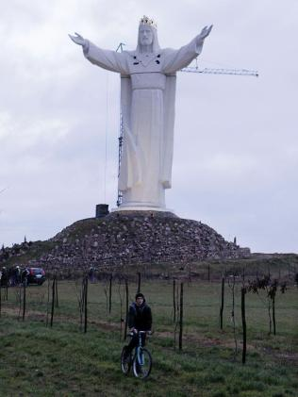 | Christ statue in Poland  Completed in 2010, this statue of “Christ the King” stands in the town of Świebodzin in Poland, not far from the border with Germany. It was completed at a cost of $1.7 million, which was collected largely from the generous support of the town of 21,000 people by Sylwester Zawadzki, an enthusiastic retired priest. Importantly, Poland’s Christ statue is 3 metres taller than the “Christ the Redeemer” statue in Rio de Janeiro on which it is modelled. In a small town, struggling to provide funding for infrastructure and community facilities, not everyone shared Zawadzki’s enthusiasm for the project.  Opponents of the Christ statue vent their frustration on YouTube
Broader / Personal  Preparation | Babel (2006 - R16)  With a title based on our reading from Genesis today, this movie takes us around the world in four inter-locking stories. Babel is a most unusual and powerful production tied around the theme of communication and understanding across languages and cultures. Starring Cate Blanchett and Brad Pitt, it was nominated for seven Oscars and won one.
Creativity /  Visual Aids    The readings come from the Contemporary English Version of the Bible (CEV) Copyright © 1995 by American Bible Society | Pentecostal flames  Cut flame shapes out of red card and give one to each person as they arrive for your church service today.  Have a supply of blue-tack or double-sided tape on hand (or pins if you have a board made of Pinex or similar). As people leave the service, get everyone to stick their flame on a wall or board so that the individual flames build into a large fire.  You could extend this activity by giving out pencils… have a break for a time of confession after the first point of the message (above). Get everyone to write, or draw, on the back of the flame those things that they are ‘building’ for themselves as a matter of pride. As an act of confessing this pride as sin, get people to come and stick their flames on the board. Then lead in a prayer of confession.  Or… in response to the second point of the message, get everyone to think of someone who they can cross a barrier of some sort to reach out to in friendship. Write their Christian name (or initials) on the back of the flame as a commitment to do something about it in the week ahead, then come and stick it on the board,  With these activities leave an “out” for those who feel uncomfortable participating in this way. Say something like, “however, one or two may prefer to use this time just pray quietly where you are in your seat.”  Dramatic reading in many languages  How many languages do you have in your congregation? See if you can get a reader from each language to participate in the following dramatic reading. Readers 1,2 and 3 will read in English (or in the predominant language of your congregation).  AATST = all at the same time. Choose some readers in addition to the first three, one from each language group. Get all of these readers to read at the same time in their own language. The result should be organised confusion – which rather illustrates the text!  AOAAT = all, one at a time. The same group as above all reads, but now one at a time so that everybody can understand in their own language – again illustrating the text.  Genesis 11.1-9  Reader 1 At first everyone spoke the same language, but after some of  them moved from the east and settled in Babylonia, they said  Reader 2 Let’s build a city with a tower that reaches to the sky! We’ll  use hard bricks and tar instead of stone and mortar. We’ll  become famous, and we won’t be scattered all over the  world.  Reader 1 But when the Lord came down to look at the city and the tower, he  said  Reader 3 These people are working together because they all speak the same  language. This is just the beginning. Soon they will be able to do  anything they want. Come on! Let’s go down and confuse them by  making them speak different languages - then they won’t be able to  understand each other.  AATST So the people had to stop building the city, because the  Lord confused their language and scattered them all over the  earth. That’s how the city of Babel got its name.  Reader 1 So the people had to stop building the city, because the Lord  confused their language and scattered them all over the earth.  That’s how the city of Babel got its name.  Acts 2.1-7  Reader 1 On the day of Pentecost all the Lord’s followers were together  in one place. Suddenly there was a noise from heaven like  the sound of a mighty wind! It filled the house where they  were meeting. Then they saw what looked like fiery tongues  moving in all directions, and a tongue came and settled on  each person there.  AOAAT The Holy Spirit took control of everyone, and they began  speaking whatever languages the Spirit let them speak. Many  religious Jews from every country in the world were living in  Jerusalem. And when they heard this noise, a crowd  gathered. But they were surprised, because they were  hearing everything in their own languages. They were excited  and amazed.  Finish by reading this last paragraph in English (or the predominant language)
NZ Music Month  Ctrl+Click to follow links    AA: Alleluia Aotearoa  FFS: Faith Forever Singing  HIOS: Hope is our Song  WHV: With heart and Voice | This May is the 12th New Zealand Music Month. Through the whole of this month we are especially recommending Kiwi music to use in your worship services.  Notes from John Thornley, NZ Hymnbook Trust  Ten Hymns from New Zealanders to Open the Church Worship Service:  From Alleluia Aotearoa  1. The majesty of mountains AA 139. Words by Michael Perry, music by Christopher Norton - imagery from nature, and a Trinitarian expression in final verse.  2. Great ring of light AA 57. Words and music by Colin Gibson. Trinitarian in structure, contemporary creation imagery, the Easter victory for any and all Sundays of the year.  From Faith Forever Singing  3. God who carved this timeless landscape FFS 31. Words by Doug Grierson, music by Colin Gibson (in book) or traditional tunes Austria or Blaenwern. Strong natural imagery of NZ and honours our rural Pakeha pioneers.  4. Whispering gently FFS 77. Words and music by Bill Bennett. Wonderful words for a Spring season service.  From Hope is our Song  5. Look in wonder HIOS 93. Words by Shirley Murray and music by Jim Strathdee (US writer of I am the light of the world). Text celebrates the beauty of our earth, and states concerns for human care and stewardship of God’s garden.  6. Praise the all-sustaining Word HIOS 116. Words and music by Colin Gibson. Strong traditional 4/4 hymn tune, and Trinitarian words.  7. Come, fill our cup with the water of life HIOS 18. Words and music by Bill Bennett. Strong opener for a service including Holy Communion. Bright and tuneful melody.  8. God bless our land HIOS 37. Words by Shirley Murray. Music by Barry Brinson. Strong candidate for an alternative national anthem. As with any new song, a singing group familiar with the music will give a good lead.  9. Where the light of Easter Day HIOS 153. Words by Shirley Murray and music by Jillian Bray. Not just for Easter Day, but for any Sunday during the Pentecost Sundays, May to August.  10. Thank you for the night HIOS 128.Words and music by leading NZ composer Jenny McLeod. Celebrates the Sabbath to follow the Saturday night time, and goes on to praise the light, the wind, the sea, the sky, the earth – all the elements that surround the composer’s birds-nest house perched high above Paekakariki.  Other New Zealand hymns and songs for this week  As the wind song through the trees HIOS 7  From the waiting comes the sign AA  God comes to us as one unheard HIOS  Join hands in the Spirit AA 82  Loving Spirit AA 94  Make spaces for Spirit! HIOS  Send us your Spirit WHV 44  Spirit of God WHV 45  More music suggestions below
Music  Ctrl+Click to  follow links  CMP: Complete Mission Praise  MHB: Methodist Hymn Book  H&P: Hymns and Psalms  S1: The Source  S2: The Source 2  S3: The Source 3  S4: The Source 4  SIS: Scripture in Song  WOV: With One Voice = AHB | Hymns & Songs  Awake, O Lord as in the time of old (A hymn by Church of England parish priest,  Henry Twells 1823-1900 words – tune Chilton foliat WOV 530)  Breathe on me breath of God MHB 300; WOV 320; H&P 280; CMP 67; S1 57  Come and move, Holy Spirit SIS 358  Come down O love divine MHB 273; WOV 310; H&P 281; CMP 89; S1 71  Come gracious Spirit WOV 311  Come Holy Spirit, Creator come WOV 309: CMP 90 (This hymn by German  Benedictine monk Rabanus Maurus 776-856 occurs in many different  translations and revisions)  Holy Spirit come SIS 446  Holy Spirit, living breath of God S4 1866  Holy Spirit you are welcome SIS 359; S2 746  O for a thousand tongues MHB 1; WOV 141; H&P 744; CMP 496; S1 383  O thou who camest from above MHB 386; WOV 486; H&P 745; CMP 525; S1 416  Refresh my heart (Geoff Bullock – words and sheet music available from  musicnotes)  Revive your work O Lord MHB 738; H&P 780; CMP 578  Spirit of the Living God SIS 303; CMP 613; S1 462  The Holy Spirit has come SIS 221  This is the air I breathe S2 1007  Hymns for Wesley Day  See above for New Zealand song suggestions
Prayers | Collect  Almighty God,  who on the day of Pentecost  sent your Holy Spirit on the disciples  with wind from heaven and with tongues of flame,  filling them with joy and boldness to preach the gospel:  send us out in the power of the same Spirit  to witness to your truth  and draw everyone to the fire of your love;  through Jesus Christ our Lord. Amen.  © The Methodist Worship Book (Peterborough, England: Methodist Publishing House, 1999)  Pentocost  It’s Pentecost  And the wild wind still blows over a thousand paddocks  The fire still refuses to burn tidily, safely, predictably  It’s Pentecost  And we still stagger before the astonishing spectacle of people passionate about making a difference, standing up with courage before the crowd, speaking in strange yet stirring tongues  We still listen in wonder as different languages proclaim the good news of Jesus, the reconciling love of God, the call to holiness and justice and hope and goodness  We still open our hearts in joy to the newness of transformed lives, outlined changes for present despair, a way out and up and over places we had despaired of ever leaving  And on this day of Pentecost  We declare once again that anything can happen:  That places of greyness can explode unexpectedly into colour: of anger into joy: of repression into freedom: of silence into music  And so we give you, Lord, the right to breathe newness into our circumstances and attitudes, our beliefs and our dreams, our hopes and plans:  For we are a people of Pentecost  We are a people of grace  We are a spirit-blessed people of hope  Blow on us: in us, and through us we pray  © Alan K Webster (Used with permission)  Prayer of Confession  Loving God  You are gracious, merciful and forgiving  You came seeking us when we had no thought for you  We confess that we get carried along by the spirit of our age  We think so much of what we may possess  So little of what we have to give  So much of the immediate  So little of the eternal  So much of ourselves  So little of you  Lord have mercy. Christ have mercy.  We crave that others would think well of us,  We want so much to make a good impression  We have so much concern for our reputation  So little for yours  We think so often of how others could serve our needs  So little of how we can serve others  Lord have mercy. Christ have mercy.  Strengthen us through the tests that we face  Deliver us from conformity to the standards of those outside your kingdom  Send your Spirit  so that we may be uncompromising in our worship and service of you  Make our lip-service into reality  that here and now we would live as your people  owned by you, and joyfully celebrating your life.  In Christ’s name. Amen  Pentecost  Our Lord and God  send your Holy Spirit to us this Pentecost Sunday  for we are much in need of your Spirit.  We readily confess that we are not the people that we could be.  You are Holy  but we are tainted,  tainted by greed and pride and our own wilfulness.  We confess that we do not serve you as we could.  In fact we’re not good servants at all.  We’d rather others served us.  And even if we do some significant good thing  we like to do it in our own strength  and receive the recognition and praise of others.  We need filling with your Holy Spirit.  Come touch us afresh.  fill us with a fresh sense of awe  fill us with your power to live effectively  fill us with your praise  Where we have shut you out of compartments of our lives  be it our desires, relationships, thoughts or finances  come Holy Spirit as a mighty wind  come right in.  Blow wind blow.  Clean us out, make us fresh, make us right, make us lively.  Fill us Holy Spirit.  Amen  Psalm 104 (selection)  Our Lord, by your wisdom you made so many things;  the whole earth is covered with your living creatures.  But what about the ocean so big and wide?  It is alive with creatures,  large and small.  All of these depend on you to provide them with food,  and you feed each one with your own hand,  until they are full.  You created all of them by your Spirit,  and you give new life to the earth.  Our Lord, we pray that your glory  will last forever  and that you will be pleased  with what you have done.  You look at the earth, and it trembles.  You touch the mountains, and smoke goes up.  As long as I live, I will sing and praise you,  the Lord God.  Contemporary English Version (CEV) Copyright © 1995 by American Bible Society
Communal  Sharing | As a lead-in to today’s message get a spontaneous show of hands:  - Who has visited Auckland’s Sky Tower?  - The Sydney Tower?  - The Eiffel tower?  - Are there people who have visited other towers?  - Which ones?  One or two might like to share something of their experience.
Children  Ctrl+Click to  follow link   | Balloons for a birthday  Tie bunches of balloons together at the front of the church. Ask the children if they ever see balloons tied up at someone’s letterbox. What does that indicate? (It shows that there is a birthday party at that house).  Well, today there’s a birthday. Does anyone know whose birthday we are celebrating? (There may be some people in the church that have a birthday today. Acknowledge them and include them in your celebration.) It’s actually the birthday of the church. Today is a special day in the church year. It is Pentecost Sunday and we call this day the birthday of the church because it was at Pentecost that the Holy Spirit came on the believers. When this happened it was the start of the church.  It is not easy to explain what the Holy Spirit is like. Some people describe the Spirit as the breath of God. These balloons are full of breath. Before I blew into them they were flat and lifeless. That’s a bit like the church… and like us. Without God’s Spirit we are flat and lifeless.  The Holy Spirit is God’s gift to the church to help us live as Christians. After the service come to the front of the church and I will give you each a balloon to take home to remind you that today is the birthday of the church.  More resources for children from sermons4kids.com You can also scroll down to the bottom of the page to “Worship Bulletin” to get a printable activity sheet on today’s readings in MS Word.
PowerPoint  Ctrl+Click to  follow links | The day of Pentecost presented in 6 slides from thebricktestament.com  or presented as a shadow puppet drama  Pictures of: an ancient Babylonian tower (or ziggurat).  a modern reconstruction of a ziggurat in Budapest, Hungary.

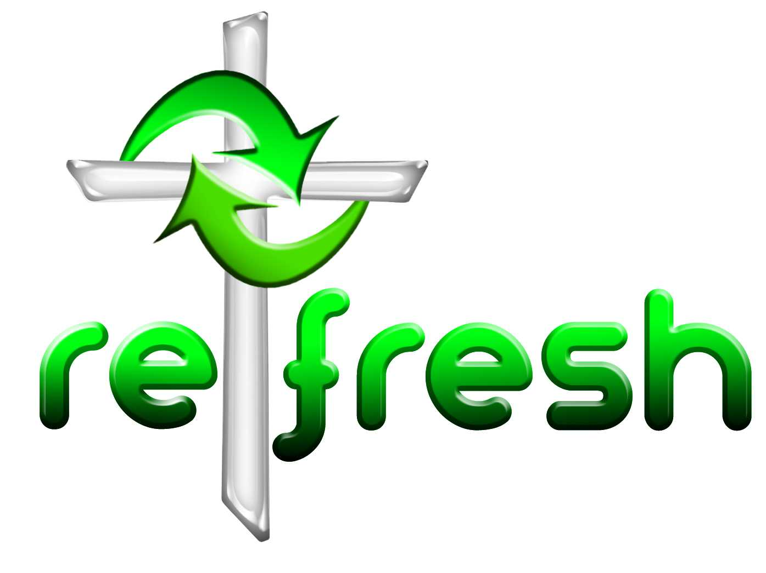
© 10 minutes on a Tuesday is a Refresh Resource. Unless otherwise acknowledged all material is prepared by Andrew Gamman. While every effort has been made to acknowledge source material, if you believe unacknowledged work has been quoted, contact the email address below to request that it be acknowledged or removed. Material included here may be freely used and reproduced for the immediate purpose of worship. Permission must be sought to republish in any form, or to reproduce for commercial gain. If you wish to share the content with others you may do so by linking through the NZ Methodist website. For more information on this and other resources, contact andrew@missionresourcing.org.nz or 0064 9 525 4179 (w)


Mission Resourcing: Inspiring and resourcing our communities for a journey with Christ that enriches lives and relationships

