
Sunday 10 February 2013

See God’s glory
Year C - Transfiguration - 17C

The Mission of the Methodist Church of New Zealand | Our Church’s mission in Aotearoa / New Zealand is to reflect and proclaim the transforming love of God as revealed in Jesus Christ and declared in the Scriptures. We are empowered by the Holy Spirit to serve God in the world. The Treaty of Waitangi is the covenant establishing our nation on the basis of a power-sharing partnership and will guide how we undertake mission.
Links | Ctrl+Click on the links below to go directly to the text you require  Readings  Introduction  Preaching thoughts  Illustrations  Broader preparation  Creativity  Music  Prayers  Communal sharing  Children  PowerPoint
Readings  Ctrl+Click to follow links | Exodus 34.29-35 The face of Moses was shining when he came down from Mt Sinai with the Ten Commandments after speaking with the Lord. The people were afraid to go near him, so he covered his face with a veil.  Psalm 99 A song in praise of the Lord who is king of the nations and loves justice and fairness.  2 Corinthians 3.12-4.2 Christ takes away the veil that keeps people from seeing the truth. As we look to the Lord we become more and more like him.  Luke 9.28-36 Jesus took Peter, James and John to a mountain top. While Jesus was praying his face changed, his clothes became shining white and Moses and Elijah appeared to them.
Introduction / Background  Ctrl+Click to follow links  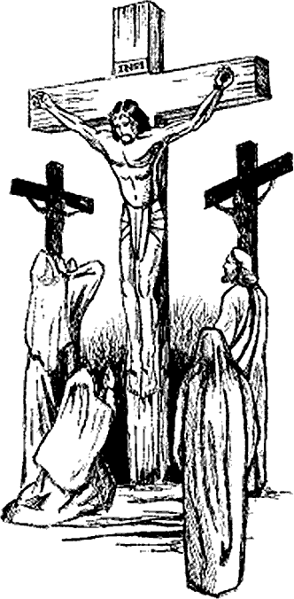   | Transfiguration in the synoptic gospels  Today’s gospel passage (Luke 9.28-36) records the transfiguration of Jesus. It is also found in Matthew 17.1-13 and Mark 9.2-13. This parallels tool from the University of Toronto will allow you to compare the three different accounts and you’ll see that it is Luke’s story that differs most from the other two. At the beginning you will note that Luke says this was eight days after Jesus speaking about discipleship, whereas the other writers say it was six days. Some of the more significant differences in the third gospel are:  - Only Luke tells us that the purpose of Jesus going up the mountain was to pray (Luke 9.28) and that the incident occurred while Jesus was praying (Luke 9.29). Prayer is one of Luke’s repeated themes.  - Luke alone tells us that the disciples were very tired (Luke 9.32) and awoke to see Jesus in his glory as he spoke with Moses and Elijah.  - Unlike the other gospel writers, Luke avoids the word metamorphosis (transfigure) instead referring to Jesus being changed (Luke 9.29).  - Only Luke tells us that the conversation of Moses and Elijah with Jesus concerned his up-coming death (departure) in Jerusalem (Luke 9.31).  - It is Luke’s opinion that Peter didn’t know what he was talking about when he offered to make shelters (Luke 9.33).  - Luke’s is the only gospel that doesn’t explain that the disciples’ silence about the incident was a result of a command from the Lord (Matthew 19.9 and Mark 9.8 cf Luke 9.36).  Glory  “Glory” is one of those funny religious words. It is both vague and ambiguous. Sometimes it is used in a way that is so vague that, while it does sound spiritual, it has virtually no meaning at all.  “Glory be” for instance once meant a prayer of praise to the Father, Son and Holy Spirit but is now used colloquially as a mere exclamation of surprise.  In the First Testament, glory is used both of the physical, shining presence of God, and symbolically, of any revelation of his being. This idea is carried though to the New Testament, along with an additional thought of the hope of glory – that is looking forward to the fuller revelation of Christ at the end of the age. Our reading from Corinthians today uses the word in the sense of the presence of Christ which is able to be seen in us his people.  Lent and Easter  This coming Wednesday is Ash Wednesday and the beginning of Lent. “10 Minutes on a Tuesday” will provide a Lenten series called “What’s it all about?” which will follow the themes of the lectionary readings from Luke and Philippians. An advertising template and other resources are available from the Refresh section of the NZ Methodist website. The series is outlined below.  What’s it all about?  17 Feb Lent 1 Luke 4.1-13 Temptation  24 Feb Lent 2 Philippians 3.17-4.1 Citizenship  3 March Lent 3 Luke 13.1-9 Grace - getting another chance  10 March Lent 4 Luke 15.1-3, 11-32 Grace - being welcomed home  17 March Lent 5 Philippians 3.4-14 Surrender  24 March Lent 6 Luke 19.28-40 Palm Sunday  28 March Maundy Thursday Tenebrae service  31 March Easter Day Luke 24.1-12 Resurrection  At the beginning of Lent this year “10 Minutes on a Tuesday” will have been published for the complete three-year lectionary cycle. That means most weeks there will be choice of two different “10 minutes” relating to the allocated Bible passages. Each week we will include a hyperlink to the older archived resource.  Children’s Day - 3 March 2013  Children’s Day this year has the theme “Treasure our children”. This is a great way to launch your parish’s interest in the New Zealand Methodist “Let the Children live” project. Have you thought about planning an event? What about a children’s street party? A tried and true (and relatively inexpensive) way of drawing a crowd of children is to hire a bouncy castle. Make sure that you have a responsible person supervising it. Add to that a sausage sizzle and/or candy-floss machine and/or bubble machine (both machines are available to hire) with your free balloons (you could also get a balloon gas bottle) and children’s leaders to promote your Sunday School, Mainly Music group etc… and you’ve got an exciting and attractive event.  Register on the Children’s Day website and get all sorts of free stuff (balloons, activity books, posters) to promote your event.  Co-ordinate with other churches by letting Esme know what you are doing. Contact: esme@missionresourcing.org.nz.
Preaching thoughts and Questions  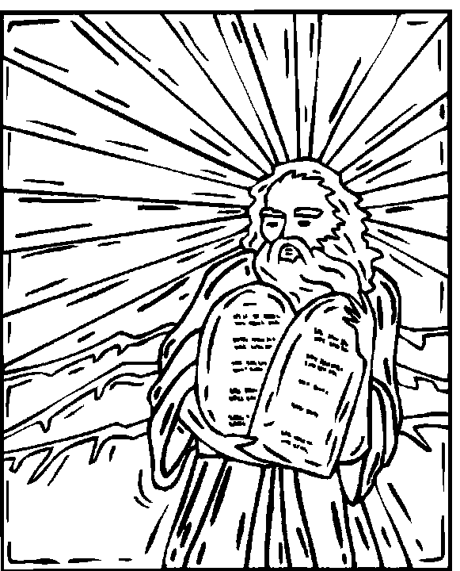  NRSV = New Revised Standard Version of the Bible  GNT = Good News Translation of the Bible  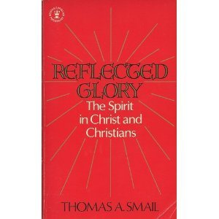  For a fuller exposition of 2 Corinthians 3.18 see Thomas A Smail, Reflected Glory (London: Hodder and Stoughton, 1975) pp24-30. | One day the Lord invited Moses to meet with him at the top of Mt Sinai. He promised to provide two flat stones on which had been written the laws that the people were to obey. There was a cloud covering the mountain as Moses climbed it and the Lord told Moses to enter into the cloud.  God’s presence descended as fire, there was thunder and the people waited at the bottom of the mountain in fear. It seemed to them that Moses was away for a very long time. The people got restless in his absence and wondered if he would ever return. Some asked Aaron, “Who is going to protect us and lead us now?”  Aaron instructed them to bring him all their gold jewellery so he could melt it down to make an image of a god for their protection. From the gold he made a beautiful shiny golden bull. The people were delighted. They danced around the bull and worshipped it.  Moses stayed on the mountain talking to God and hidden from the view of the people for forty days. Then he started to descend, carefully holding on to the Ten Commandments. As he neared the people he could hear all their noise. When he arrived at the foot of the mountain and saw them worshipping the golden bull he got so angry that he threw down the stones on which the Ten Commandments were written and smashed them to pieces.  Later, the Lord told Moses to cut another two flat stones to replace the ones that Moses broke. Once again the Lord called Moses to meet him up Mount Sinai. Moses carried the stones up the mountain and the Lord God again came down in a cloud and met him.  When Moses returned from the mountain after speaking with the Lord this time his face was shining brightly. Seeing this, the people were afraid to go near him. To shield the people from his shining face he covered it with a veil.  …. Our reading from Corinthians today has a rather interesting postscript to this story. It adds something that the First Testament writer does not tell us: Later on, the shining brightness of Moses face began to fade - but Moses still kept the veil over his face to prevent the people from finding out that the glory was fading! (2 Corinthians 3.13).  So what on earth are we to make of all that?... And is there any practical relevance for us, or anything we could do as a result?  See the glory  Our readings today are about encounter with God.  - Moses had an encounter with the Living God on the top of Mt Sinai.  - Again on a mountain top, in our gospel reading Peter, James and John see Jesus transfigured and realise that they are in the presence of divinity.  - Then Paul writes to the church and tells us that all of us can see the glory of the Lord (“all of us, with unveiled faces, seeing the glory of the Lord” 2 Corinthians 3.18 NRSV).  These are all encounters with God that have transformed people.  Have you ever had such an encounter?  Have you ever sensed the divine presence?  Sometimes it is unexpected… But it can come to any of us as we look to the Lord.  Does our church community provide and expect this as we gather together to worship?  The priority of our Sunday worship is not fellowship, or exploring ideas about the Christian faith, good as these things may be. Our priority is an encounter with God. This comes as we look to God and expect his transforming presence. It is by encountering with God in our worship on Sunday that we are motivated to go out and serve him on Monday.  Reflect the glory  “All of us, then, reflect the glory of the Lord with uncovered faces; and that same glory, coming from the Lord, who is the Spirit, transforms us into his likeness in an ever greater degree of glory.” 2 Corinthians 3.18 GNT.  There is a word in verse 18 that, depending on the version of the Bible you have, is variously translated “reflecting as a mirror” or “contemplating.” Both are good translations – and it is true that, as we look to Jesus (contemplate him), we begin to reflect his light to others. In fact the more we look to him, the more we are changed to become like him, and the light gets brighter and brighter.  The verb “transformed” is also interesting. It is literally “metamorphosis” (changed from the inside to the out like a caterpillar changes to a butterfly). This is marvellous! And it is in the passive mood. It is not us that do the changing. It is the Spirit who does this as we open ourselves to Christ. And he does it bit by bit “from one degree of glory to another”.  It is also plural. It is not me that is being changed. With our Western individualism, so often we read these promises in terms of I and me, but in this verse it is we, the church, that reflect the light and are changed to be brighter and brighter.  This is the glowing attraction of a Christian community that loves one another.  Here in Corinthians the word “glory” is used of the presence of Christ which is able to be seen in us his people.  This is a message for ordinary Christians, you and me. We are to reflect God’s glory!  Strip away pretence  The Bible is full of stories of the people that seek to serve God. It seems even the best of them are flawed and defective. We cannot think of the hero of the First Testament, King David, without his sin with Bathsheba coming to mind and the cover-up which included the cold-hearted killing of her husband. And we cannot think of Peter, the leader of the early church, without bringing to mind his repeated denial of Christ.  It is also true that those of us who seek to serve God today are flawed and defective. The gospel of grace encourages us to come in openness and frankness before God in the knowledge that there we will find forgiveness and acceptance. It is only when we strip away the pretence that we find real freedom and joy. Likewise, in our relationships with others in the church, it is only in removing the pretence of our wonderful goodness that authentic Christian fellowship is created.  Our goodness comes, not of ourselves, but as we see and begin to reflect the glory of God.
Illustrations /  Stories  Ctrl+Click to  follow link   | Angela is of Scottish descent and very pale skinned. She works in an office in the inner city, so doesn’t get to see much sun and she is quite self-conscious about her pallid complexion. To make matters worse her office is full of olive skinned beauties.  She likes to take her annual holidays in August and has made a habit of heading to Australia’s Sunshine Coast. While the rest of her work colleagues chill in the winter winds, she delights in the fact that she is basking in the sunshine on a beautiful sandy beach. And, despite health warnings that this is not good for you, she returns tan and proud.  …But the tan quickly fades.  However, Angela has recently found that there are lotions and potions that can be applied to give an artificial tan. By carefully applying these she can conceal the fact that her genuine tan is fading, thus perpetuating the pretence that she retains the golden glow from the Queensland sun.  …But it doesn’t quite look the same tone as the real thing.  Moses veiled his face (2 Corinthians 3.13) so that his people could not see that the shining glory that he received from being in God’s presence was fading. Similarly, we may seek to conceal the fact that the glow of excitement, that we received from our first encounter with the Lord, has faded, We can keep up the pretence by attending church meetings and using religious language.  … But God is calling us back into his presence so we can get more of the real thing.
Broader / Personal  Preparation  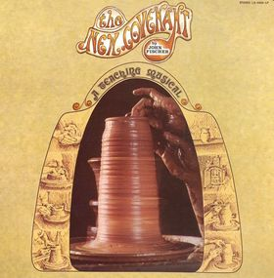  The New Covenant  John Fischer | Familiarity with the divine presence  A first encounter with God, and our initial experiences of prayer, are sometimes quite dramatic. This can be particularly so for those who have not grown up in the Christian faith. Some have described it as being like the curtains being opened and being able to see things clearly for the first time.  After we’ve opened the curtains, we learn to live in the light. It becomes the new normal. The experience of becoming familiar with the divine presence is blessed… as well as dangerous. Just like in our relationships with the people we are around all the time, it is easy to begin to take things for granted.  In one of the churches where I served as pastor there was an older Christian leader who was reflecting on the disciplines of prayer and reading the Scriptures. He said something like, “When you get older and mature as a Christian the Christian faith becomes so much part of you that these disciplines are no longer necessary.”  I worry about that. I know what he said is wrong, but I fear that inadvertently we often make the same assumption.  “The New Covenant”  This is a Christian musical by John Fischer, written in 1974. It includes the song “Evangelical Veil Productions” which is based on Paul’s comment that Moses kept his veil on long after the glory had faded. What Fischer is pointing out is the practice of putting on the pretence of spiritual airs and graces to impress God or others. When we pretend to have a holy glow it may help cover our feelings of inadequacy, but it runs counter to the grace of God that accepts us complete with our weaknesses and short-comings. Look at these lyrics:  Evangelical veil productions  Pick one up at quite a reduction!  Got all kinds of shapes and sizes;  Introductory bonus prizes!  Special quality, one-way see-through;  You can see them but they can’t see you.  Never have to show yourself again!
Creativity /  Visual Aids  Ctrl+Click to follow links    Brooke Fraser | Veils  See if you can gather a collection of wedding photographs of women from your congregation wearing bridal veils and display them at the front of the church. A wedding is the place where you are most likely to see a modern Western woman wearing a veil. The veil is often worn over the bride’s hair and occasionally over her face as well. As part of the wedding ceremony the groom may lift the veil, after the vows have been exchanged, and kiss his new bride. The veil is a symbol of the bride’s purity and the lifting of it symbolises both the revealing of her hidden beauty and the new relationship that the couple will have together.    A little less common is the tradition of women wearing a black veil at a funeral. This symbolises the mourning woman’s respect for the deceased person and gives her a sense of wearing a protective barrier. The removal of the veil, in this case, symbolises the end of the time of high mourning.    I see the king of glory/ Hosanna  This song by Brooke Fraser is based around today’s psalm. Watch on YouTube  Read the lyrics You’ll find the music in The Source 4 no 1898.
Music  AA: Alleluia Aotearoa  CMP: Complete Mission Praise  HIOS: Hope is our Song  FFS: Faith Forever Singing  MHB: Methodist Hymn Book  H&P: Hymns and Psalms  S1: The Source  S2: The Source 2  S3: The Source 3  S4: The Source 4  SIS: Scripture in Song  WHV: With heart and Voice  WOV: With One Voice | Hymns & Songs  At the name of Jesus WOV 170; H&P 74; CMP 41; S1 33  Beautiful presence HIOS 9  Be still for the presence of the Lord CMP 50; S1 47  Christ whose glory fills the skies MHB 924; WOV 140; H&P 457; CMP 79  God your glory we have seen WOV 395  Glory to the King of kings S1 121  Great ring of light AA 57  Holy, holy, holy MHB 36; WOV 65; H&P 7; CMP 237; S1 176  Holy, holy, holy is the Lord CMP 239  How good Lord to be here WOV 390; H&P 156  Immortal invisible God only wise MHB 34; WOV 80; H&P 9; CMP 327; S1 220  (NB verse 4 “take the veil from our faces, the veil from our heart.)  I see the king of glory S4 1898  Light of the world S3 1406  Lord the light of your love SIS 580; CMP 445; S1 335  Maker of mystery FFS 47  Open our eyes Lord SIS 390; CMP 915; S3 1468  Open the eyes of my heart S2 926  See his glory CMP 925; S1 446  The Lord reigns SIS 342; CMP 1007; S1 485  To God be the glory MHB 313; WOV 85; H&P 463; CMP 708; S1 526  Turn your eyes upon Jesus SIS 34; CMP 712; S1 533  Within the veil SIS 145; CMP 778
Prayers  Ctrl+Click to follow link | Collect  God our Father,  whose Word has come among us:  may the light of faith, kindled in our hearts,  shine in our words and deeds;  through him who is Christ the Lord,  who is alive and reigns with you,  in the unity of the Holy Spirit,  one God, now and for ever. Amen.  © The Methodist Worship Book (Peterborough, England: Methodist Publishing House, 1999)  A prayer calling on the Spirit of God  Birth me again, my God,  with the bond of a nurturing nest.  Soak me, my God,  in the purity of the mountain water.  Enthuse me, my God,  with the thrill of canyon courage.  Rattle my complacency, my God,  with the turbulence of rushing waters.  As I breathe the words of prayer,  may the spirit of your light, be the words of eternal life, Amen.  © John Howell, Longings for the Eternal (Taupo: St Paul’s Parish Union Church, 2009) - used with permission  Psalm 99 (selection)  God rules. On your toes, everybody!  He rules from his angel throne—take notice!  God looms majestic in Zion,  He towers in splendour over all the big names.  Great and terrible your beauty: let everyone praise you!  Holy. Yes, holy.  Strong King, lover of justice,  You laid things out fair and square;  You set down the foundations in Jacob,  Foundation stones of just and right ways.  Honour God, our God; worship his rule!  Holy. Yes, holy.  Lift high God, our God; worship at his holy mountain.  Holy. Yes, holy is God our God  The Message (MSG) Copyright © 1993, 1994, 1995, 1996, 2000, 2001, 2002 by Eugene H. Peterson  Prayer of confession  Our Lord God  you are both gracious and merciful.  We are saddened when we reflect on how we are separated from you  because of our own short-comings  Our lives are much the poorer as a result.  Our natural inclination is to ignore our sin,  or forget about it  or postpone dealing with it.  Forgive us we pray.  Convict us with the urgent need for reconciliation with you  and with each other.  Restore us by your grace.  In the name of Jesus Christ we pray.  Amen  More prayers written in an Australian context by Moira Laidlaw.
Communal  Sharing  Ctrl+Click to  follow link   | Shrove Tuesday pancake breakfast  Shrove Tuesday is the last day before Lent. To mark the entry into the new church season hold a church pancake breakfast or a pancake supper on this day. You could suggest all meeting at the local McDonald’s for a “hotcakes” breakfast.  Explain the significance of the day…The word Shrove comes from the medieval word shriven which means forgiven. It is a day to confess to God the things that may have displeased him in the past year.  People used to avoid eating meat and dairy products during Lent, so on Shrove Tuesday they would eat up all the food that wouldn’t last until Easter. In some countries they call it Fat Tuesday (in French Mardi Gras) or farewell flesh (in Italian Carnival). In Britain people got into the habit of using up cooking fat, eggs and milk by making pancakes, and it became known as Pancake Day.  Print and hand out copies of the Prayer of Confession above.
Children  Ctrl+Click to  follow link  GNT = Good News Translation of the Bible | Tossing pancakes  Bring along a frying pan and a pancake. Run up the church aisle tossing the pancake as an introduction to explaining the meaning of Shrove Tuesday above.  Butterfly life cycle    Use the butterfly’s life cycle to explain the idea of God bringing change.  If you have access to a Monarch Butterfly chrysalis from a swan plant, bring this along with you to show the children.  Ask if anyone knows what the process of change from a caterpillar to a butterfly is called. The term is “metamorphosis”.  The same word is in our Bible reading today. It says in 2 Corinthians 3.18 (GNT) that as we look to Jesus “the Spirit, transforms us into his likeness.” The New Testament was written in Greek and transforms us translates the Greek word metamorphosis.  Some people say that you can’t change someone. What they mean is that a bad person will always be a bad person. But the good news from the Bible is that God can change anybody. As we look to Jesus, he makes us into better people. He changes us from the inside – just like a caterpillar changes into a butterfly.  More resources for children from sermons4kids.com
PowerPoint  Ctrl+Click to  follow links | Depending on your approach, Google images for butterfly, butterfly life cycle or wedding veils.  Cartoons of Moses and the Ten Commandments and the golden calf from reverendfun  Go to this page for paintings of the transfiguration by Raphael, Bellini and Perugino in high resolution.


© 10 minutes on a Tuesday is a Refresh Resource. Unless otherwise acknowledged all material is prepared by Andrew Gamman. While every effort has been made to acknowledge source material, if you believe unacknowledged work has been quoted, contact the email address below to request that it be acknowledged or removed. Material included here may be freely used and reproduced for the immediate purpose of worship. Permission must be sought to republish in any form, or to reproduce for commercial gain. If you wish to share the content with others you may do so by linking through the NZ Methodist website. For more information on this and other resources, contact andrew@missionresourcing.org.nz or 09 525 4179 (w)


Mission Resourcing: Inspiring and resourcing our communities for a journey with Christ that enriches lives and relationships

