
Sunday 25 August 2013

Shaken?
Year C – Pentecost 14 – 53C

The Mission of the Methodist Church of New Zealand | Our Church’s mission in Aotearoa / New Zealand is to reflect and proclaim the transforming love of God as revealed in Jesus Christ and declared in the Scriptures. We are empowered by the Holy Spirit to serve God in the world. The Treaty of Waitangi is the covenant establishing our nation on the basis of a power-sharing partnership and will guide how we undertake mission.
Links | Ctrl+Click on the links below to go directly to the text you require  Readings  Introduction  Preaching thoughts  Illustrations  Broader preparation  Creativity  Music  Prayers  Communal sharing  Children  PowerPoint
Readings  Ctrl+Click to follow links | Jeremiah 1.4-10 The Lord chooses Jeremiah to be his prophet, but Jeremiah protests that he is not qualified for such a task.  Psalm 71.1-6 This psalm has an expression of confidence in God and plea for his protection. “You are my mighty rock and my fortress.”  Hebrews 12.18-29 The writer to the Hebrews brings us to a vision of God in his heaven and warns that everything on earth will be shaken. Therefore we are called to be obedient and to invest in those things that cannot be shaken.  Luke 13:10-17 Jesus upsets a religious leader by healing a crippled woman on the Sabbath.
Introduction / Background  Ctrl+Click to follow links    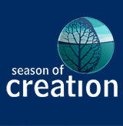 | The letter to the Hebrews  The first section of this letter (chapters 1 to10) focuses on the pre-eminence of Christ. The current lectionary readings take us to the second section (chapters 11 to 13) where the focus is on the importance of faith. This gives rise to the following themes:  11 August Title Deeds Hebrews 11.1-3; 8-16  18 August Heroes Hebrews 11.29-12.2  25 August Shaken? Hebrews 12.18-29  Youth Sunday  On one of the last two Sundays of August we recognise Youth Sunday. If you have an active youth group, you could hand the service over to them. Otherwise, try to involve as many young people as possible in the service.  Daffodil Day – 30 August 2013  The daffodil is one of the first flowers of spring, whose bright yellow blooms remind us of the joys the new season will bring. It represents the hope there is for the one in three New Zealanders affected by cancer.  This coming Friday is Daffodil Day (Friday 30 August). You may want to take a moment in your service to pray for those battling cancer, and for medical professionals and hospice workers supporting cancer sufferers and their families. It may also be appropriate to give thanks for the memory of those whose lives have been lost. You’ll find resources on the website www.daffodilday.org.nz and the Cancer Society may provide daffodils if you wish to take up an offering for them. Text "daffodil" to 305 to make an instant $3 donation.  Season of creation  Through the month of September “10 Minutes on a Tuesday” will follow the readings and themes for the Season of Creation. The observance of a Season of Creation began in the Lutheran Church in Australia in 2000 as a response to the environmental crisis. Since then this opportunity for the church to examine creation-based themes has spread to many different denominations and around the world. The series is outlined below:  1 September Ocean Sunday  8 September Flora and fauna Sunday  15 September Storm Sunday  22 September Social justice Sunday  29 September Blessing of the animals  In the archived Refresh section of the New Zealand Methodist website you will find a previous “10 Minutes on a Tuesday” resource that focuses on today’s gospel passage, Year C - Pentecost 13 - 53C (22 August 2010). Bill Peddie’s blogsite also follows the gospel reading.
Preaching thoughts and Questions  Ctrl+Click to  follow link  CEV= Contemporary English Version of the Bible  * This is a two sentence summary of Jesus’ parable of the banquet as recorded by both Matthew and Luke. You will find an entertaining re-telling of the parable on YouTube. | Ever since September 2010 the people of Christchurch have known what it is to be shaken. Aftershocks continued from that time right up until the big shake of February 2011 and, even as I write this (at the end of July), Canterbury continues to shake.  I had my turn to experience some serious shaking on Sunday 21 July this year when I was waiting for a flight out of Blenheim. A shake measuring 6.5 on the richter scale, and centred only a few kilometres away in Seddon, shook the building. Some of those who were near tables dived underneath them, and I spied one equestrian enthusiast who had donned her helmet for protection. Little aftershocks continued for the next three-quarters of an hour until our plane was cleared to leave. Each additional small movement of the earth produced pensive looks from the waiting passengers.  The writer to the Hebrews talks of “shaking” in describing several contrasting pictures in our reading today:  - Created things that will be shaken are contrasted with a kingdom that cannot be shaken.  - The rule of law is contrasted with the rule of grace  - Forgiveness is contrasted with vengeance  We begin with God’s invitation to…  Come near (Hebrew 12 .8-24)  What a graphic picture is painted here of Mt Sinai. This is the place where the Ten Commandments were given to Moses. Moses went to meet with God at the top of the mountain. The presence of God produced an electric atmosphere and the mountain was surrounded by the hum of the awesome, frightening and deadly power of God. God was unapproachable. Access for the people was prevented. Moses was told to, “Warn the people that they are forbidden to touch any part of the mountain. Anyone who does will be put to death” Exodus 19.12 (CEV).  The scene then shifts to another mountain. It is Mt Zion, where Solomon built his temple in Jerusalem. This mountain became a symbol for Jerusalem and then, in the New Testament, for the dwelling place of God and his kingdom rule.  Both of these mountain images portray God in his awesome might. The difference is that at Mt Sinai God who gave the law was inaccessible, whereas Mt Zion pictures God coming near to us. His kingdom rule extends an invitation to us. Jesus is here with an offer of forgiveness. By his grace we are welcomed into his presence, and into the presence of all God’s people. We are the people who gather to God at this mountain… and we are invited to come near.  Be Warned (Hebrews12.25)  We are invited to come near… but the passage is not without warning. To hear the gospel message is to hear the open invitation of God. In Jesus, God has put out the welcome mat. The message is as wonderful as it is direct. We are invited into relationship with the living God. But it is an invitation that requires response. In one of those stories that Jesus told he explained that it is like the man who arranges a barbeque for his mates only to find that one after another makes excuses for their absence. The generosity of the host’s welcome and hospitality is then extended to many others and the original invitees miss out altogether.*  So within the invitation is a warning that we could miss out on something wonderful if we do not respond. “Do you think you can possibly escape, if you refuse to obey the one who speaks to you from heaven?” Things are going to be shaken and we will need something to hold on to.  Hold on (Hebrew 12.27-29)  It is not surprising that the ancients associated earthquakes with the presence of God. Anyone who has been through a significant earthquake can speak of being in the presence of an awesome force that is totally beyond our control. So, according to the psalmists, the earth shakes and trembles at the presence of God (Psalm 68.8 and 114.7). And our writer to the Hebrews says, “God has promised to shake the earth” (Hebrew 12.26). Everything that can be shaken will be shaken. But what can we hang on to when the very ground on which we stand is shaky?  Sooner or later we all experience the fragility of human life: illness, separation, a death in the family, a sudden redundancy and the firm ground in which we thought we stood begins to crumble away. Trials and difficulties show up what is of value and separate those things that are transitory from those things that have value that endures.  On a bigger scale our confidence can be shaken in some of those things we trusted to make life better. The scientific knowledge that we dreamed would cure all our ailments and feed the world has brought instead global warming, laser weapons and the possibility of a nuclear bombs in space. Our denomination which we thought would transform the nation with the message of the gospel is instead shunted to the fringe and considered by many to be irrelevant. Our high-tech possessions become obsolete within a couple of years and are polluting the earth with their waste. All those things we possess as well as the people around us will one day pass away… and we ourselves will one day die.  So what is it then that cannot be shaken? What can we hang on to?  Our relationship with God.  It is this relationship, the one which we can so easily ignore or consider of little value, that becomes the thing of great value when everything else is shaken.  Accept the invitation to come near to God… and hold on tight to him when everything is shaken.
Illustrations /  Stories  Ctrl+Click to  follow links  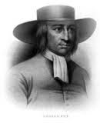  George Fox  1624-1691 | How shall we escape?  The old wooden church building in Hastings, in which my family worshipped when I was a child, had a verse from today’s reading (Hebrews 12.25) written large over the doorway at the rear:  “How shall we escape if we neglect so great a salvation?”  The verse represented the evangelistic emphasis of that fellowship in that time. The idea was to present a challenging question to worshippers as they left the building. The old church building has long been demolished and the sign has gone with it, but the question remains.  The Shakers  The Shakers were an interesting charismatic, Christian sect that started in eighteenth century England and then flourished in the New England states of America. Led by Ann Lee, they are said to have attracted 20,000 coverts to their communitarian, celibate, pacifist and monastic life-style. Their name came from the ecstatic nature of their dancing and singing in worship. Listen to Shaker music.  The Quakers  This is another dissenting Protestant group with a very interesting history. The group survives today as a respected denomination properly known as the Society of Friends. George Fox, their founder, believed that ordained clergy were unnecessary for people to have a genuine experience of God. The term “Quaker” started off as a form of ridicule directed at those who “quaked” at the word of the Lord. Toward the end of the seventeenth century Quakers numbered 60,000 in England and Wales. Persecution caused many to flee to America where the state of Pennsylvania was established under Quaker principles by William Penn (1644-1718).
Broader / Personal  Preparation  Ctrl+Click to  follow links | A couple of worship songs about being shaken, from the Contemporary Christian Music scene. (Click on the titles to listen on YouTube.) Both are suitable for use in your worship service.  - We won’t be shaken is the title track from the 2013 album by an American Christian rock band called Building 429  - Shaken by another American musician, Paul Baloche, is based on today’s passage from Hebrews. It is from his 2009 album “Glorious”. Buy the sheet music.
Creativity /  Visual Aids  Ctrl+Click to  follow link  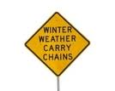    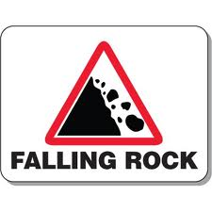 | Warning signs  Print off some warning signs.  - You could simply display them at the front of the church to reinforce the warning message in the passage  - Or you could turn them into a “station” with the following instructions:  Look at the warning signs  Where would you expect to see each of these signs?  What action would you take if you saw each of these?  Read this warning from Hebrews  Make sure that you obey the one who speaks to you. The people did not escape, when they refused to obey the one who spoke to them at Mount Sinai. Do you think you can possibly escape, if you refuse to obey the one who speaks to you from heaven? When God spoke the first time, his voice shook only the earth. This time he has promised to shake the earth once again, and heaven too. Hebrews 12.25-26  Think  Why is this passage sounding a warning?  What would it mean for me to obey God who speaks to me?  What am I expected to do as a result?  Write or draw  your response on a slip of paper and take it with you  Pray  Lord help me to eagerly respond to your invitation  And to be an obedient follower of Christ  Amen  See also the children’s section below.
Music  AA: Alleluia Aotearoa  CMP: Complete Mission Praise  HIOS: Hope is our Song  FFS: Faith Forever Singing  MHB: Methodist Hymn Book  H&P: Hymns and Psalms  S1: The Source  S2: The Source 2  S3: The Source 3  S4: The Source 4  SIS: Scripture in Song  WHV: With heart and Voice  WOV: With One Voice  WOV = AHB | Hymns & Songs  Alleluia, alleluia, give thanks WOV 647; H&P 250; SIS 276; CMP 30; S1 4  Arm of the Lord awake MHB 486  Be patient be ready S1 46  Be still for the presence of the Lord CMP 50; S1 47  Blessed city, heavenly Salem WOV 343; H&P 485  Entered the holy place above MHB 232; WOV 296  Glorious things of you are spoken MHB 706; WOV 374; H&P 817; CMP 173  God himself is present WOV 47  God is our refuge and strength CMP 188  Great is the Lord SIS 70  He’s shaking me out of the things that I know SIS 641  How much am I worth? HIOS 63  I see the king of glory S4 1898  Jesus calls us! O’er the tumult MHB 157; WOV 505; H&P 141; CMP 359  Jerusalem the golden WOV 346  Join all the glorious names MHB 96; WOV 135; H&P 78; CMP 392  Lord of all being MHB 32; H&P 11; CMP 439  Now in the name of him WOV 413  One, two, three, Alleluia AA 111  O thou who camest from above MHB 386; WOV 486; H&P 745; CMP 525; S1 416  Our God is an awesome God CMP 1005; S1 418  The Lord reigns SIS 342  We have come to a holy mountain S2 1034
Prayers | Today’s passage from Hebrews pictures God as mighty and awe-inspiring. It brings to mind a couple of the traditional prayers of the church, both of which recount the Christian story with praise: Te Deum and The Great Thanksgiving.  The title Te Deum comes from the Latin of the first words of the prayer.  The Great Thanksgiving is found in a variety of versions and is used as an introduction to communion. In keeping with this week’s theme, it could be used as a stand-alone liturgy today.  Te Deum  We praise you O God:  we acclaim you as the Lord  All creation worships you:  the Father everlasting  To you all angels, all the powers of heaven:  cherubim and seraphim, sing in endless praise  “Holy, holy, holy, Lord God of power and might:  heaven and earth are full of your glory.”  The glorious company of the apostles praise you:  the noble fellowship of the prophets praise you  the white-robed army of martyrs praise you.  The holy church throughout all the world acknowledges you:  Father of majesty unbounded  your true and only Son, worthy of all worship:  and the Holy Spirit, our advocate and guide  You Christ are the king of glory:  the eternal Son of the Father  When you became incarnate to set us free:  you humbly accepted the Virgin’s womb  You overcame the sting of death:  and opened the kingdom of heaven to all believers  You are seated on God’s right hand in glory:  we believe that you will come to be our judge  We therefore ask you to come and help your people:  bought with the price of your own blood.  And bring us with your saints:  to glory everlasting  Save your people and bless your inheritance:  govern and uphold them now and always  Day by day we praise you:  and worship your name forever  Keep us today Lord from all sin:  have mercy on us Lord, have mercy  Lord show us your love and mercy:  for we put out trust in you  In you Lord is our hope:  let us never be confounded  The Great Thanksgiving  The Lord be with you.  And also with you.  Lift up your hearts.  We lift them up to the Lord.  Let us give thanks to the Lord our God.  It is right to give our thanks and praise.  It is right, and a good and joyful thing,  always and everywhere to give thanks to you,  Father Almighty, creator of heaven and earth.  You formed us in your image and breathed into us the breath of life.  When we turned away, and our love failed, your love remained steadfast.  You delivered us from captivity, made covenant to be our sovereign God,  and spoke to us through your prophets.  And so, with your people on earth and all the company of heaven,  we praise your name and join their unending hymn:  Holy, holy, holy Lord, God of power and might,  heaven and earth are full of your glory,  Hosanna in the highest.  Blessed is he who comes in the name of the Lord.  Hosanna in the highest.  Holy are you, and blessed is your Son Jesus Christ.  Your Spirit anointed him to preach good news to the poor,  to proclaim release to the captives  and recovery of sight to the blind,  to set at liberty those who are oppressed,  and to announce that the time had come  when you would save your people.  He healed the sick, fed the hungry, and ate with sinners.  By the baptism of his suffering, death, and resurrection  you gave birth to your Church,  delivered us from slavery to sin and death,  and made with us a new covenant by water and the spirit.  When the Lord Jesus ascended he promised to be with us always,  in the power of your Word and Holy Spirit.  Christ has died;  Christ is risen;  Christ will come again.  Through your Son Jesus Christ,  with your Holy Spirit in your Holy Church,  all honour and glory is yours, Almighty Father,  now and forever. Amen.  Collect  Merciful God,  grant that your Church,  being gathered by your Holy Spirit into one,  may reveal your glory among all peoples,  to the honour of your name;  through Jesus Christ our Lord. Amen.  © The Methodist Worship Book (Peterborough, England: Methodist Publishing House, 1999)  A prayer for God's protection - Psalm 71.1-6  I run to you, Lord,  for protection.  Don't disappoint me.  You do what is right,  so come to my rescue.  Listen to my prayer  and keep me safe.  Be my mighty rock, the place  where I can always run  for protection.  Save me by your command!  You are my mighty rock  and my fortress.  Come and save me, Lord God,  from vicious and cruel  and brutal enemies!  I depend on you,  and I have trusted you  since I was young.  I have relied on you from the day I was born.  You brought me safely  through birth,  and I always praise you  Contemporary English Version (CEV) Copyright © 1995 by American Bible Society  God is our refuge – Psalm 46  God is our refuge and strength,  always ready to help in times of trouble.  So we will not fear when earthquakes come  and the mountains crumble into the sea.  Let the oceans roar and foam.  Let the mountains tremble as the waters surge!  A river brings joy to the city of our God,  the sacred home of the Most High.  God dwells in that city; it cannot be destroyed.  From the very break of day, God will protect it.  The nations are in chaos,  and their kingdoms crumble!  God’s voice thunders,  and the earth melts!  The Lord of Heaven’s Armies is here among us;  the God of Israel is our fortress.  Come, see the glorious works of the Lord:  See how he brings destruction upon the world.  He causes wars to end throughout the earth.  He breaks the bow and snaps the spear;  he burns the shields with fire.  “Be still, and know that I am God!  I will be honoured by every nation.  I will be honoured throughout the world.”  The Lord of Heaven’s Armies is here among us;  the God of Israel is our fortress.  Holy Bible. New Living Translation copyright© 1996, 2004, 2007 by Tyndale House Foundation. Used by permission of Tyndale House Publishers Inc., Carol Stream, Illinois 60188. All rights reserved.
Communal  Sharing  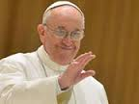  Pope Francis | Advice from Pope Francis  - Ask some of the youth of the church to comment on this quote from Pope Francis: “I don’t like a young person who doesn’t protest.” (Spoken to the youth of Brazil.) Ask - what issues are considered by today’s young people to be worthy of protest?  - Ask those with a pastoral ministry to comment on this quote: “Bishops must be pastors, close to the people, men who love poverty, men who do not think and behave like princes. Men who are not ambitious. Men capable of watching over the flock entrusted to them.” (Spoken to the Latin American bishops during the Pope’s visit to Brazil last month, but with application to everyone in a pastoral role.)
Children  Ctrl+Click to  follow link  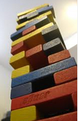  CEV= Contemporary English Version of the Bible | A block tower  Get a bag of wooden blocks. Give the same number of blocks to two volunteers and have a competition to see which one of them can build the highest block tower. When they are done, give a small prize to each of them.  As you are standing over the towers praising their fine efforts, “accidentally” bump the table so that the towers collapse. Explain that by knocking the table you shook the towers and that they were not strong enough to stand.  Our reading from Hebrews today is about shaking and things not being able to stand. It says of God that….  he has promised to shake the earth once again, and heaven too. The words  “once again” mean that these created things will someday be shaken and  removed. Then what cannot be shaken will last. We should be grateful that  we were given a kingdom that cannot be shaken. Hebrews 12.26-28 (CEV)  Most of the things that we count on for security and stability prove unreliable when they are shaken. This is what many people in Christchurch found when the earthquake destroyed their homes and church buildings. That is why God says to put our trust in his rule in our lives and our relationship with him. These are things which cannot be shaken and will last.  More lectionary-based resources for children are available from sermons4kids.com - scroll down to the bottom of the page for a printable Children’s bulletin in MS Word.
PowerPoint  Ctrl+Click to  follow link | Cartoon from reverendfun: shaking  Google images for “earthquake” or “warning signs”

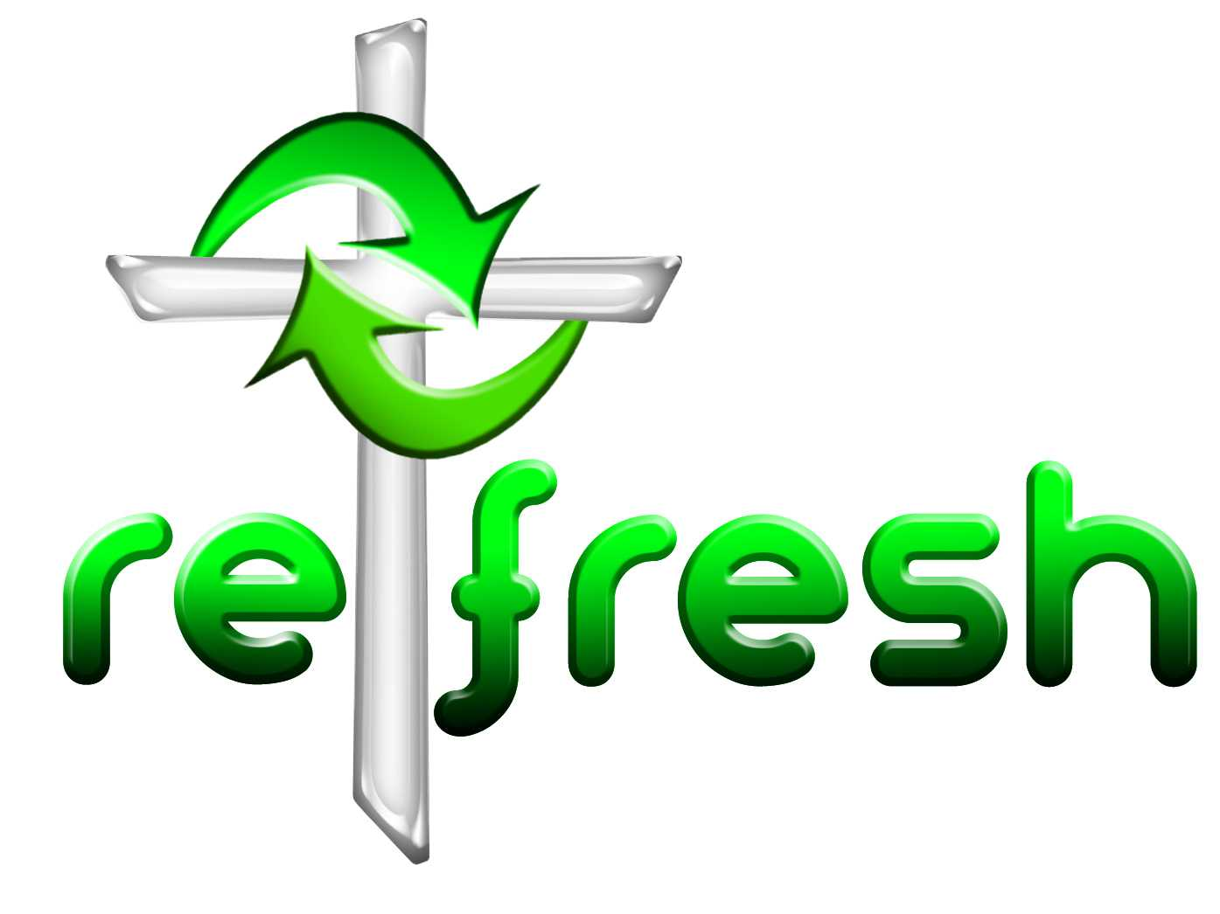
© 10 minutes on a Tuesday is a Refresh Resource. Unless otherwise acknowledged all material is prepared by Andrew Gamman. While every effort has been made to acknowledge source material, if you believe unacknowledged work has been quoted, contact the email address below to request that it be acknowledged or removed. Material included here may be freely used and reproduced for the immediate purpose of worship. Permission must be sought to republish in any form, or to reproduce for commercial gain. If you wish to share the content with others you may do so by linking through the NZ Methodist website. For more information on this and other resources, contact andrew@missionresourcing.org.nz or 09 525 4179 (w)


Mission Resourcing: Inspiring and resourcing our communities for a journey with Christ that enriches lives and relationships

