
Sunday 11 August 2013

Title Deeds
Year C – Pentecost 12 – 51C

The Mission of the Methodist Church of New Zealand | Our Church’s mission in Aotearoa / New Zealand is to reflect and proclaim the transforming love of God as revealed in Jesus Christ and declared in the Scriptures. We are empowered by the Holy Spirit to serve God in the world. The Treaty of Waitangi is the covenant establishing our nation on the basis of a power-sharing partnership and will guide how we undertake mission.
Links | Ctrl+Click on the links below to go directly to the text you require  Readings  Introduction  Preaching thoughts  Illustrations  Broader preparation  Creativity  Music  Prayers  Communal sharing  Children  PowerPoint
Readings  Ctrl+Click to follow links | Isaiah 1.1, 10-20 Isaiah brings the message that the Lord has had his fill of his people coming to worship when they don’t act justly. Contains the poignant, “Your sins are scarlet red, but they will be whiter than snow.”  Psalm 50.1-8, 22-23 The psalmist speaks of God’s judgment on those who claim to be his followers but who ignore him. God requires obedience and a thankful heart.  Hebrews 11.1-3, 8-16 This is the great chapter about the faith of God’s people. Faith makes us sure of what we hope for.  Luke 12.32-40 Jesus tells his disciples to give to the poor and store treasure in heaven. He then tells them a story about servants who remain awake and ready for their master’s return, even though his return is late at night or early in the morning.  It is Lay Preachers Sunday today so if you have lay preachers in your church you could hand the service over to them. Otherwise, try to involve as many lay people as possible in the service.
Introduction / Background  Ctrl+Click to follow links  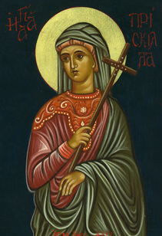  Priscilla | Hebrews  The lectionary takes us to the letter to the Hebrews and for the next three weeks we will follow the theme of faith through these readings. The odd thing about this letter is that, despite its substantial size and content, we know very little about it. Questions like who wrote it, and when, and to whom are hard to answer in any definitive way.  Although the King James Version of the Bible boldly headed it, “Paul’s letter to the Hebrews” the idea of Paul being the author is unconvincing for most Bible scholars. The thought and style do not have the characteristics of Paul’s writing. The letter was associated with Paul from an early date, but it is believed that the attachment of Paul’s name was just to add some credibility to the letter. It took longer than most other books to become part of the undisputed New Testament canon and if it was thought Paul was the author, this was sure to help its cause. In the sixteenth century, long after the canon was settled, Martin Luther still had his doubts about this letter.  I rather like the suggestion that it was written by Priscilla. We know that Priscilla and Aquila were a married couple who travelled with Paul (Acts 18.18), instructed Apollos in the Christian way (Acts 18.26) and led the church at Ephesus (1 Corinthians 16.19). The fact that Priscilla’s name is often mentioned first (in a male dominated society) indicates that she was the prominent one of the pair. If she was the author of this letter to the Hebrews it is understandable that this authorship was suppressed due to the lack of acceptance of women in this role. Others commonly named by those guessing at authorship include Barnabas, Silas and Apollos.  The letter talks of both persecution of Christians in the past and expected persecution to come. If we tie this in with the persecution of Christians by the Roman Emperor Nero and later by Domitian it would date the writing between 64 and 85CE.  It was written to the Hebrews, but to what Hebrews? The two main theories are that it was written to Christian Jews living in Rome, and that it was written to the church in Jerusalem.  The first section of the letter (chapters 1 to10) focuses on the pre-eminence of Christ. The lectionary today lands us at the beginning of the second section (chapters 11 to 13) where the focus is on the importance of faith. This will give us the following themes over the next three weeks:  11 August Title Deeds Hebrews 11.1-3; 8-16  18 August Heroes Hebrews 11.29-12.2  25 August Shaken? Hebrews 12.18-29  Each year the lectionary readings take small bites of the letter to the Hebrews. It is a mystery to me why today’s reading about faith would omit Hebrews11.6, “Without faith no one can please God. We must believe that God is real and that he rewards everyone who searches for him.” This is the essential element for followers of Jesus! Why not suggest that the children learn this as a memory verse in the week ahead and have a prize for those who can recite it next Sunday? Many people have been concerned about the important omissions in the Revised Common Lectionary and this has led to several suggestions of a four year lectionary. A Year D resource was published by Cascade Books in 2012 and is available from Amazon.  In the archived Refresh section of the New Zealand Methodist website you will find a previous “10 Minutes on a Tuesday” resource that focuses on today’s gospel passage, Year C - Pentecost 11 - 51C (8 August 2010). Bill Peddie’s blogsite also follows the gospel reading.
Preaching thoughts and Questions  Ctrl+Click to  follow link  Read the news report of this story  * The Greek word is Hypostasis.  Hypo = under  Stasis = stand | It was 1996 when the civil war in the Democratic Republic of the Congo spread to the area where Saluma and his family lived. They fled the conflict fearing for their lives. Crossing into neighbouring Tanzania, they became refugees. (There are 15.4 million refugees in our world today.) When he left his home, Saluma lost everything: his cows, his fields, his home, his land.  Twelve years later, and aged in his 60s, Saluma was included in the first group of 68 refugees to return to the Congo with the help of the United Nations Refugee Agency. But it was not just a matter of taking his seven children going back to his old home and land. With so many people displaced, and more than 64,000 refugees returning, how was he to prove it was his land?  On arrival back in his homeland he had to take up residence in a transit camp. From there he made an application through government and United Nations agencies to reclaim his land. The wheels turned slowly. Then in 2011, after three years waiting, there was a government ceremony in which Saluma was officially given the title deed for his former property.  "I can't believe it," he said, in possession of his title deed and his voice breaking with emotion. "Nobody can argue with me now about my land. I've become the owner."  The title deeds made all the difference!  Be sure  This morning we come to Hebrews 11, the great chapter in the Bible about faith. But what is faith? It can be a slippery concept and hard to define. Some people use the word to mean something akin to wishful thinking or having a positive attitude. This is not at all what the writer to the Hebrews had in mind when she wrote: “Faith makes us sure of what we hope for”. The word* translated “makes us sure” is not a common one. It occurs in the New Testament only in Hebrews and 2 Corinthians, but the interesting thing is the secular use of the word. It is sometimes used for a body of documents that form the evidence of the ownership of a property. It’s the title deeds.  And the title deeds make all the difference.  Faith is the title deed of what we hope for, and gives as proof of what we can’t see. It looks beyond the present and guarantees something not yet attained. Inherent in this idea is a sense of dissatisfaction and yearning.  Do you ever feel dissatisfied with the way the world is?  Do you ever feel dissatisfied with the way you are?  Faith is the title deed for something better. It is the guarantee of the new and everlasting life in Christ for those who trust in him. It’s the title deed of our salvation. It’s our handle on the spiritual world and all that we cannot see. And without it no-one can please God (Hebrews 11.6).  A persistent question, in our age of religious pluralism, is “How can Christians possibly suggest that they have the right way when so many in the world will never even hear the name of Christ?” The answer from this same verse (Hebrews 11.6) is, “We must believe God is real and he rewards everyone who searches for him.” In the end all who earnestly seek after God and desire to conform to his will reap divine rewards.  Such seeking does require that we…  Give priority to the unseen  “…what can be seen was made out of what cannot be seen” (Hebrews 11.3). All that we see around about us came as a result of the word, the command of God. Because the things we possess, or desire to possess, are in front of our eyes they can easily demand our full attention. So it is that our cars, homes, televisions and so forth can become the focus of our lives. But there are unseen things that speak of a greater reality and a demand a greater priority.  So what is unseen that is so important?  Think for a moment...  Where is the space in our lives for God? for grace? for love? for forgiveness? for our future existence with God?  These unseen things don’t come with all the hype and glamour and in-your-face appeal of Lotto’s Big Wednesday. But they are the really important things. Sadly, many choose to ignore altogether those things that cannot be experienced with the senses. But faith says there is another realm, another dimension. Belief in God opens up to us this other dimension that changes everything. If God’s word spoke the universe into existence his word has power to speak into our lives also, to create and recreate life in us. By listening and responding to God’s word new possibilities open up. So beware the entanglement of materialism and give priority to things unseen.  Live like a refugee  We started out with the story of Saluma, who was a refugee in Tanzania. For twelve years he and his family had to live as foreigners and strangers in a land that was not their own. They longed for their homeland… but for all those years they were unable to return.  Speaking of Abraham and Sarah, the heroes of faith mentioned at length in our chapter from Hebrews today, the writer declares “they were only strangers and foreigners on this earth” (Hebrews 11.13). Their lives were a pilgrimage of obedience as they wandered from one place to another at the Lord’s direction.  It is a picture of the Christian life.  It was Augustine who said, “we are sojourners exiled from our fatherland.” The book of Acts calls the Christian life “the Way”. As pilgrims we are to travel light. Sure, we are to have our feet firmly on the ground but we are also to be careful not to get too entangled with temporal attractions, for we have a glimpse of a bigger picture and a greater goal. And when the Way gets hard, as it does from time to time, our hearts join the cry of the old “spiritual”, sometimes I feel like a motherless child, a long way from home. It’s true that there is a sense in which we live like refugees. We long for another country. It’s not pie in the sky; it’s the promise of an eternal home with Christ, a redeemed people and a redeemed earth.
Illustrations /  Stories  Ctrl+Click to  follow link | A long obedience in the same direction  This phrase picks up the idea of faith as expressed by the life of Abraham in Hebrews 11. Strangely, it originates with Friedrich Nietzsche (1844 - 1900) who is perhaps best known for his “Death of God” philosophy. Even stranger perhaps is the fact that it is used by Eugene Peterson as the title for his book on the Psalms of Ascent. The full quote from Nietzsche is: "The essential thing ‘in heaven and earth’ is that there should be a long obedience in the same direction; there thereby results, and has always resulted in the long run, something which has made life worth living."  See The Birthday Party (below)
Broader / Personal  Preparation  Ctrl+Click to  follow links  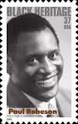 | Three songs  Each of these songs picks up a theme from Hebrews 11 and could be used in your service today. Starting with the oldest:  - Sometimes I feel like a motherless child  A traditional “spiritual” from the enslaved African people in America – dating back to mid nineteenth century. The “home” longed for was not just Africa, but an eternal home with the Lord. The song was given a wider audience by the Fisk Jubilee Singers and has been recorded by too many people to list here. The lyrics vary according to the artist.  Sometimes I feel like a motherless child  Sometimes I feel like a motherless child  Sometimes I feel like a motherless child  A long ways from home  A long ways from home  True believer  A long ways from home  A long ways from home  Listen to Paul Robeson’s rendition  - De Garmo and Key - Aliens and strangers  This song comes from their 1989 album The Pledge, and echoes Hebrews 11.13 “they were only strangers and foreigners on this earth.”  My closest friends are aliens and strangers,  travellers here living with danger.  Listen on YouTube Read all the lyrics.  - U2 - Walk on  From U2’s 2000 album All that you can’t leave behind comes this track that speaks of the priority of faith and the unseen world:  You're packing a suitcase for a place  none of us has been  A place that has to be believed  to be seen  Listen on YouTube Read all the lyrics A related idea is found in the track Stranger in a strange land off their 1981 album October.
Creativity /  Visual Aids   | Title Deed  Print off enough copies of the certificate below for everyone to have a copy. Set up a “station” in the church foyer for people to visit as they leave church this morning. You will need to provide pencils or pens and the following instructions:  Consider the unseen things that can be received by faith.  Write your name on the certificate.  Fill in those things that God has promised and that you would like to receive by faith (Some ideas: Eternal life in Christ, forgiveness, acceptance, a new start, love, grace…).  Take your certificate with you when you leave.  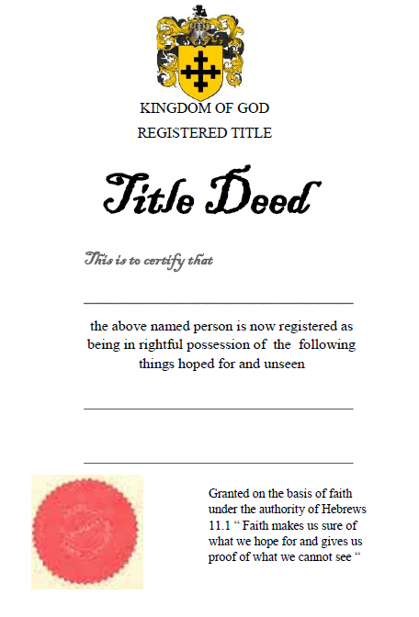
Music  AA: Alleluia Aotearoa  CMP: Complete Mission Praise  HIOS: Hope is our Song  FFS: Faith Forever Singing  MHB: Methodist Hymn Book  H&P: Hymns and Psalms  S1: The Source  S2: The Source 2  S3: The Source 3  S4: The Source 4  SIS: Scripture in Song  WHV: With heart and Voice  WOV: With One Voice  WOV = AHB  Ctrl+Click to follow link | Hymns & Songs  All my hope on God is founded MHB 70; WOV 465; H&P 63; CMP 16; S2 620  Author of faith, eternal world WOV 473; H&P 662  Christ is made the sure foundation WOV 343; H&P 485; CMP 73; S2 654  Faith is God’s creation WHV 35  Guide me O thou great Jehovah MHB 615; WOV 478; H&P 437; CMP 201;  S2 708  Have faith in God my heart WOV 552; H&P 675  Here, O my Lord, I see you face to face MHB 772; WOV 438; H&P 608; CMP 230  Holy Spirit, living breath S4 1866  How firm a foundation WOV 491; CMP 243; S1 186  If you but trust in God to guide you WOV 459; H&P 713  In Christ alone S1 225  In this familiar place AA 72  I walk by faith S1 253  Lord of all the earth S4 1971  Lord, we believe when we call S3 1422  My life is in you, Lord S1 368  The God of Abraham praise MHB 21; WOV 53; H&P 452; CMP 645; S2 975  The God of time and eternity S4 2065  Turn your eyes upon Jesus SIS 34; CMP 712; S1 533  Wisdom be our guide HIOS 156  With all my heart S1 581  Without faith it’s impossible (A good bounce-along song by Frank Hernandez and Sherry Saunders  Powell that will appeal to younger folk. Not in any of my song books but you can listen on YouTube.)  You will keep them in perfect peace SIS 89
Prayers | Collect  O God, the protector of all who trust in you,  without whom nothing is strong, nothing is holy:  increase and multiply upon us your mercy  that with you as our ruler and guide,  we may so pass through things temporal  that we finally lose not the things eternal;  grant this, heavenly Father,  for the sake of Jesus Christ our Lord. Amen.  © The Methodist Worship Book (Peterborough, England: Methodist Publishing House, 1999)  Something in us that believes  Lord  There is something in us that believes  That wants to fly beyond tangible, the measurable, the known  And there is also something earthbound  Mired in past disappointments and what our parents called reality  Released,  we would be free to discover our wildest dreams,  to seize the golden and fleeting opportunity,  to boldly claim all that is best and holy and pure:  Bound,  The grinding necessity for finding cause and effect, for making ends meet, for adding up the logic  can blind us to the miracle of everyday  At one and the same time Lord  We want – how we want! –  Both the faith of the child gazing in wonder at the rainbow rimmed puddle on the driveway  And the searing drive of the person demanding to know who split the petrol  We want the trust that asks for the best from our loving father  and  The rigour of mind that will not be deceived by false hope  The gentleness of spirit that enables us to see the miracle  And an honesty of insight that checks it out  As we balance these poles, Lord  We ask both for  a gentle cynicism that guards us from credulity  and a tender insight that humbly acknowledges  we are often blind in a world far more colourful than we can ever know  © Alan K Webster (used with permission)  Respecting the sacred  Sacred God,  The sacred water is beneath the surface,  and if we are to gain its perspective,  we must be on our knees,  not prone on a luxury bed.  The sacred is not something the market can sell,  for coinage of the heart  is not measured in dollars and cents,  but in costly and reckless giving.  May we honour You with our wealth,  respect the resources of our habitat,  and worship You in the sacred places,  with self-giving and reckless generosity of love,  to reflect the gift of your Son,  the crucified One.  Only then can we find sacred peace.  Set my feet on its path. Amen.  © John Howell, Sighs too deep for words (Taupo: St Paul’s Union Church, 2007) -used with permission  Psalm 50.1-8, 23  The Lord, the Mighty One, is God,  and he has spoken;  he has summoned all humanity  from where the sun rises to where it sets.  From Mount Zion, the perfection of beauty,  God shines in glorious radiance.  Our God approaches,  and he is not silent.  Fire devours everything in his way,  and a great storm rages around him.  He calls on the heavens above and earth below  to witness the judgment of his people.  “Bring my faithful people to me—  those who made a covenant with me by giving sacrifices.”  Then let the heavens proclaim his justice,  for God himself will be the judge  “Giving thanks is a sacrifice that truly honours me.  If you keep to my path,  I will reveal to you the salvation of God.”  Holy Bible. New Living Translation copyright© 1996, 2004, 2007 by Tyndale House Foundation. Used by permission of Tyndale House Publishers Inc., Carol Stream, Illinois 60188. All rights reserved.
Communal  Sharing  Ctrl+Click to  follow link | Refugee re-settlement  Are there refugee families associated with your church, or volunteers working in refugee re-settlement who could share their experiences in the service today? If not you might like to promote the work of NZ Refugee Services. Visit the website and click on “how you can help”.
Children  Ctrl+Click to  follow link   | The birthday party  Who has a birthday coming up soon?  Are you going to have a party?  Jonathan’s birthday will be on Saturday 7 September. That’s few weeks away but he sure is getting a bit excited about it already. He can’t stop thinking about it. It will be Jonathan’s ninth birthday and, because he is a fan of Dr Who, his mum has agreed to make him a Dalek birthday cake. He has four special friends that he is going to invite around for his birthday party. His mum is getting a bit tired of hearing him drop hints that he’d like to get the first series of Dr Who on DVD as a birthday present. Of course, his present will be a surprise, so he doesn’t know what he’ll get until the day comes. One thing he does know though is that his birthday will come.  Our Bible reading today says, “Faith makes us sure of what we hope for and gives us proof of what we can’t see”. (Hebrews 11.1). That is a bit like Jonathan who is looking forward to his birthday and hoping for it. He is sure it will come - but there is still an element of surprise.  Christians hope for a better world and life with Jesus that will go on for ever. We know that it will come, but it will also be full of surprises for us.  More resources for children from sermons4kids.com
PowerPoint  Ctrl+Click to  follow links | Google images for “faith”  “Faith” cartoons from reverendfun:  - Hebrews 11.1  - My sister faith

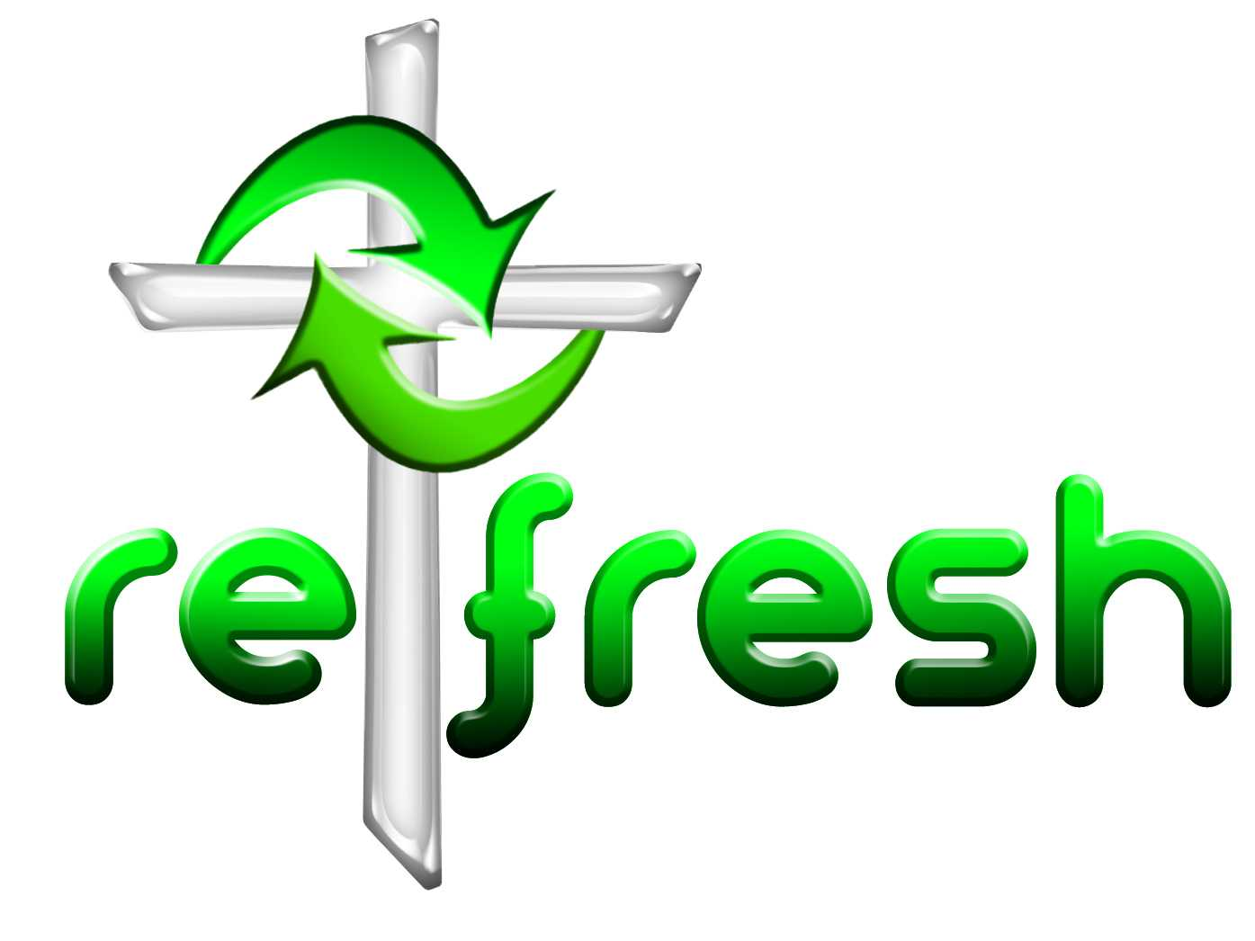
© 10 minutes on a Tuesday is a Refresh Resource. Unless otherwise acknowledged all material is prepared by Andrew Gamman. While every effort has been made to acknowledge source material, if you believe unacknowledged work has been quoted, contact the email address below to request that it be acknowledged or removed. Material included here may be freely used and reproduced for the immediate purpose of worship. Permission must be sought to republish in any form, or to reproduce for commercial gain. If you wish to share the content with others you may do so by linking through the NZ Methodist website. For more information on this and other resources, contact andrew@missionresourcing.org.nz or 09 525 4179 (w)


Mission Resourcing: Inspiring and resourcing our communities for a journey with Christ that enriches lives and relationships

