
Friday 6 April 2012

Contemplate the Cross
Year B - Good Friday - 29B

The Mission of the Methodist Church of New Zealand | Our Church’s mission in Aotearoa / New Zealand is to reflect and proclaim the transforming love of God as revealed in Jesus Christ and declared in the Scriptures. We are empowered by the Holy Spirit to serve God in the world. The Treaty of Waitangi is the covenant establishing our nation on the basis of a power-sharing partnership and will guide how we undertake mission.
Links | Ctrl+Click on the links below to go directly to the text you require  Readings  Preparation/ creativity  Service outline  Music  Prayers  Children  PowerPoint
Readings  Ctrl+Click to follow links | Isaiah 52.13-53.12 The prophet tells of the suffering of the servant of the Lord. “He was wounded and crushed because of our sins.”  Psalm 22 From deep suffering the psalmist cries out in anguish, “My God, my God why have you deserted me?” His shame turns to praise when God’s deliverance comes.  Hebrews 4.14-16, 5.7-9 or 10.16-25 Both of these readings encourage confidence because of who Jesus was and what he stood for. “We have a great High Priest.”  John 18.1-19.42 This is John’s account of the betrayal, arrest, trial, sentencing, death and burial of Jesus.
Preparation / Creativity  Ctrl+Click to follow links | For Good Friday try a very simple and solemn service that focuses on the narrative of the passion of Christ in John’s gospel. Replace the sermon with a short reflection, or eliminate it altogether. The mood will be dark and sombre. It is a time of sorrow and repentance. We reflect on the death of Christ and on our own short-comings.  Make a large, rough cross and have it at the front of the church. If you are unable to secure it upright, just lie it on the floor. Lean a soldier’s spear against it. Have pens, notepaper and hammers available at the front of the church. Strip the church bare of everything else possible for this service. Ideally all that remains will be the cross, the spear, and the hammers. The stark and empty church reminds us that everything we have is a result of the Good Friday death of Jesus.  As people arrive at the church, give each a nail to hold in their hand through the service. Arrange for several different readers to read John’s account of the passion. Divide the reading up into blocks. Ask people to contemplate the forgiveness that is offered through the cross.  At the end of the service pronounce the benediction and, as people leave, get them to come forward with their nail. Ask them to write on the note paper those things they’d like to confess (sins, short-comings, omissions, insults, mistakes etc) then fold the paper and nail it to the cross. The sound of hammer and nails will resound around the church and be quite dramatic.  Over the exit print some words of absolution like, “If we admit our sins—make a clean breast of them—he won't let us down; he'll be true to himself. He'll forgive our sins and purge us of all wrongdoing.” (1 John 1.9 The Message)  Other ideas for Good Friday from 2010 and 2011 are available from the “10 Minutes on a Tuesday” archives on the Methodist website.
Service outline  HIOS = Hope is our song  WHV = With heart and voice  SIS = Scripture in song  SIS = Scripture in song  CMP – Complete mission praise  S1 = The source 1 | Call to worship  On this sad day we gather to remember Jesus  We remember  … his betrayal and his arrest  … the disciples who deserted him and denied him  … his interrogation by the High Priest and his trial by Pilate  … the crowds who cried for his blood  … and the unjust sentence handed down  … the mocking of the soldiers  … and their nailing of him to the cross  Together:  And yet he was wounded and crushed because of our sins;  by taking our punishment, he made us whole.  We were all like sheep that had wandered off.  We had each gone our own way,  but the Lord gave him the punishment we deserved  Good Friday  Nails Isaiah 52:13; Psalm 22:14-18; John 19:16-17  There is something brittle about nails.  The hammer wedges the shrapnel  through the muscles into the wood.  These nails would break, not bend.  Isaiah said the servant would prosper-  But they thought they had him nailed.  How could these nails build a civilization?  Nails build houses, but what sort of house was this?  Together:  Suffering servant,  your bones were out of joint,  your hands and feet were shrivelled,  scarred and torn.  Yet you survive armies and empires,  and your way of the cross  defies pain and despair.  I honour you.  I thank you.  Let your death not be pointless.  Let your love live through me,  Amen.  © John Howell (used with permission)  Hymn On a cool and autumn dawn HIOS 110  Reader 1 John 18.1-11 Jesus is betrayed and arrested  Reader 2 John 18.12-14 Jesus is brought to Annas  Reader 3 John 18.15-18 Peter says he doesn’t know Jesus  Reader 4 John 18.19-24 Jesus is questioned by the High Priest  Reader 3 John 18.25-27 Peter again denies that he knows Jesus  Hymn The cross that once on Calvary’s hill WHV 49  Reader 5 John 18.28-37 Jesus is tried by Pilate  Reader 6 John 18.38-19.16 Jesus is sentenced to death  Reader 7 John 19.17-27 Jesus is nailed to a cross  Reader 8 John 19.28-30 The death of Jesus  One minute silence  Song Fill my eyes SIS 105  Reader 9 John 19.31-37 A spear is stuck in Jesus’ side  Reader 10 John 19.38-42 Jesus is buried  Reflection  I received an email this week asking why the churches call Easter Friday “Good Friday.” Picking up sentiments that most of us would have, the writer remarked, “I don’t think it was a good Friday but a bad Friday because that is the day that Jesus was crucified which was a ghastly way to be executed.”  So it is interesting to learn that the term "Good Friday" is mainly used in English speaking countries. In other countries the day is variously called Long Friday, Holy Friday, Day of Preparation, Day of the Lord's Passion or Passion of the Cross. "Good Friday" is actually a corruption of the Medieval "God's Friday". It's God's Friday, not because God was responsible for all the evil that happened on that day, but because it was in God's providence and purpose that Christ suffered and died, and it was for our benefit.  The death of Jesus is central to the gospel message. We can never plumb the depths of its meaning. So significant was it to the writers of the gospels that they gave over a third of their space to the accounts of the events surrounding the Christ’s death. In the church’s statement of belief, the Apostles’ Creed we go straight for the birth of Christ to his death without even any mention of his ministry.  “…born of the virgin Mary. He suffered under Pontius Pilate, was crucified, died and was buried.” And when Jesus wanted to give his disciples something to remember him by, he took bread and wine and made them into a memorial of his death.  On this day Christians will gather, as millions have before them, in the narrow streets in the old part of Jerusalem. For as long as Christians have been coming to Jerusalem they have wanted to walk the sorrowful path (the Via Dolorosa) that Jesus took to his death on the cross. The route has been more or less the same for the past 1000 years. Along the path are fourteen places (stations) where people like to stop to remember the things that happened to Jesus on the fateful day when he walked this way. In many churches these stations are displayed around the walls.  This sorrowful way is what we remember today.  It is God’s Friday, because through Jesus’ death we find forgiveness. And it is Good Friday because the sorrowful way is not the end of the story!  Hymn There is a Redeemer SIS 644; CMP 673; S1 492  Benediction  Almighty God  as we depart this church building today  our minds are full of our Lord Jesus Christ  who endured suffering and death on the cross for our sake.  Forgive us for those times we have fallen short of his call  and grant to us the courage that we need  to each take up our own cross and follow boldly after him.
Music  AA: Alleluia Aotearoa  CMP: Complete Mission Praise  HIOS: Hope is our Song  FFS: Faith Forever Singing  MHB: Methodist Hymn Book  H&P: Hymns and Psalms  S1: The Source  S2: The Source 2  S3: The Source 3  SIS: Scripture in Song  WHV: With heart and Voice  WOV: With One Voice | Other hymns & songs  And can it be MHB 371; WOV 138; H&P 216; CMP 33; S1 21  At the foot of the cross S1 32  Beneath the cross of Jesus MHB 179; H&P 165; CMP 55; S1 45  E te Iwi AA 32  Follow the way FFS 16  For the crowd another busy day FFS 18  God who weeps HIOS 52  Great ring of light AA 57  How deep the Father’s love for us CMP 988; S1 185  It is a thing most wonderful MHB 854; H&P 224; CMP 346; S2 801  It’s your blood SIS 566; CMP 351; S1 250  I will sing the wondrous story MHB 380; WOV 171; H&P 223; CMP 315; S2 821  Man of sorrows MHB 176; S1 350; H&P 228; CMP 458; S1 350  O Christ, you hang upon a cross HIOS 108  On a hill far away CMP 536; S1 403; CMP 536; S1 403  O the passion S2 930  O sacred head once wounded MHB 202; WOV 255; H7P 176  The cross that once on Calvary’s hill WHV 49  There is a green hill far away MHB 180; WOV 266; H&P 178; CMP 674; S2 990  Were you there? WOV 261; H&P 181; CMP 745; S3 1592  What have we done to you? FFS 70  When I survey MHB 182; WOV 258; H&P 180; CMP 755; S1 572  Who will carry the cross with me? FFS 79  You did not wait for me CMP 969  You exchanged my curses for blessings SIS 479
Prayers  Ctrl+Click to  follow link | Collect  Gracious and eternal God,  look with mercy on this your family,  for which our Lord Jesus Christ  was content to be betrayed  and given up into the hands of sinners  and to suffer death upon the cross;  who is alive and glorified with you,  in the unity of the Holy Spirit,  one God, now and for ever. Amen.  © The Methodist Worship Book (Peterborough, England: Methodist Publishing House, 1999)  Psalm 22  My God, my God, why have you deserted me?  Why are you so far away?  Won’t you listen to my groans and come to my rescue?  I cry day and night, but you don’t answer  and I can never rest.  Yet you are the holy God, ruling from your throne  and praised by Israel.  Our ancestors trusted you, and you rescued them.  When they cried to you for help you saved them  and you didn’t let them down when they depended on you.  But I am merely a worm, far less than human  and I am hated and rejected by people everywhere  Everyone who sees me makes fun and sneers  They shake their heads and say,  “Trust the Lord! If you are his favourite  let him protect you and keep you safe”  I can count all my bones  and my enemies just stare and sneer at me.  They took my clothes and gambled them.  Don’t stay far away Lord!  My strength comes from you, so hurry and help  Everyone on this earth will remember you Lord  People all over the world will turn and worship you  because you are in control, the ruler of the nations.  In future everyone will worship  and learn about you, our Lord.  People not yet born will be told  “The Lord has saved us!”  Contemporary English Version (CEV) Copyright © 1995 by American Bible Society  More prayers written in an Australian context by Moira Laidlaw
Children  Ctrl+Click to  follow link | Tell the story of the death of Jesus with the help of the children’s picture book “The Crucifixion of Jesus” (published by the Hong Kong Bible Society - it uses the Contemporary English Version of the Bible and is available from most Christian bookshops) , a clip from “The Miracle Maker” clay animation movie (G Rating – 2000), or The Brick Testament (below).  More Good Friday resources for children from sermons for kids
PowerPoint  Ctrl+Click to  follow links | 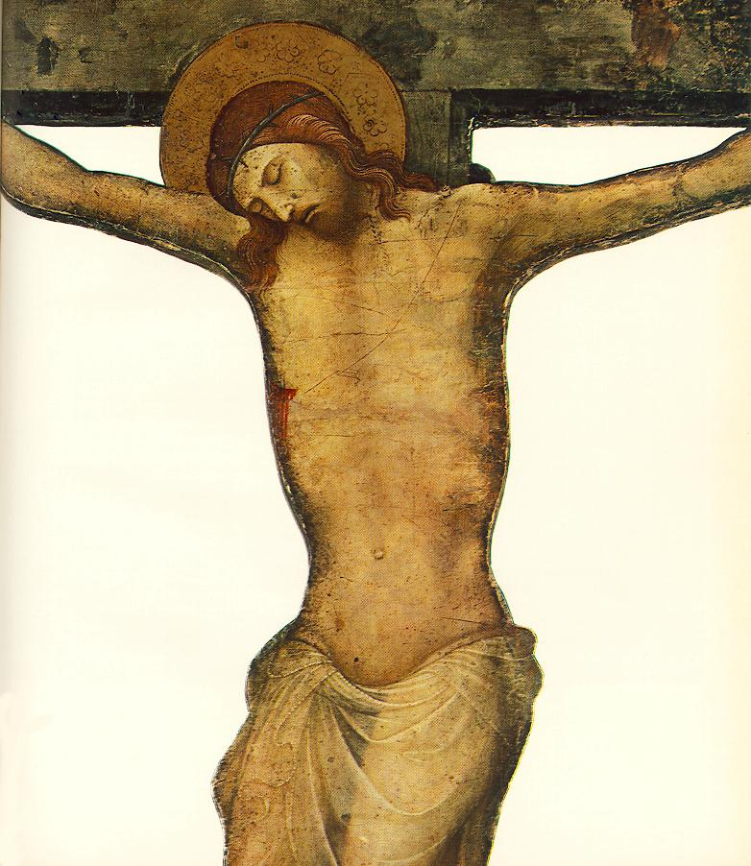  Google images for “crucifixion” or “passion of the Christ” and make you own PowerPoint slide show  Good Friday art from Vanderbilt Divinity Library  The Crucifixion from The Brick Testament in 24 slides


© 10 minutes on a Tuesday is a Refresh Resource. Unless otherwise acknowledged all material is prepared by Andrew Gamman. While every effort has been made to acknowledge source material, if you believe unacknowledged work has been quoted, contact the email address below to request that it be acknowledged or removed. Material included here may be freely used and reproduced for the immediate purpose of worship. Permission must be sought to republish in any form, or to reproduce for commercial gain. If you wish to share the content with others you may do so by linking through the NZ Methodist website. For more information on this and other resources, contact andrew@missionresourcing.org.nz or 09 525 4179 (w)


Mission Resourcing: Inspiring and resourcing our communities for a journey with Christ that enriches lives relationships

