
Sunday 4 March 2012

Easter Songs 2. Suffering
Year B - Lent 2 - 20B

The Mission of the Methodist Church of New Zealand | Our Church’s mission in Aotearoa / New Zealand is to reflect and proclaim the transforming love of God as revealed in Jesus Christ and declared in the Scriptures. We are empowered by the Holy Spirit to serve God in the world. The Treaty of Waitangi is the covenant establishing our nation on the basis of a power-sharing partnership and will guide how we undertake mission.
Links | Ctrl+Click on the links below to go directly to the text you require  Readings  Introduction  Broader preparation  Creativity  Preaching thoughts  Illustrations  Music  Prayers  Children  PowerPoint
Readings  Ctrl+Click to follow links  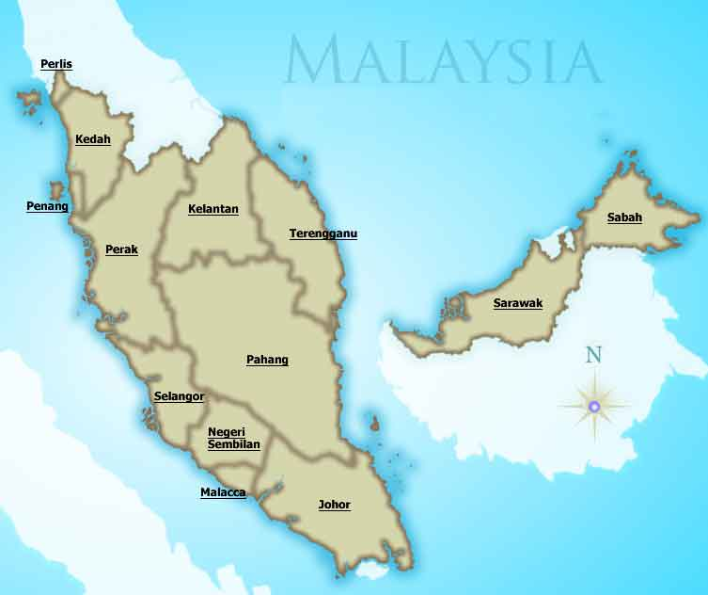 | Genesis 17.1-7,15-16 God makes an agreement with Abraham. In return for Abraham’s loyalty and obedience God promises him and Sarah countless descendants who will make up many nations.  Psalm 22.23-31 In a time of weakness and desolation David declares that God is in control. When we cry out to him he listens to us and does not turn away.  Romans 4 .13-25 Abraham had faith that God would fulfil his promise, so God accepted him. We are also accepted because of our faith in God who raised Jesus to life.  Mark 8.31-38 Jesus explains clearly to his disciples that he must suffer and die. Peter protests and is rebuked by Jesus. Then Jesus outlines the cost of being one of his followers. “If any of you want to be my followers, you must forget about yourself. You must take up your cross and follow me”  World Day of Prayer  This is the nearest Sunday to the World Day of Prayer (Friday 2 March). The theme this year is “let justice prevail” and you are encouraged to pray for Malaysia, a nation of diverse cultures, religions and races.
Introduction / Background  Ctrl+Click to follow links | Today is the second Sunday of Lent. An outline of the “10 Minutes on a Tuesday” Lenten series “Easter Songs” is printed below and additional resources, including last year’s material, are available from the NZ Methodist website.  26 February – Guidance and pardon (Psalm 25)  4 March – Suffering (Psalm 22)  11 March – The heavens reveal God (Psalm 19)  18 March – Rescued by God (Psalm 107)  25 March – Reconciliation (Psalm 51)  1 April Palm Sunday (Psalm 118)  5 April Maundy Thursday – Tenebrae: a service of shadows  6 April Good Friday – Contemplate the cross (John 18.1-19.42)  8 April Easter Sunday – Celebrate the resurrection (Mark 16.1-8)  The lectionary reading for today from the Psalms covers the final nine verses of chapter 22. This is a psalm of lament but in these final verses David praises God for listening to him and delivering him from death. The reading for Good Friday takes in the complete Psalm and in this “10 Minutes on a Tuesday” we will extend the reading to look at the Psalm as a whole. The agony and suffering of the first half of the psalm (verses 1-21) belong with the joy of God’s answer (verses 22-31) and vice-versa.  While this psalm is listed in the Psalter as being a psalm “of David” some commentators can see no circumstances in David’s life to which the psalm could be applicable, and so they speculate that it is a psalm by one of the more tragic figures in later Jewish history, perhaps Hezekiah or Jeremiah. Regardless, the passage conveys a message far greater than the original author intended. From its earliest days, the church has seen the person of Christ as the one being referred to by this psalm.  NRSV, RSV and NLT render Psalm 22.3 “Yet you are holy, enthroned on the praises of Israel” – an interesting picture of the power of praise that is not carried by other translations.
Broader / Personal  Preparation  Ctrl+Click to follow links   | Christian blues  African Americans made an art-form out of singing about their experiences of suffering. The “spirituals” are a particularly Christian form of this, but much of the “blues” in general has Christian overtones. The categories are broad and the songs are countless in number. To mention a few:  A good recent example that could be used to set the tone is “Hold me” off Glen Kaiser’s “Cardboard box” album (2011). Listen on YouTube.  Or something really old like “Sometimes I feel like a motherless child” Listen to Jimmy Scott’s rendition.  Or Blind Willie Johnson’s “Soul of a man” as covered by Canadian singer/songwriter Bruce Cockburn’s on his Nothing but a burning light album (1992). Listen on YouTube  Or, if you’d like something more mellow, try “Till we get the healing done” off the Shades of Blue self-titled album (1994)  Some movies that you may consider screening over Lent and Easter:  - Chocolat (2000 - M). A mother and her young daughter arrive in a small French village and open a chocolatiere during Lent, provoking the ire of the devout mayor. Raises the issue of compassion verses legalism. Nominated for five Academy awards.  - Godspell (1973 - G). A movie adaptation of the musical. Based on Matthew’s gospel but set in New York City.  - Jesus Christ Superstar (1973 - M). The movie based on the Andrew Lloyd Webber and Tim Rice rock opera – an oldie, but the music stands the test of time.  - Jesus of Montreal (1989 - M). A group of actors put on an unconventional passion play. The lead actor’s story cleverly parallels that of Christ. As such it intersects with our Lenten themes. Nominated for an Academy award for best foreign language film. (It’s in French with subtitles.)  - Jesus the Movie (1979 - G). A two hour classic life of Christ based on Luke’s gospel which was made as an evangelistic tool. Now available in over 1000 languages.  - The Miracle Maker (2000 - PG). An engaging animation of the life of Christ. The expressiveness of the characters gives an uncanny realism. Will be enjoyed by all people of ages.  - The Passion of the Christ (2004 - R15). Mel Gibson’s (writer and director) powerful portrayal of the death of Christ is a bit stark and graphic for the kids. The New Zealand censors gave it an R16 certificate – then reduced it to R15. It covers the last twelve hours of Christ’s life. Received generally good reviews (nominated for three Academy awards). In Aramaic, Latin and Hebrew with English subtitles.  - Son of God (2008 - PG). Tom Wright acts as a consultant to this three part BBC documentary which draws on historical, scientific and archaeological research and uses computer graphics to recreate the world of Christ. Part homage to Christ and part homage to science. Total running time 150 minutes.
Creativity /  Visual Aids  Ctrl+Click to follow links  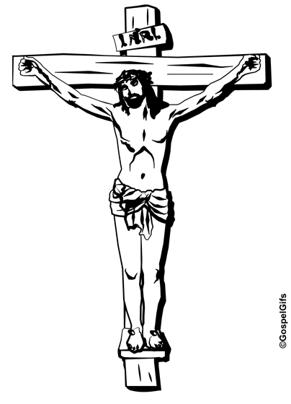 | Lenten reflection  (For those in the Auckland area this is an idea for a church outing to see a Sam Harrison artwork. People in Canterbury may be able to find a local gallery exhibiting other works by Harrison depicting the passion of Christ. Everyone, no matter where you are, can access Harrison’s work on the web)  Read John’s Gospel chapter 19, then take a trip to the TSB Bank Wallace Arts Centre, 72 Hillsborough Rd, Hillsborough, Auckland. Admission is free, there is off-street parking and the centre is open 10.00am to 3.00pm Tuesday to Friday and 10.00am to 5.00pm Saturday & Sunday.  On the stairwell find Christchurch artist Sam Harrison’s 2009 woodcut print “The Crucifixion” (John 19.31-37). This, despite being a woodcut, is a life-sized work and the display area forces you to get up-close. Those out of Auckland can view the work on the Art News website (scroll down).  Look at the large figures in the print: The soldiers, the women, the man, Christ…  - What do their faces tell you?  - Who might the man facing us be? (John 19.25-27)  - Why are there lines all over Jesus? (John 19.1)  Now turn to the smaller figures…  - How many faces can you see in the gathered clouds of doom?  - If the artist had put your face into this picture, what expression would he capture on your face?  Also of interest:  - The Pah Homestead where the art collection is housed. It is a magnificent building that was built in the 1870s as the largest house in Auckland. It has had a six million dollar refurbishment to restore it to its original state and was re-opened as a gallery in 2010.  - The wonderfully under-populated Monte Cecelia Park which has some of the largest trees in the city.  - The Art Centre Café which serves excellent coffee at a reasonable price and has outdoor tables on the veranda with stunning views of the city and Manukau Harbour.  Other Harrison woodcut works of the passion of Christ can be viewed on the  Solander Gallery website  Centre of Contemporary Art website  NZ artists website click on each work for a high resolution image
Preaching thoughts and Questions | “My God, my God, why have you forsaken me?” This sharp start to Psalm 22 takes us straight into the suffering of Christ on the cross. The sense of desolation and desperation hits us with such power that the rest of the psalm is swamped by its impact. While David was writing about his own experience of abandonment and alienation, Christians rightly read this passage in the light of its New Testament connections. Both Matthew and Mark record these words in Aramaic on the lips of Jesus. (Aramaic was the language that Jesus spoke.)  I’m not going to pretend that we can penetrate the full mystery of these words. But maybe we can understand a little. This Psalm is intertwined with the whole of the crucifixion narrative…  Everyone who sees me makes fun and sneers.  They shake their heads, and say,  "Trust the Lord! If you are his favorite,  let him protect you and keep you safe."  I can count all my bones,  and my enemies just stare and sneer at me.  They took my clothes and gambled for them. Psalm 22. 7, 8, 17 and 18  Jesus knew this Psalm, and the agony of its first words came to his lips as he suffered on the cross.  Many people have gone to the Psalms of lament and found comfort and encouragement in the way they identify with their own experience of suffering. And, in the case of Psalm 22, the ending has a great statement of hope, “The Lord has saved us!” (Psalm 22.31)  While the Psalm may speak of our own suffering, it relates uniquely to the crucifixion of Jesus. But there is much more in Jesus’ cry than just him finding solace in the familiar words of the Psalms.  “My God, my God, why have you forsaken me?”  Godforsaken! Jesus was Godforsaken. It’s not a word we use much. Was God now hiding from Jesus? Or was it that Jesus had lost sight of God? At that moment of history we are told that the sinfulness of this world fell upon Jesus.  Paul explains it this way, “He who knew no sin was made sin for us” (2 Corinthians 5.21). It was inevitable that Jesus would suffer the separation from God that was the consequence of him identifying with the sin of humanity.  Jesus chose to take a life like ours upon this earth. He was tempted as we are. He had seen his friends desert him and had faced the hatred of his enemies. He suffered as he endured the searing pain of being nailed to a cross but, up until now, he had never experienced the consequences of sin. For the terrible thing that sin does is that it separates us from God.  And now Jesus was Godforsaken…  Are you there God?? … Nothing! ... Godforsaken!  Ever felt like that?  Ever felt sooo low? Godforsaken? Where can you go with feelings like that? Who would understand? If so, you stand in line with many of God’s people who have at some time felt this way: King David, Job… not to mention Jesus Christ, the Son of God – he understands!  David goes on to reflect, “The Lord doesn't despise the helpless in all of their troubles” (Psalm 22.24).  I visited a man dying of AIDS in the hospital’s intensive care ward. I had to get gowned and masked up. I was so covered up in white that I looked like a no-person. I had all the appearance of a remote medical mercenary. I entered his sterile room and wanting to carry to him the grace and mercy of Christ, I reached out and put my hand on him… His flesh was limp. He felt like a corpse. He looked Godforsaken. Maybe some people would say that he was Godforsaken. Who can identify with someone that low? I know who! Our Lord Jesus Christ.  We prayed…“Lord Jesus Christ, Son of God, have mercy.” We asked for mercy… and he died not long afterwards.  Any time we’re feeling low, abandoned, despairing we can come to Jesus. He knows. He’s been Godforsaken.  Anytime we’re confronted with our own frailty and faultiness we can come to Jesus. He knows. He’s been Godforsaken. When we suffer there is unique comfort in finding, in Christ, someone who can identify with us.  And at the cross, at this centre-point in history, Jesus abandoned himself to his fate. He lost his life. He let go.  Sometimes the ground we are standing on slips away. All our support seems to disappear and it is as if we cry out, “Lord I am just hanging by a thread, what am I going to do?”  At such a time, the voice of God comes to us, “Let go.” It’s the hardest thing, because we like to have all the answers. We like to be in control.  Let go!  Jesus felt Godforsaken, but it was not his final or permanent mood. He abandoned himself to God’s mercy, and God’s will was accomplished. It was Jesus who (from today’s gospel reading) said that those who want to save their life will lose it, and those who lose their lives for his sake and for the sake of the gospel will save it (Mark 8.35 and 36).  The season of Lent brings our attention to suffering. That may make us feel uncomfortable. But through suffering comes redemption.  So come to Jesus. Come to Jesus and find acceptance and forgiveness. And let go. Let go and allow God’s will to be accomplished. Amen.
Illustrations / Stories  Ctrl+Click to  follow link | Sympathetic vibration  Physics has a law of sympathetic vibration. When a trumpet is in tune with a piano, notes sounded on the trumpet cause the strings of the piano to vibrate. Notes F,A and C, played in rapid staccato fashion will cause the piano notes E-flat, G, and B-flat to vibrate. It is like playing a duet by yourself. This is like what is happening between Christ and the psalmist. Each is so in tune with the other that their spirits are vibrating in close harmony. Alone on the cross, Christ is comforted by the sounds from the psalmist he is hearing in his heart. These notes of harmony were played for Christ; they can also play for us.  J Truett Gannon, Feasting on the Word; Year B, Vol 2, eds David L Bartlett & Barbara Brown Taylor (Louisville: Westminster John Knox Press, 2008) p293  Ravensbruck prayer  O Lord, remember not only the men and women of good will, but also those of ill will. But do not remember all of the suffering they have inflicted upon us: Instead remember the fruits we have borne because of this suffering, our fellowship, our loyalty to one another, our humility, our courage, our generosity, the greatness of heart that has grown from this trouble. When our persecutors come to be judged by you, let all of these fruits that we have borne be their forgiveness.  Found in the clothing of a dead child at Ravensbruck concentration camp where over 90,000 women and children perished at the hands of the Nazis during World War II.
Music  AA: Alleluia Aotearoa  CMP: Complete Mission Praise  HIOS: Hope is our Song  FFS: Faith Forever Singing  MHB: Methodist Hymn Book  H&P: Hymns and Psalms  S1: The Source  S2: The Source 2  S3: The Source 3  SIS: Scripture in Song  WHV: With heart and Voice  WOV: With One Voice | Hymns & Songs  And can it be MHB 371; WOV 138; H&P 216; CMP 33; S1 21  Beneath the cross of Jesus MHB 179; H&P 165; CMP 55; S1 45  Companions let us pray together HIOS 21  Filled with compassion CMP 828; S1 105  Fill my eyes SIS 105  I have decided to follow Jesus CMP 272  In the cross of Christ I glory MHB 183; WOV 265; WHV 167  In the quiet of this day FFS 37  It is a thing most wonderful MHB 854; H&P 224; CMP 346; S2 801  It’s your blood SIS 566; CMP 351; S1 250  I will sing the wondrous story MHB 380; WOV 171; H&P 223; CMP 315; S2 821  Kneels at the feet of his friends WOV 561  Man of sorrows MHB 176; S1 350; H&P 228; CMP 458; S1 350  O Christ, you hang upon a cross HIOS 108  O love that will not let me go MHB 448; WOV 525; H&P 685; CMP 515; S2 917  O safe the rock MHB 499;  Salvation belongs to our God CMP 924; S1 443  Sing out S3 1506  Take up your cross WOV 496  There is a Redeemer SIS 644; S1 492; CMP 673; S1 492  We wait for you AA 149  You did not wait for me CMP 969
Prayers  Ctrl+Click to  follow link | Collects  Christ, Son of the living God,  who for a season laid aside the divine glory  and learned obedience through suffering:  teach us in all our afflictions  to raise our eyes to the place of your mercy  and to find in you our peace and deliverance.  We make our prayer in your name. Amen.  © The Methodist Worship Book (Peterborough, England: Methodist Publishing House, 1999)  Mark 8:34  God of peace,  Yours was the way,  not of the bullet or bomb,  but the way of a cross.  How will I know  what kind of sacrifice  is required of me?  Together:  God, your challenge is always before us.  To follow your way,  we need wisdom, courage,  and the humility of the deep truth  found in Jesus my friend.  Grant me your insight.  Amen.  © John Howell (used with permission)  Psalm 22 (selection)  My God, my God, why have you deserted me?  Why are you so far away?  Won't you listen to my groans and come to my rescue?  I cry out day and night,  but you don't answer, and I can never rest.  Yet you are the holy God,  ruling from your throne and praised by Israel.  Our ancestors trusted you, and you rescued them.  When they cried out for help, you saved them,  and you did not let them down when they depended on you.  But I am merely a worm, far less than human,  and I am hated and rejected by people everywhere.  Everyone who sees me makes fun and sneers.  They shake their heads, and say,  "Trust the Lord! If you are his favorite,  let him protect you and keep you safe."  You, Lord, brought me safely through birth,  and you protected me when I was a baby at my mother's breast.  From the day I was born, I have been in your care,  and from the time of my birth, you have been my God.  Don't stay far off when I am in trouble  with no one to help me.  I have no more strength than a few drops of water.  The Lord doesn't hate or despise the helpless  in all of their troubles.  When I cried out, he listened and did not turn away.  When your people meet,  you will fill my heart with your praises, Lord,  and everyone will see me keep my promises to you.  Everyone on this earth will remember you, Lord.  People all over the world will turn and worship you,  because you are in control, the ruler of all nations.  In the future, everyone will worship and learn  about you, our Lord.  People not yet born will be told,  "The Lord has saved us!"  Contemporary English Version (CEV) Copyright © 1995 by American Bible Society  Lament  Address  O God and Father of our Lord Jesus Christ  We have been brought near to you only by the suffering of your Son  After he suffered and died on the cross  You raised him to life again  We look to him as our Lord and Saviour  Complaint  Life is hard for us God  Good people suffer grief and illness  People we depend on let us down  We feel hurt, abandoned, lonely and crushed  Our hopes have been shattered into a thousand pieces  like a dropped crystal vase  Sometimes life is so painful  we wonder how we can continue  Darkness descends upon us like a thick cloud  and death is around every corner  (Pause - to make your own complaint)  Petition  Be a friend to us when we are alone  and help us when we are troubled  Heal the pain  and take away our fears  Motivation  Because of your grace and love  and your faithfulness to your people in the past  be merciful to us  We are in your hands  Vow of offering  And we will praise you, our Lord and God  because you are good  Assurance of being heard  You are our God and our protector  May everyone know of your greatness  Amen  © Andrew Gamman  Benediction  Lord:  Life seems so fragile sometimes…  We ask in the midst of uncertainty,  in the midst of things suddenly different,  in the mists and swirling fog of incomplete diagnoses and misunderstandings,  of fears and memories and uncertainties  the security of your love,  the care of your people,  the ongoing presence of your hope for the family,  for those for whom we pray,  and for ourselves as we stand with these who we love.  © Alan K Webster - abridged (used with permission)  More prayers written in an Australian context by Moira Laidlaw
Children  Ctrl+Click to  follow link   | I feel like a worm  Bring along an earthworm in a cup of soil. Ask, “who likes worms?” If there is a child that does, get him or her to find the worm in the cup of soil and gently hold it up for all to see. (If there are no volunteers, you will have to do this yourself.)  Really, the life of a worm can’t be much fun. All they do is crawl around in the dirt and the dark, day and night. Sometimes when people are feeling really bad they say, “I feel like a worm.”  Maybe you feel like that sometimes. Especially if other people are picking on you, or you’re always in trouble, or you’ve got no friends.  In today’s psalm the writer says, “I am merely a worm, far less than human,  and I am hated and rejected by people everywhere” (Psalm 22.6). A long time after it was written, this was a psalm that came to mind for Jesus when people treated him very badly and nailed him to a cross.  Just because sometimes we feel bad, it doesn’t mean that God doesn’t care for us. In fact the times when we are feeling helpless and troubled are the times that God is very near to us. This is what King David, who wrote the psalm, found out. He wrote “The Lord doesn't hate or despise the helpless in all of their troubles.  When I cried out, he listened and did not turn away.” Psalm 22  More resources for children from sermons4kids.com
PowerPoint | Google images for “crucifixion” or “passion of the Christ”


© 10 minutes on a Tuesday is a Refresh Resource. Unless otherwise acknowledged all material is prepared by Andrew Gamman. While every effort has been made to acknowledge source material, if you believe unacknowledged work has been quoted, contact the email address below to request that it be acknowledged or removed. Material included here may be freely used and reproduced for the immediate purpose of worship. Permission must be sought to republish in any form, or to reproduce for commercial gain. If you wish to share the content with others you may do so by linking through the NZ Methodist website. For more information on this and other resources, contact andrew@missionresourcing.org.nz or 09 525 4179 (w)


Mission Resourcing: Inspiring and resourcing our communities for a journey with Christ that enriches lives and relationships

