
Sunday 3 June 2012

Join the dance
Year B - Trinity - 40B

The Mission of the Methodist Church of New Zealand | Our Church’s mission in Aotearoa / New Zealand is to reflect and proclaim the transforming love of God as revealed in Jesus Christ and declared in the Scriptures. We are empowered by the Holy Spirit to serve God in the world. The Treaty of Waitangi is the covenant establishing our nation on the basis of a power-sharing partnership and will guide how we undertake mission.
Links | Ctrl+Click on the links below to go directly to the text you require  Readings  Introduction  Broader preparation  Creativity  Preaching thoughts  Illustrations  Music  Prayers  Communal sharing  Children  PowerPoint
Readings  Ctrl+Click to follow links  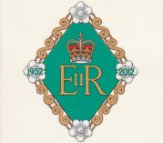 | Isaiah 6.1-8 Isaiah has a vision of the Lord in the temple. He becomes aware of his sinfulness, is forgiven and receives a call from God  Psalm 29 A psalm of David in praise of the Lord, whose voice is heard in the storm and who gives strength and peace to his people.  Romans 8.12-17 God’s children are led by his Spirit. We call God Father and the Spirit makes us sure that we are his children. We will also share in the glory of Christ because we have suffered with him.  John 3.1-17 Jesus talks to Nicodemus about the need to be born from above. God’s Spirit can change us and give us new life. “God loved the people of this world so much that he gave his only Son, so that everyone who has faith in him will have eternal life and never really die.”  The Queen’s Diamond Jubilee  This weekend is Queen’s Birthday Weekend and the month of June is also a time to celebrate the Queen’s Diamond Jubilee. A Jubilee Thanksgiving Service is to be held in St Paul's Cathedral, London on 5 June 2012 to mark Queen Elizabeth’s 60 years as sovereign. She became New Zealand’s monarch on the death of her father King George VI in 1952. Her formal coronation took place later, in June 1953. Government House has established a special section of its website dedicated to the Diamond Jubilee.  If you are planning a Diamond Jubilee Service please contact the Government House Public Affairs Team with details of the event  email: info@govthouse.govt.nz  or phone: Antony Paltridge, Public Affairs Manager 04 382 0872  The following prayer, written at the Queen's direction by the Chapter of St Paul's Cathedral for Her Majesty's Diamond Jubilee, will be used at the St Paul's Thanksgiving Service. The Archbishops of Canterbury and York have commended it for use throughout the Church of England. Other churches are also welcome to use the prayer.  God of time and eternity  whose Son reigns as servant, not master;  we give you thanks and praise  that you have blessed this Nation, the Realms and Territories  with ELIZABETH,  our beloved and glorious Queen.  In this year of Jubilee,  grant her your gifts of love and joy and peace  as she continues in faithful obedience to you, her Lord and God  and in devoted service to her lands and peoples,  and those of the Commonwealth,  now and all the days of her life;  through Jesus Christ our Lord.  Amen
Introduction / Background  CEV = Contemporary English Version of the Bible | Amen amen  The Hebrew word “amen” is used to convey agreement or certainly. It is transliterated into the Greek New Testament as well as into English and is used in the sense of “I agree” or “so be it”. John uses the word in a special way in his gospel. It is always on the lips of Jesus and he does a double-up of the word. So it appears as “Amen amen”, and he does this twenty five times. This double amen is used to give a statement special emphasis. So, when we come across it, we should pay special attention. Think of it as “listen up” or, according to CEV, “I tell you for certain”. In today’s gospel reading the double amen occurs three times.  - Amen, amen you must be born from above before you can see God’s kingdom! (John 3.3)  - Amen, amen before you can get into God’s kingdom, you must be born not only by water, but by the Spirit. (John 3.5)  - Amen, amen we know what we are talking about because we have seen it ourselves. (John 3.11)  Nicodemus  Nicodemus was a man of high religious standing. We find him only in John’s gospel (John 3.1-11, 7.50-52 and 19.39-42). He was a Pharisee, a member of the Sanhedrin (ie ruler of the Jews) and would have had considerable wealth. In today’s gospel reading Nicodemus comes to Jesus as a sincere enquirer. Later, in a meeting of the chief priests and Pharisees, he is not afraid to boldly protest stating that Jesus should not be condemned without a fair hearing.  Looking ahead  This lectionary year (year B) is the year of Mark. Next week we come to a run of seven Sundays when the lectionary takes us back to Mark’s gospel and “10 Minutes on a Tuesday” will focus on these gospel passages.  June 10 A Kingdom divided Mark 3.20-35  June 17 A story about seeds Mark 4.26-34  June 24 A storm Mark 4.25-41  July 1 Dare to touch Mark 5.21-43  July 8 Sending the twelve Mark 6.1-13  July 15 John the Baptist Mark 6.14-29  July 22 Sheep without a shepherd Mark 6.30-34, 53-56
Broader / Personal  Preparation  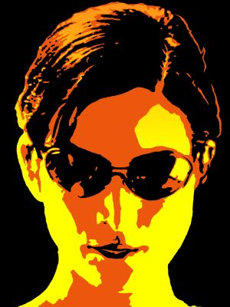  Trinity | The Shack  William Paul Young visited New Zealand as an author/ speaker in January of this year. His novel The Shack, first published in 2007, has become a best-seller with over 12 million copies sold. Like Alice Sebold’s Lovely Bones the plot revolves around a child murder. Unlike Lovely Bones the book’s main character, the father of the murdered child, gets to talk with the Trinitarian God about all that is troubling him.  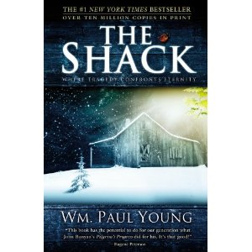  With God the Father taking the form of an Afro-American woman and the Holy Spirit manifesting himself as an Asian woman some Christians have been shouting “heresy”. However, it’s a novel not a theology book, and read this way it has some profound and delightful things to say. One of the enduring pictures that the reader is left with is of the loving relationship between the persons of the Trinity.  Eugene Peterson writes, "this book has the potential to do for our generation what John Bunyan's Pilgrim's Progress did for his."  The Matrix (1999 – M)  The first of a trilogy of movies about a computer hacker, Neo (played by Keanu Reeves) who seeks to rebel after finding that his world is an illusion. With its heavy Christian terminology and overtones, the naming of one of the key characters as “Trinity” is clearly intentionally symbolic. Played by Carrie Anne Moss, Trinity is a computer programmer who is Neo’s love interest and brings about his resurrection after he has been killed by Agent Smith. The movie won four Oscars.
Creativity /  Visual Aids    CEV = Contemporary English Version of the Bible | An electrical circuit  Using a snap circuit electronic kit make a basic circuit with a switch, battery and bulb.  Explain that electricity is a type of energy that can flow from one place to another. It is caused by tiny particles called electrons. A current of electricity is a steady flow of electrons. In a circuit like this one, when the switch is turned on the electrons move around the circuit carrying energy from one place to another.  Turn the switch on and explain that the glowing bulb shows that the current is flowing all around this circuit.  In a similar way God’s love constantly flows between the Father, Son and Holy Spirit.  Snap in some extra length in the circuit and add another bulb.  Here’s the amazing thing. Just like we’ve added to this circuit and extended the flow of energy, we can be joined in to the flow of God’s love and receive his life.  In our gospel reading today Jesus explained that “God loved the people of this world so much that he gave his only Son, so that everyone who has faith in him will have eternal life.” He wants us to be connected in and receive his life. Later on Jesus talked about the flow of love when he said, “I have loved you, just as my Father has loved me. So remain faithful to my love for you. If you obey me, I will keep loving you, just as my Father keeps loving me, because I have obeyed him” John 15.9-10 CEV.  Thanks to Graeme Finlay for this idea  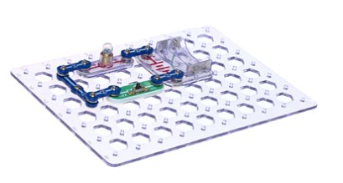
Preaching thoughts and Questions  Ctrl+Click to follow link  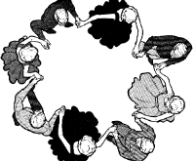  Diagram courtesy of Graeme Finlay, East Coast Bays Methodist Parish | Each year on Trinity Sunday we have the opportunity to explore the nature of our Trinitarian God. This is not a matter of arguing over words and definitions, but understanding afresh that God exists in relationship. God is Father, Son and Holy Spirit. As such we see that it is the nature of God is to be in relationship. And we are drawn into that relationship in different ways. God is over us, God is with us and God is in us.  The oldest form of dancing that history records is the circle dance. It was performed by the ancient Greeks and is retained in Greek culture today as a feature of traditional Greek weddings and special occasions. The Greek circle dance is accompanied by bright music, clapping and celebration. In the summer of 2007 on the beach of Agia Napa, which is on the east coast of Cyprus, 268 dancers performed the longest circle dance ever. The record appears in the Guinness Book of Records.  “So what has that got to do with the Holy Trinity?” you may think. Well, quite a lot. When some of the early church Fathers began to think about the mystery of the Trinity, and how the persons of the Trinity were related, rather than being stuck in static definitions they wanted to capture the flow of love and joy between the Father, Son and Spirit. The word that they used to do this was the word for the ancient Greek circle dance. This gives us an image of the Trinity that is full of life and movement. John of Damascus (c 676 –749) described it as a "cleaving together" of the persons of the Trinity. It is a helpful metaphor for us on this Trinity Sunday. And it includes within it the invitation extended to us to join in the dance.  Which brings us to our passage from John’s gospel today. The gospels are full of accounts of Jesus moving among ordinary people and having conversations with them. In today’s reading John has recorded a dialogue between Jesus and a religious leader called Nicodemus. Most of the conversations that Jesus had with Jewish rulers and people of high standing were rather confrontational. The good news carried by Jesus did not sit well with all their rules and judgemental attitudes. Nicodemus seems to be an exception. He was cautious, but nevertheless was a sincere seeker after truth.  Unseen by others, Nicodemus came to Jesus late one night with his heart full of questions. After Nicodemus acknowledged that Jesus was sent from God, Jesus cut straight to the chase and said, “Listen up – you must be born from above before you can see God’s kingdom.”  Jesus frequently spoke about the kingdom. When he spoke in parables, nearly all of the stories he told were about God’s kingdom. But he wasn’t talking about a geographical area. God’s kingdom is where God rules, where he is in charge. So Jesus was raising the question of who is in charge, who is ultimately the boss. Which causes us to think for a moment about who might be the boss for us here today in New Zealand…  “Ahh… John Key,” you may respond.  But while John Key is Prime Minister… and he might have the influence to sell off some of the country’s assets… if I ask, “does he really rule your life?”  “No way!” you’d respond, “I am my own boss. I’m in charge of my own life. Nobody tells me what to do.”  This is the point of Jesus’ conversation. We need to get ourselves out of the driver’s seat and put God there. When we do that God rules us. We become part of the larger place where God rules – we’re in God’s kingdom. This represents such a radical change that it is like starting life all over again. It’s like being born from above.  This talk about being born from above was both surprising and confusing for Nicodemus. It represented a radically different way of seeing things.  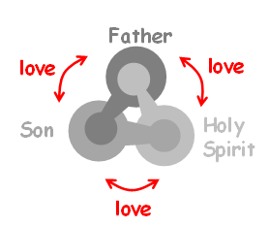  Jesus said, “Don’t be surprised when I say that you must be born from above. Only God’s Spirit gives new life” (John 3.7-8). Now we have Jesus talking of God the Father as well as the Holy Spirit. The whole of the Holy Trinity is involved and Nicodemus was being invited to join in with a new kind of life. There is love and life that flow between the Father, Son and Spirit. And Nicodemus was presented the opportunity to enter into the flow – to join the dance. But he was still confused.  Jesus explained that the love that comes from God is big enough to extend to all people, “God loved the people of this world so much that he gave his only Son, so that everyone who has faith in him will have eternal life and never really die” (John 3.16).  The invitation to eternal life is not just to a life that goes on, and on, and on. That could be boring. But it is an invitation to a life of a different quality, an eternal quality. We can begin to experience this in the here and now as we consciously put our lives under the rule of God and in line with his purposes.  Of course, we would like to know what happened to Nicodemus. Did he join the dance? Did he embrace eternal life? We don’t really get an indication one way or another from our reading today. But a couple of verses at the end of John’s gospel perhaps give us a clue. At the burial of Jesus, Nicodemus brought an expensive mix of burial spices, myrrh and aloes, to wrap the body. What is remarkable is the amount he brought - 35 kilograms! This was a quantity appropriate for the burial of a king and is surely recorded by John as a sign of the devotion of Nicodemus to Christ. So my guess is that he did join the dance.  The more important question is what about you and me? Have we joined the dance? Have we got ourselves out of the driver’s seat and allowed God’s rule, God’s kingdom, to come to us? This Trinity Sunday come and join the dance - and enter into the love and life that flows between the persons of the Trinity.
Illustrations / Stories  Ctrl+Click to follow link  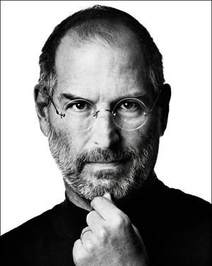  Steve Jobs | Adoption  I’m an adopted child... well at least in one sense. According to our reading from Romans today the Holy Spirit brought about our adoption as sons and daughters into God’s family. This gives rise to several thoughts about families.  There doesn’t seem to be a “typical” family any more. Today blended, adoptive and single-parent families all rate as normal. The sense of belonging comes from the love in the family rather than its particular make up. The good thing about our adoption into God’s family is that he provides the loving framework for our healthy development.  In this context I can’t help thinking of Steve Jobs the co-founder of Apple who died in October last year. Steve was adopted as an infant by Paul and Clara Jobs in February 1955. Paul and Clara quickly realised the talents of their intelligent son. They went out of their way to make their son feel special and to cater for his needs. According to Steve, “Both my parents got me. They felt a lot of responsibility once they sensed that I was special. They found ways to keep feeding me stuff and putting me in better schools. They were willing to defer to my needs.”  After developing the first Apple computer with Stephen Wozniak, Job’s flare for promotion and innovation led to the iPod, iPad and iPhone. With more than $500 billion in market capitalization, Apple is today the world's most valuable company.  Quote from Walter Isaacson, Steve Jobs (London: Little Brown 2011):11.  Join the dance  “Dancing transforms us. We teach the steps to the District 13 guests. Insist on a special number for the bride and groom. Join hands and make a giant, spinning circle where people show off their footwork. Nothing silly, joyful or fun has happened in so long. This could go on all night…”  Suzanne Collins, Mockingjay (New York: Scholastic Press, 2011) - The final book in the Hunger Games Trilogy.  And those who were seen dancing were thought to be insane by those who could not hear the music. - Friedrich Nietzsche  Consciousness expresses itself through creation. This world we live in is the dance of the creator. Dancers come and go in the twinkling of an eye but the dance lives on. On many an occasion when I am dancing, I have felt touched by something sacred. In those moments, I felt my spirit soar and become one with everything that exists. – Michael Jackson  Go to this link for a story by Baxter Kruger about him play-fighting with his son and his son’s friend. The story illustrates getting drawn into relationship with the Trinitarian God.
Music  AA: Alleluia Aotearoa  CMP: Complete Mission Praise  HIOS: Hope is our Song  FFS: Faith Forever Singing  MHB: Methodist Hymn Book  H&P: Hymns and Psalms  S1: The Source  S2: The Source 2  S3: The Source 3  SIS: Scripture in Song  WHV: With heart and Voice  WOV: With One Voice  Ctrl+Click to follow link | Hymns & Songs  All creatures of our God and king MHB 28; WOV 3; H&P 329; CMP 7; S2 614  Born again SIS 475  Father in heaven grant to your children WOV 399; H&P 3  Father in whom we live MHB 39; WOV 51; H&P 4  Father we adore you SIS 457; CMP 139  Father we love you SIS 451; CMP 142; S1 103  God is love let heaven adore him WOV 93; H&P 36; CMP 187  Heavenly Father I appreciate you SIS 39  Holy, holy, holy MHB 36; WOV 65; H&P 7; CMP 237; S1 176  I bind unto myself today MHB 392  I sing the grace HIOS 68  Lead us heavenly father lead us MHB 611; WOV 492; H&P 68; CMP 400; S1 311  Maker of mystery FFS 47  May the grace of our Lord Jesus SIS 247  Meekness and majesty CMP 465; S1 353  One God S3 1463  O threefold God of tender unity AA110  The God of Abraham praise MHB 21; WOV 53; H&P 452; CMP 645; S2 975  The majesty of mountains AA 139  Thou whose almighty word MHB 803; WOV 61; H&P 29; CMP 699  We limit not the truth of God WOV 335  There are at least two lovely hymns based on the Nicene Creed and set to Beethoven’s “Ode to Joy”. I haven’t been able to track down the authors or copyright information. You’ll find the words to the one that starts  “We believe in God the Father  God Almighty by whose plan”  on St Ursula’s church website. The other begins  “We believe in God the Father  We believe in God the Son”
Prayers  Ctrl+Click to follow link | Collects  Trinity Sunday John 3:1-17  God of the wind,  shape in me your spirit.  Lift me to a new plain,  to walk a new highway;  to shine as a new star,  to bring light in the dark.  Gift me eternal life,  through the Son of Man,  Amen.  © John Howell (used with permission)  Father God,  you have created all things  and through Christ revealed your salvation  in all the world.  Give us a vision of your glory  and by your Holy Spirit fill us with life and love  that we may praise and serve you  through Jesus Christ our Lord,  who is alive and reigns with you,  in the unity of the Holy Spirit,  one God, for ever and ever. Amen.  © The Methodist Worship Book (Peterborough, England: Methodist Publishing House, 1999)  The voice of the Lord in the storm  Praise the Lord, you heavenly beings;  praise his glory and power.  Praise the Lord's glorious name;  bow down before the Holy One when he appears.  The voice of the Lord is heard on the seas;  the glorious God thunders,  and his voice echoes over the ocean.  The voice of the Lord is heard  in all its might and majesty.  The voice of the Lord breaks the cedars;  the voice of the Lord makes the lightning flash.  His voice makes the desert shake.  The Lord's voice shakes the oaks  and strips the leaves from the trees  while everyone in his Temple shouts,  Glory to God!  The Lord rules over the deep waters;  he rules as king forever.  The Lord gives strength to his people  and blesses them with peace.  Psalm 29 (selection). Good News Translation (GNT) Copyright © 1992 by American Bible Society  The Nicene Creed  We believe in one God,  the Father, the Almighty,  maker of heaven and earth,  of all that is, seen and unseen.  We believe in one Lord, Jesus Christ,  the only Son of God,  eternally begotten of the Father,  God from God, Light from Light,  true God from true God,  begotten, not made,  of one Being with the Father.  Through him all things were made.  For us and for our salvation  he came down from heaven;  by the power of the Holy Spirit  he became incarnate from the virgin Mary, and was made man.  For our sake he was crucified under Pontius Pilate;  he suffered death and was buried.  On the third day he rose again  in accordance with the Scriptures;  he ascended into heaven  and is seated at the right hand of the Father.  He will come again in glory to judge the living and the dead,  and his kingdom will have no end.  We believe in the Holy Spirit, the Lord, the giver of life,  who proceeds from the Father and the Son.  With the Father and the Son he is worshiped and glorified.  He has spoken through the Prophets.  We believe in one holy catholic and apostolic Church.  We acknowledge one Baptism for the forgiveness of sins.  We look for the resurrection of the dead,  and the life of the world to come. Amen.  More prayers written in an Australian context by Moira Laidlaw.
Communal  Sharing | Testimony time  This is an appropriate Sunday to arrange for one or two from the congregation to share about their personal spiritual journey. Suggest that they talk about the influences that led them to come to faith and how being a follower of Jesus has changed their life. Is it possible to get both a younger and an older person to share? Perhaps get a teenager to share their experience of being a Christian in the current school environment and make a video of one of the elderly “shut in” church members.
Children  Ctrl+Click to  follow links   | Memory verse  “God loved the people of this world so much that he gave his only Son, so that everyone who has faith in him will have eternal life and never really die.” John 3.16 (Contemporary English Version).  This verse has been called the heart of the gospel. Make it into a memory verse.  Display the words and get the children to read them out together several times. Cover the last four words and say the verse again. Progressively cover more words until the verse is said with all the words covered. Give each of the children a slip of card with the verse on it to take home. Offer a small prize (chocolate fish perhaps) to anyone who can say it from memory next week.  More resources for children from sermons4kids.com  See also creativity above.
PowerPoint  Ctrl+Click to  follow link | Trinity cartoon from reverendfun.com  Google images for “circle dance” or “Greek circle dance”

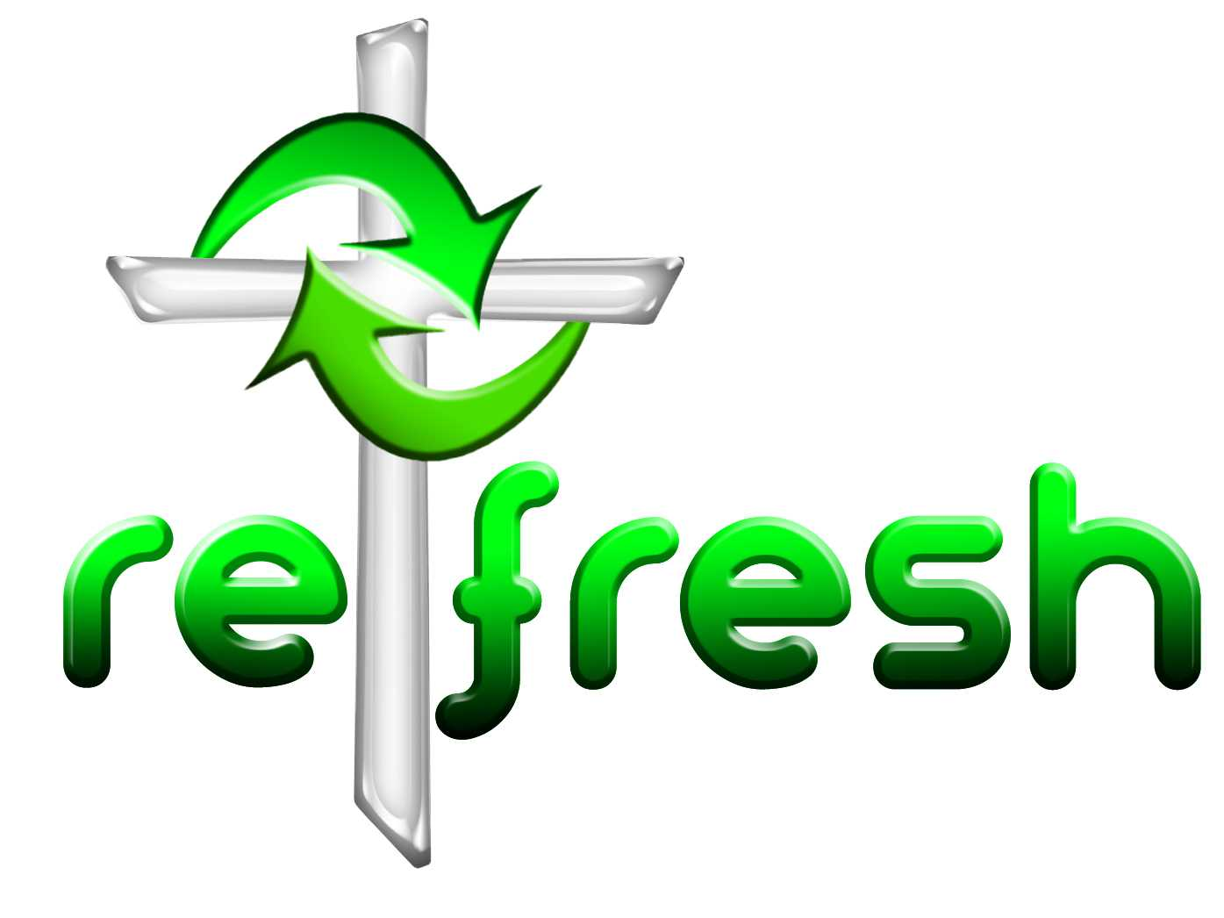
© 10 minutes on a Tuesday is a Refresh Resource. Unless otherwise acknowledged all material is prepared by Andrew Gamman. While every effort has been made to acknowledge source material, if you believe unacknowledged work has been quoted, contact the email address below to request that it be acknowledged or removed. Material included here may be freely used and reproduced for the immediate purpose of worship. Permission must be sought to republish in any form, or to reproduce for commercial gain. If you wish to share the content with others you may do so by linking through the NZ Methodist website. For more information on this and other resources, contact andrew@missionresourcing.org.nz or 09 525 4179 (w)


Mission Resourcing: Inspiring and resourcing our communities for a journey with Christ that enriches lives and relationships

