
Sunday 27 May 2012

Can these bones live?
Year B – Pentecost - 39B

The Mission of the Methodist Church of New Zealand | Our Church’s mission in Aotearoa / New Zealand is to reflect and proclaim the transforming love of God as revealed in Jesus Christ and declared in the Scriptures. We are empowered by the Holy Spirit to serve God in the world. The Treaty of Waitangi is the covenant establishing our nation on the basis of a power-sharing partnership and will guide how we undertake mission.
Links | Ctrl+Click on the links below to go directly to the text you require  Readings  NZ Music Month  Introduction  Broader preparation  Creativity  Preaching thoughts  Illustrations  Music  Prayers  Communal sharing  Children  PowerPoint
Readings  Ctrl+Click to follow links     | Ezekiel 37.1-14 Ezekiel has a vision of a valley full of bones. The Lord puts breath into the bones. They join together, rise up, are covered with muscles and skin, live again and make a great army. Animated Bible reading from YouTube.  Psalm 104.24-34, 35 A psalm in praise of the creator God who, by his Spirit, gives life to the earth. (The lectionary omits half of the last verse where, typical of many psalms, the psalmist vents his desire to see his enemies destroyed.)  Acts 2.1-21 During the Pentecost feast the Holy Spirit came on 120 believers. Visiting pilgrims from many nations heard them declaring the wonders of God in their own languages  John 15.26-27, 16.4-15 Jesus promises to send the Holy Spirit to help his disciples. The Spirit will show people the truth about sin, justice and judgement.  40 hour famine  World Vision’s 40 hour famine is this weekend. Acknowledge and support those from your congregation participating in the famine or follow this link to donate (through Team Whangaparaoa College). This year’s focus is on Mali and Niger. Mali and Niger in West Africa are two of the poorest countries in the world. Both have shocking hunger statistics. More than 30 per cent of children under five years old in Mali and just over half of children under five in Niger are malnourished. This year, lack of rain and failed harvests in Mali and Niger have left millions of children and families without enough food to eat. Many families are selling their animals – their only source of income – to survive.  Week of prayer for Christian unity 20-27 May  In the Southern Hemisphere this is the time we celebrate the week of prayer for Christian unity. The World Council of Churches website has a full, downloadable order of service for 2012. Why not initiate some combined churches events or services and see what you can learn from other denominations?
NZ Music Month  Ctrl+Click to follow links    AA: Alleluia Aotearoa  HIOS: Hope is our Song  FFS: Faith Forever Singing  SIS: Scripture in Song  WHV: With Heart and Voice | This May is the 11th New Zealand Music Month. Through the whole of this month we have been especially recommending Kiwi music to use in your worship services.  Notes from John Thornley, NZ Hymnbook Trust  Pentecost  (From Alleluia Aotearoa) ‘Loving Spirit’ – a choice of two tunes here!  (From Faith Forever Singing) ‘Come, teach us, Spirit of our God’  (From Hope is our Song) Two texts from Jocelyn Marshall, sung to familiar tunes: ‘God comes to us as one unheard’ and ‘God of solemnity, God of festivity’  Other New Zealand hymns and songs  As the wind song through the trees HIOS 7  Because you came HIOS 10  If we died with him SIS 354  I’m a living stone HIOS 70  Join hands in the Spirit AA 82  Praise the all-sustaining Word HIOS 116  Send us your Spirit WHV 44  Spirit of God WHV 45  Brooke Fraser – Faithful  You may like to use this track of Brooke’s “Albertine” album to introduce the Pentecost theme.  “When I can't feel you, I have learned to reach out just the same  When I can't hear you, I know you still hear everyword I pray”  Read all the lyrics.  Sing Pentecost  The spirit comes upon us,  a rushing, powerful gale  that blows away our worries,  our fears that we will fail:  enlarges our horizons,  removes our petty ways.  Our minds become more Godlike;  our hearts are filled with praise.  The spirit comes upon us  in flickering bursts of flame.  It kindles life within us,  and cancels sin and shame.  It heats up all our passion,  our need and our desire  to serve him the more fully,  our God of holy fire.  The spirit comes upon us  and those from every land;  and wondrously they’re speaking  in words we understand.  We share with them our feelings,  support them in their pain;  and talk about a Saviour  whose death was not in vain.  So sing and dance, God’s people,  in this our Pentecost;  and praise in any language  the Saviour of the lost.  Let wind and fire now cleanse us:  inspire us on our way,  so we can dance for Jesus  in this his glorious day.  © Jan Chamberlain (used with permission) Tune: Penlan, WOV 504
Introduction / Background | John Wesley applied Ezekiel’s vision in the following three ways:  - The resurrection people, from the death of sin, to the life of following Christ  - The resurrection of the church from its sorry state, to liberty and peace  - The resurrection of the body to life eternal.
Broader / Personal  Preparation | Home Improvement – Wilson and the Holy Spirit  Making a regular appearance in Tim Allen’s 1990s American sitcom “Home Improvement” was the next door neighbour known as Wilson. It is easy to see Wilson as a Holy Spirit type of figure. He appears as the neighbour who can always be trusted to give sage advice. Any time Tim needs him, which is usually when he us in trouble or has made some mistake, he goes to the fence and Wilson seems to be there. But Wilson is also a bit mysterious. He is behind the fence. You know he is there but you can never quite see him.  Wilson was played by the late Earl Hindman. “Home Improvement” launched the acting career of Tim Allen as well as the television career of Pamela Anderson who appeared in seasons one, two and six.  
Creativity /  Visual Aids  Ctrl+Click to follow link     | Flames for Pentecost  Get some red card and cut out enough flame shapes to blue-tack one on each end of every pew.  Birthday cake and balloons  The coming of the Holy Spirit on believers is considered to be the start of the church. In this sense the Day of Pentecost is the church’s birthday. Decorate the front of the church with balloons and place a birthday cake prominently on a table at the front. The balloons will also set the scene if you wish to use the suggested children’s activity below.  
Preaching thoughts and Questions  NRSV = New Revised Standard Version of the Bible  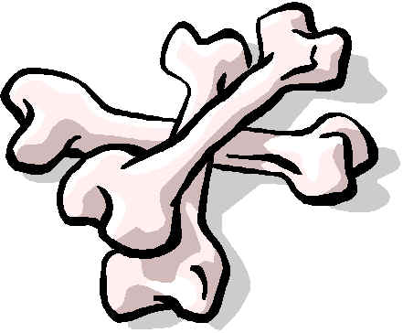 | Our reading from prophets today is the best known chapter in the book of Ezekiel. Maybe people know this passage because of the old African American ‘spiritual’ that tells about “Dem bones, dem bones, dem dry bones.” On the other hand, it may be the best known passage because most of the rest of the book is so outrageous and strange. Some commentators have even suggested that the prophet was suffering from mental illness. Ezekiel is a challenging book, but well worth having a read through if you have never done so, or if you haven’t read it for a while.  In chapter 37 Ezekiel is caught up in the Spirit. In a vision he is transported to a valley. It is the scene of an old battlefield where heavy losses have been suffered. The valley is full of human bones that have been lying out in the hot desert sun. “There were very many… and they were dry.” (Ezekiel 37.2 NRSV). God says to the prophet, “Can these bones come back to life?”  The answer, of course, is - No. No way! Do hens have teeth? Can the Blues win the Super 15?... forget it!  But Ezekiel knows that he is dealing with God… and “impossible” is not how God sees things… so he warily replies, “only you Lord can answer that.”  God tells him to speak to the bones and tell them that they will be wrapped with muscles and skin and God will put his breath into them. (It could be “breath” or “spirit” or “wind” as each of these English words is a valid translation of the word in the text.)  So Ezekiel speaks and while he is still speaking there’s a rattle, rattle… and the bones come together… and muscles and skin cover them… but there is no breath. God instructs Ezekiel to speak again and tell the spirit to enter the bodies. When he does, they come to life, stand up and form a great army.  The last few verses of our reading from the prophet (Ezekiel 37.11-14) give us an interpretation of the vision. A fugitive had arrived among the exiles in Babylon (Ezekiel 33.21) bringing news that Jerusalem had fallen. The nation had, to all appearances perished. Further, Jerusalem was where their faith was centred. Its fall seemed to be a sign that their faith was breaking up. God said that the bones are the people of Israel (Ezekiel 37.11). The people that make up the shattered remains of the nation are prisoners in Babylon who had been in captivity for more than ten years. The hope that they had earlier has now been extinguished. They are like dry bones. “They complain that they are dried up and that they have no hope for the future.” (Ezekiel 37.11). But God responds by telling them that he doesn’t know the word “hopeless” – that he will raise them from death and restore them to their land. “My Spirit will give you breath, and you will live again. I will bring you home, and you will know that I have kept my promise. I, the Lord, have spoken.” (Ezekiel 37.14)  We don’t have to think very hard, on this Pentecost Sunday, to realize that there are applications here for us and our situation.  Can these bones live? What an important question for the church.  When New Zealand Pakeha are exiting the church in unprecedented numbers we ask…  Can these bones live?  When so many church buildings are virtually empty of worshipers…  Can these bones live?  When few of those participating in church life are under fifty years old…  Can these bones live?  When most of the community thinks that the church is simply the pretty building in town that needs to be preserved because it is an historic landmark…  Can these bones live?  Others think of the church as a quaint and dying institution that is locked into a moral code that comes from a past generation…  Can these bones live?  And the gospel, that once was once so full of life and strength, is often stripped of its essence by a cynical liberalism or by a simplistic fundamentalism. What is left is just a pile of dry bones. There is no life left there! There’s no content left – it is like one of those hollow chocolate eggs we have at Easter - we scratch through the surface and there’s nothing inside.  And so, clutching at straws, we are drawn to climb on the latest Christian band wagon. We are told that what we need is emergent worship, missional church, a progressive Christianity, fresh expressions, a decade of evangelism, youth church, a Bible reading challenge, messy church, an ecological project…  All of which may be very good in themselves… but we can be doing them and still be just dry bones.  Can these bones live?  It’s God who asks the question (Ezekiel 37.3). Is there any hope for my people? Is there a prospect of life for my people? It is when the Lord breathes on the bones, when he gives them his Spirit, that they come to life.  For without the life of the Spirit:  - the scriptures and the liturgy are dry as dust  - the most creative worship techniques are just a matter of going through the motions  - our theology is lifeless dogma  - the Christian life is a mere display of respectability  We need the breath of heaven. And God asks, “Can these bones live?”  Ezekiel responds, “only you can answer that.” (Ezekiel 37.3) There is nothing we can do to make ourselves lively Christians. We need the Spirit that God offers to us. And his word to the church this Pentecost Sunday is  to stop striving  and look to him for the resources to bring life and vitality to the church.  The church needs the power from on high.  Can these bones live? What an important question for you and me.  Have you ever felt that your spiritual life is dry?  Or have you ever been in a personal space where you have felt that you’ve lost all grounds for hope? – Where it seems that there is no possibility of recovery or resolution. There is nothing that you can do to make things right. The situation is disastrous, impossible - and you feel powerless.  At such a time we need to hear the message of Ezekiel’s vision. For the coming together of dead bones speaks of a God who can bring life from any situation. It speaks of a God who achieves the impossible. Isn’t that the message that we get from “dem dry bones”? And many people can testify that from personal disaster has come a new closeness to God, new life and a more resolute purpose.  Oh, it may not happen in our way or in our time… and sometimes not even this side of the grave. But we can never be totally disheartened because with God there is always the possibility of new life – even if all he has to work with is dry bones.  Our hope is in the power of the Spirit of God. Here in Ezekiel is one of the few passages in the First Testament from which we can develop a doctrine of the Holy Spirit. Here we meet the Spirit who gives life and strength when all seems to hopelessness and despair  After the service this morning there will be an opportunity to receive prayer – for God’s power to come into your situation – to refresh, to enliven, to create new hope. But be careful – this is God’s Spirit and he doesn’t move to our dictates! He will do things in his way and in his time.  Can these bones live?  “My Spirit will give you breath, and you will live again… I the Lord have spoken. “ (Ezekiel 37.14)
Illustrations / Stories   | The Phoenix  The legends of the phoenix go back hundreds, in fact thousands, of years and come from places as diverse as China, Persia, Egypt and India. The stories vary but they tell of a very large bird like an eagle but with scarlet and gold plumage, a melodious cry and soaring flight.  According to one of the most common forms of the story only one of these birds exists at a time and it lives for 500 years. At the end of its life it makes a nest of aromatic spices and branches. Then it sets fire to the nest and burns itself in the flames until only ashes are left. That is when the miracle occurs. From the ashes a new phoenix arises.  In China it was believed that when the phoenix was seen momentous events were about to occur. (Similarly the rare appearances of the White Heron feature in Maori legend as being a good omen from the spirit world.)  The story of the phoenix features in early Christian art and literature. The appeal of the legend was that they saw in it a parable of the resurrection. New life rises from the ashes.
Music  CMP: Complete Mission Praise  MHB: Methodist Hymn Book  H&P: Hymns and Psalms  S1: The Source  S2: The Source 2  S3: The Source 3  SIS: Scripture in Song  WOV: With One Voice  Ctrl+Click to follow links | Hymns & Songs  Awake, O Lord as in the time of old (A hymn by Church of England parish priest,  Henry Twells 1823-1900 words – tune Chilton foliat WOV 530)  Breathe on me breath of God MHB 300; WOV 320; H&P 280; CMP 67; S1 57  Come and move, Holy Spirit SIS 358  Come down O love divine MHB 273; WOV 310; H&P 281; CMP 89; S1 71  Come gracious Spirit WOV 311  Dem bones dem bones (words below– scoresheet of Gearhart arrangement  available from musicnotes)  Fire of God titanic Spirit (words – tune: Ode to joy)  Holy Spirit come SIS 446  Holy Spirit you are welcome SIS 359; S2 746  O thou who camest from above MHB 386; WOV 486; H&P 745; CMP 525; S1 416  Refresh my heart (Geoff Bullock – words and sheet music available from  musicnotes)  Revive your work O Lord MHB 738; H&P 780; CMP 578  Spirit of the Living God SIS 303; CMP 613; S1 462  The Holy Spirit has come SIS 221  This is the air I breathe S2 1007  To get a touch from the Lord SIS 4  Dem bones, dem bones  Dem bones, dem bones, dem dry bones,  Dem bones, dem bones, dem dry bones,  Dem bones, dem bones, dem dry bones,  Oh, hear the word of the Lord.  ‘Ze-kiel connected dem bones, dem dry bones,  ‘Ze-kiel connected dem bones, dem dry bones,  ‘Ze-kiel connected dem bones, dem dry bones,  Oh hear the word of the Lord.  The toe bone connected to the heel bone,  The heel bone connected to the foot bone,  The foot bone connected to the leg bone,  The leg bone connected to the knee bone,  Oh, hear the word of the Lord.  Dem bones, dem bones, dem dry bones,  Dem bones, dem bones, dem dry bones,  Dem bones, dem bones, dem dry bones,  Oh, hear the word of the Lord.  The knee bone connected to the thigh bone,  The thigh bone connected to the back bone,  The back bone connected to the neck bone,  The neck bone connected to the head bone,  Oh, hear the word of the Lord!  Dem bones, dem bones gonna walk aroun'  Dem bones, dem bones, gonna walk aroun'  Dem bones, dem bones, gonna walk aroun'  Oh, hear the word of the Lord.  Traditional
Prayers  Ctrl+Click to follow link | Call to worship  This is Pentecost Sunday  Listen to the movement of the Holy Spirit in the church  Sense the depths of God  Think thoughts higher than your own thoughts  Pray prayers better than your own prayers  Experience power beyond your own power  Come and praise the Lord  © Andrew Gamman  Collects  Almighty God,  who on the day of Pentecost  sent your Holy Spirit on the disciples  with wind from heaven and with tongues of flame,  filling them with joy and boldness to preach the gospel:  send us out in the power of the same Spirit  to witness to your truth  and draw everyone to the fire of your love;  through Jesus Christ our Lord. Amen.  © The Methodist Worship Book (Peterborough, England: Methodist Publishing House, 1999)  Faithful God,  you fulfilled the promise of Easter  by sending your Holy Spirit  and opening the way of eternal life  to all the human race.  Keep us in the unity of your Spirit,  that every tongue may tell your glory;  through Jesus Christ our Lord,  who is alive and reigns with you,  in the unity of the Holy Spirit,  one God, now and forever. Amen.  © The Methodist Worship Book (Peterborough, England: Methodist Publishing House, 1999)  A prayer calling the Spirit of God  Birth me again, my God,  with the bond of a nurturing nest.  Soak me, my God,  in the purity of the mountain water.  Enthuse me, my God,  with the thrill of canyon courage.  Rattle my complacency, my God,  with the turbulence of rushing waters.  As I breathe the words of prayer,  may the spirit of your light,  be the words of eternal life, Amen.  © John Howell from Longings for the Eternal (Used with permission)  Pentecost  You renew the face of the ground- Psalm 104:30  You guide us into all truth- John 16:13  Grant me, my God, an enquiring mind,  openly searching for all truth,  to understand the ways of creation.  Save me, my God, from a closed mind,  the positional rebuttal,  to protect a myopic view.  Grant me, my God, an empathic feeling,  finding wisdom in relationship,  to gather insights in the ways of the heart.  Save me, my God, from bitterness or hatred,  fear of losing control,  or surrendering to self-centredness.  Guide me, Spirit of truth, a trusting soul,  to renew the face of the ground,  and testify to the good life.  I long for the Spirit of truth,  to be in me.  Amen.  © John Howell (used with permission)  More prayers written in an Australian context by Moira Laidlaw.
Communal  Sharing   | Birthday Basket  Do you have a custom of acknowledging birthdays in your church? It is really significant for children to have their birthdays acknowledged by the worshipping community. We may also want to celebrate with, and pray for, those who are turning 21 or who have one of those special decade birthdays 30, 40, 50, 60 ,70, 80, 90… If someone is still attending at their 100th birthday, I’d give the whole service over to acknowledging them, their history and their faith.  In a smaller church why not acknowledge all birthdays. Ask, “Has anyone had a birthday in the past week?” If they are embarrassed by the question they won’t say anything… but there will also be people who like others to know. Get a basket and fill it with a combination of mini candy bars and knickknacks from the Christian Bookshop (bookmarks, pencils, mini pads etc – you’ll be surprised what you’ll find for a few cents). Get each of the birthday people to help themselves to a small gift.
Children  Ctrl+Click to  follow link   | Tell, or read from a children’s Bible, the story of Ezekiel in the valley of dry bones (Ezekiel 37.1-14). Bring along a balloon (as suggested in sermon4kids link below) as this ties in well with both the Ezekiel and the Acts readings. Without the breath of God the bones were dry and lifeless. Blow up the balloon but don’t tie it off. Hold it up and show that when we are celebrating this is what a balloon should look like. We wouldn’t decorate a room with balloons while they are still deflated and flat!  Let go of the balloon and let it whizz around the room. Explain that when the Holy Spirit gives us life he gets us going and we never know where we’ll end up.  More resources for children from sermons4kids.com
PowerPoint  Ctrl+Click to  follow links | Instant fluency – the record of the Day of Pentecost from Acts 2 in six slides from the Brick Testament.  Valley of dry bones image from deviant art.  Dem bones song on YouTube by Delta Rhythm Boys (traditional); by The Wiggles (children’s) and a cartoon anatomy lesson

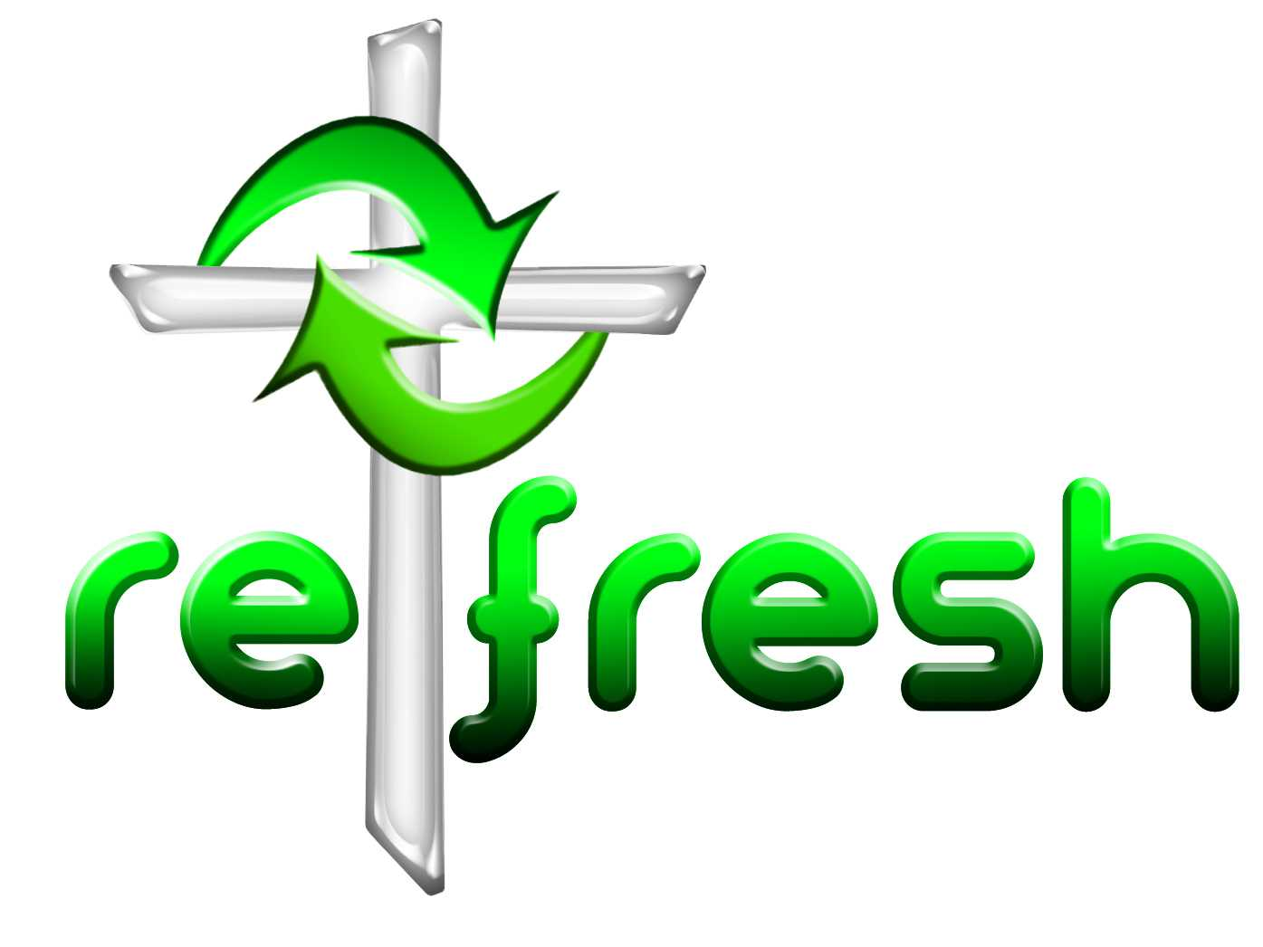
© 10 minutes on a Tuesday is a Refresh Resource. Unless otherwise acknowledged all material is prepared by Andrew Gamman. While every effort has been made to acknowledge source material, if you believe unacknowledged work has been quoted, contact the email address below to request that it be acknowledged or removed. Material included here may be freely used and reproduced for the immediate purpose of worship. Permission must be sought to republish in any form, or to reproduce for commercial gain. If you wish to share the content with others you may do so by linking through the NZ Methodist website. For more information on this and other resources, contact andrew@missionresourcing.org.nz or 09 525 4179 (w)


Mission Resourcing: Inspiring and resourcing our communities for a journey with Christ that enriches lives and relationships

