
Sunday 16 September 2012

Daily Discipleship – Speak Right
Year B - Pentecost 16 - 56B

The Mission of the Methodist Church of New Zealand | Our Church’s mission in Aotearoa / New Zealand is to reflect and proclaim the transforming love of God as revealed in Jesus Christ and declared in the Scriptures. We are empowered by the Holy Spirit to serve God in the world. The Treaty of Waitangi is the covenant establishing our nation on the basis of a power-sharing partnership and will guide how we undertake mission.
Links | Ctrl+Click on the links below to go directly to the text you require  Readings  Introduction  Broader preparation  Creativity  Preaching thoughts  Illustrations  Music  Prayers  Communal sharing  Children  PowerPoint  Bible study
Readings  Ctrl+Click to follow links | Proverbs 1.20-33 Wisdom personified shouts out, warning people to listen to her advice.  Psalm 19 A psalm in praise of the creator God and of his Law. “The heavens keep telling the wonders of God, and the skies declare what he has done.”  James 3.1-12 James talks about the importance of controlling the tongue. It is like a spark that can start a forest fire.  Mark 8.27-38 After Peter declared that Jesus was the Messiah, Jesus told the disciples that he must suffer and die. He then told the crowd and the disciples, “If any of you want to be my followers, you must forget about yourself. You must take up your cross and follow me.”  Season of Creation – 3rd Sunday in Creation - Sky Sunday  Excellent resources for this are to be found on:  - the season of creation website  - and on textweek  - and on the let all creation praise website.  2012 Theme: The Word in creation  Sept 2 1st Sunday in Creation Planet Earth Sunday  Sept 9 2nd Sunday in Creation Humanity Sunday  Sept 16 3rd Sunday in Creation Sky Sunday  Sept 23 4th Sunday in Creation Social Justice Sunday  Sept 30 5th Sunday in Creation Blessing of the Animals  Oct 7 Final Sunday in Creation River Sunday  If you are following the Season of Creation, Mission Resourcing has a few copies of a Faraday Institute DVD and study book called “Test of Faith” that are appropriate for this season and are available to borrow for use with a group in your church. Request a DVD and one study book for the group leader from nehu@missionresourcing.org.nz.
Introduction / Background   | September - The Letter of James  Through the month of September the lectionary readings take us to the little Epistle of James. “10 Minutes on a Tuesday” is following the James readings, looking at “Daily Discipleship” under the headings outlined below:  2 Sept James 1 Pass the test  9 Sept James 2 Act right  16 Sept James 3 Speak right  23 Sept James 4 Be humble  30 Sept James 5 Pray  I suggest that you extend the Bible readings to include all of the chapter each week, so that through the month of September the whole letter is covered.  The body  The terminology that James uses through chapter three is interesting. He repeatedly uses the terms “body” and “member”. On first reading we understand that he is referring to the repercussions that good and bad speech have on an individual. But read through again bearing in mind the Apostle Paul’s talk of the church as the “body of Christ” and us as “members”. Writing after Paul, we would assume that James was familiar with Paul’s letters. With this in mind we now see a message for the church. We are brought face to face with the power that words have in the context of Christian fellowship. Criticism and gossip can have devastating repercussions. On the other hand, an encouraging and affirming environment has enormous attractional power and is a key to church health and life.
Broader / Personal  Preparation  Ctrl+Click to  follow links   | “We who teach”  The introductory words of James chapter three show us that James is particularly concerned about church leaders and the negative influence that they could have. Including himself among those who need to come under rigorous scrutiny, he says, “we who teach will be judged with greater strictness”.  That should give pause for thought for those of us preaching this Sunday! We have been entrusted with the awesome responsibility of correctly representing by our words the gospel of Jesus Christ. But nobody listens only to our words. Our lives also bear an unspoken message. We are required to act in such a way that our lives are a witness to the gospel. We need to pray for help and grace to have actions consistent with our words.  I remember a conversation that brought me to a stark awareness of the responsibility of my ministry role. It was at the end of an eight-year pastorate and I was talking to a young woman who was a regular attender at our church. She had been of school age when I arrived as the new minister all those years before. As we chatted, I became aware that her sole concept of what it meant to be a Christian minister was based on how she had seen me fill the role.  Words – The Bee Gees  This track written by the Bee Gees could be used to introduce the idea of the importance of our words. It was originally written for Cliff Richard, but when he didn’t use it the Bee Gees released it themselves as a mono single in 1968. It then appeared in a poorly mixed stereo version on their 1969 Best of Bee Gees album. Cover versions are found on albums by many other artists including: Elvis Presley, Roy Orbison, Cilla Black and Rita Coolidge.  It’s only words  And words are all I have  To take your heart way.  Read the lyrics Watch on YouTube
Creativity /  Visual Aids  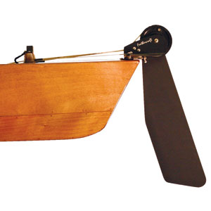    Rudder     | Metaphors  Once again in chapter three James has given us a string of metaphors, any one of which could be used to give a visual cue to lead into our theme today. As in our present day turn of phrase, James uses “the tongue” as a metaphor for the things that we say. From there the other metaphors and similes used for the way that we speak in chapter three are:  - We all stumble  - Controlling our words is like bridling the body  - The tongue, like a bit in a horse’s mouth, guides us  - The tongue, like a rudder on a sailing ship, guides us  - The tongue is like a spark that can start a forest fire  - The tongue can dirty the body  - The tongue can set a life aflame  - Unlike animals and sea creatures the tongue cannot be tamed  - The tongue spreads deadly poison  - Good and bad speech from the same person should not be. It is like clean and dirty water coming from the same spring  - …or like a fig tree producing olives  - …or like a grapevine producing figs  - …or like fresh water from a salt water well  - Peacemakers plant seeds of peace and harvest justice  Choose one of the images above. Is there someone with horses who could loan you a bridle and bit? Maybe there is someone with a small yacht (an opti’ perhaps) who could bring it along, put it at the front of the church, then explain how the rudder works. Failing that you could print out a poison label like the one on the left and stick it on a bucket. Whichever image you choose, print it in your order of service sheet and/ or project it on the screen. Take a moment at the beginning of the service to explain why it is there and how James uses the imagery.
Preaching thoughts and Questions  Ctrl+Click to  follow link  See another approach to today’s reading in the 16 September 2012 sermon on Bill Peddie’s website  CEV = Contemporary English Version of the Bible | It is definitely not something thought of favourably in the twenty-first century, but for many years people liked to be entertained by watching wild animals perform tricks. Crowds would flock to the circus to watch a trainer with a whip coaxing a lion to jump through a hoop. People would take their families to SeaWorld where they could see a trainer gliding through the water while standing on the nose of a killer whale.  Wow!  It seems that we can tame even the largest, wildest and most vicious of animals. But, according to our reading from James, there’s one thing that we can’t tame… and it’s only little. It’s our tongue. Although we can never perfectly control our words, the whole purpose of James chapter three is that we’ve got to try. And it takes real effort, because even when the finest people make their best effort, their tongues get out of control from time to time.  James is a very practical letter. It is full of instructions on how to live given in an imperative mood. Today he tells us to…  Be truthful  Our tongues “boast about big things” says James (James 3.5). They do. We want people to think well of us and it is so easy to bend the truth a little to our own advantage. We exaggerate the experiences that we’ve had as well as the influence we have over others.  When the newspapers report on high profile CEOs who have been caught out exaggerating their qualifications in their CVs we smile at their foolishness. But, at heart, we also like to inflate the ideas that others have of us. It’s easy to embellish a story here and there for selfish advantage… and then if someone cross-examines us we get caught in the trap of having to tell lies to cover our lies.  The deception inherent in the much-used saying “the end justifies the means” has often led to an erosion of truthfulness. It even comes out in our presentation of the gospel. We can present an easy “believism” that leaves the impression that Jesus will take all our troubles away. Of course, there is an element of truth in that. But that’s the problem. It is only an element of truth. The whole truth turns out to be something more like: our faith in Jesus gives us strength to endure the most trying of circumstances.  When we want to fit in, it is easy to create a false persona to win the admiration of those around us. Clergy often experience this when they engage in a conversation with stranger. One moment the person they are talking to is swearing like a trooper. When, in the course of conversation, the curser becomes aware they are talking with a minister the language all of a sudden becomes cherub-like and the conversation may even change to their own church involvement.  Sadly, one of the repercussions of deceiving others with our words is that we assume others do the same, and inadvertently destroy our own ability to trust. So James says “if you can control your tongue, you are mature and able to control your whole body” (James 3.2 CEV). To do that we need to…  Be self controlled  “By putting a bit into the mouth of a horse, we can turn the horse in different directions. It takes strong winds to move a large sailing ship, but the captain uses only a small rudder to make it go in any direction.” (James 3.3-4)  The interesting thing about both a ship’s rudder and a bit in a horse’s mouth is that both of these relatively small things control strong forces that could cause motion in the wrong direction. The rudder stops the wind taking a sailing ship wherever it blows, and the bit stops the horse running off any direction it pleases. Just like the rudder and the bit, our words can steer our whole lives.  If we say, “I’m no good, I couldn’t do that” – the chances are we won’t do it, and our words will be fulfilled.  But if we say, “I think I can. I’d like to help” – the chances are we’ll give it a go, and we’ll make ourselves into helpful people, who are sought after by others and useful to God.  Even the smallest of comments can steer a life around and have huge repercussions. A flippant remark, a word that slips out in the heat of the moment - these things can be dangerous. That goes for silly talk too. When we are fooling around, an ill-advised jest can have enormous consequences. We make an impression on others by our idle chatter, and can then be trapped by the reputation that we create for ourselves.  Words that never should have been spoken can divide people into camps and set them in opposition to one another. And we are all aware of the negative power of criticism. Even in church life, criticism has been known to scar, and maim, and literally make people sick. So it is that we are called to be self controlled and…  Be encouraging  James leaves us in no doubt about the fact that our words are powerful. We form them and control them until they reach our lips. Then they have a life of their own, and can create or destroy. They can touch the inner-most parts of a person. They can annoy, or gladden or comfort.  And words bring change. They change people, they change situations and they change nations. So it is that we are exhorted to use our words to affirm, heal, encourage, soothe, appreciate, edify, forgive, recognise and reinforce.  The writer to the Hebrews puts it this way, “You must encourage one another each day” (Hebrews 3.13). You see encouraging one another is so easy for all of us to do, and it has such a powerful impact.  This is where we, as the church, can have such a large influence, because the world is full of discouragers. It is not hard to pour cold water on the ideas of others - but we, God’s people, are called to be encouragers.  Once we create an environment where the norm is to encourage, our fellowship becomes attractive and draws people in.  Last week, we saw how James explained that our faith has to be matched by our works. Today he says that our faith must be matched by our words. Let us determine to guard our words and use them to encourage one another.
Illustrations / Stories  Ctrl+Click to follow links  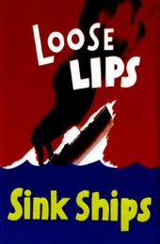 | Forest fires  As I write this a state of emergency has been declared in the Balkans where a heat wave has fuelled forest fires. Forest fires are often caused naturally by lightning strikes when the forest is tinder dry. Sadly, sometimes they are also deliberately lit by arsonists. And then there are those that are started by people because of their carelessness. Sometimes a camp fire can get out of control. Investigators found that one of the largest forest fires in Canadian history was started by a discarded cigarette butt.  James says, “It only takes a spark to start a forest fire. The tongue is like a spark”  (James 3.5-6). A short angry outburst can destroy a relationship of trust that has taken years to built.  Loose lips sink ships.  During World War II the American propaganda machine produced the “loose lips sink ships” slogan and poster. The idea was to advise servicemen and their families of the dire consequences that could result from any careless talk that included information helpful to the enemy. If a spy was to overhear a shipping schedule, the ships mentioned may be intercepted and sunk. It was a warning about the use of the tongue, and a reminder that a comment that we may think is harmless can have a powerful or disastrous effect.  The English equivalent of the American poster depicted a beautiful, reclining blonde with the slogan, “Keep mum she’s not so dumb – careless talk costs lives.”  General Rules  The General Rules of the Methodist Church were formulated by John Wesley for his United Societies in 1743. The first rule was to do no harm, and included the advice to avoid:  “Uncharitable or unprofitable conversation; particularly speaking evil of magistrates or of ministers.”
Music  AA: Alleluia Aotearoa  CMP: Complete Mission Praise  HIOS: Hope is our Song  FFS: Faith Forever Singing  MHB: Methodist Hymn Book  H&P: Hymns and Psalms  S1: The Source  S2: The Source 2  S3: The Source 3  S4: The Source 4  SIS: Scripture in Song  WHV: With heart and Voice  WOV: With One Voice | Hymns & Songs  Be thou my vision, O Lord of my heart MHB 632; WOV 455; H&P 378; CMP 51;  S1 50  Father hear the prayer we offer WOV 510; H&P 436  Father lead me day by day MHB 849; H&P 790  God be in my head MHB 405; WOV 456; H&P 694  Happy is the one that finds the grace MHB 360  I need you every hour MHB 475; H&P 524  Jesus with your church abide MHB 727  Let the words of my mouth SIS 124  Look in wonder HIOS 93  Lord, speak to me that I may speak H&P 553; CMP 444  Lord, make me an instrument SIS 196; CMP 437  Make me a captive Lord MHB 596; WOV 528; H&P 714  Make me a channel of your peace CMP 456; S1 348  O God of earth and altar WOV 542; H&P 426  O Lord my God, when I in awesome wonder CMP 506; S1 396  Take my life MHB 400; WOV 520; H&P 705; CMP 624; S1 468  The heavens declare the glory of God CMP 648;  The heavens declare your glory MHB 802; WOV 330; H&P 481  The heavens shall declare S1 480  Where the love of God is guiding FFS 76  Wisdom be our guide HIOS 156
Prayers  Ctrl+Click to follow link | Collects  Restoring my sight Psalm 19:1 (also Rom 1:20); Mark 8:25  Creating God,  Open my mind to see clearly.  Lift my eyes to the heavens.  I gaze at the stars,  the forming of galaxies,  the vast space  and see your creative art.  Creating God,  move me to a new perspective,  and heal my vision,  Amen.  © John Howell (used with permission)  God, our Redeemer,  who called your Church to witness  that you were in Christ  reconciling the world to yourself:  help us to so proclaim the good news of your love  that all who hear it may be reconciled to you;  through Jesus Christ our Lord. Amen.  © The Methodist Worship Book (Peterborough, England: Methodist Publishing House, 1999)  General Confession  Almighty and merciful God,  Father of our Lord Jesus Christ,  we confess that we have sinned against you  and against our neighbour.  We have sinned in thought, word and deed,  through negligence, through weakness,  through our own deliberate fault.  We have not loved you with our whole heart.  We have not loved our neighbours as ourselves.  We are truly sorry  and repent of all our sins.  For the sake of your Son, Jesus Christ,  who died for us,  in your mercy forgive us all that is past  and grant that we may serve you in newness of life  to the glory of your name.  Help us to amend what we are,  and direct what we shall be;  that we may do justly,  love mercy,  and walk humbly with you, our God.  Amen  Psalm 19  The heavens proclaim the glory of God.  The skies display his craftsmanship.  Day after day they continue to speak;  night after night they make him known.  They speak without a sound or word;  their voice is never heard.  Yet their message has gone throughout the earth,  and their words to all the world.  God has made a home in the heavens for the sun.  It bursts forth like a radiant bridegroom after his wedding.  It rejoices like a great athlete eager to run the race.  The sun rises at one end of the heavens  and follows its course to the other end.  Nothing can hide from its heat.  The instructions of the Lord are perfect,  reviving the soul.  The decrees of the Lord are trustworthy,  making wise the simple.  The commandments of the Lord are right,  bringing joy to the heart.  The commands of the Lord are clear,  giving insight for living.  Reverence for the Lord is pure,  lasting forever.  The laws of the Lord are true;  each one is fair.  They are more desirable than gold,  even the finest gold.  They are sweeter than honey,  even honey dripping from the comb.  They are a warning to your servant,  a great reward for those who obey them.  How can I know all the sins lurking in my heart?  Cleanse me from these hidden faults.  Keep your servant from deliberate sins!  Don’t let them control me.  Then I will be free of guilt  and innocent of great sin.  May the words of my mouth  and the meditation of my heart  be pleasing to you,  O Lord, my rock and my redeemer.  New Living Translation (NLT) Holy Bible. New Living Translation copyright © 1996, 2004, 2007 by Tyndale House Foundation  More prayers written in an Australian context by Moira Laidlaw.
Communal  Sharing   | Public speaking workshop  Get someone with experience in public speaking (your Presbyter perhaps) to run a public speaking workshop at the church. Encourage those interested in participating in the worship services, giving readings or leading prayers, to attend. Advertise it to the wider community as well. Cover such things as over-coming nerves, use of microphones, voice projection, speaking at an appropriate volume and speed.  If you’d like a more detailed outline of what you could include, contact me at the email address below.
Children  Ctrl+Click to  follow link  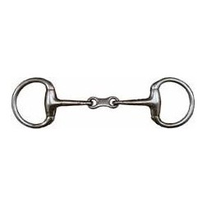 | A bit in a horse’s mouth  If you have a horse-owner in your congregation get them to bring along a bride and a bit and explain to the children how they work. Otherwise print off a picture of a bit and explain to the children…  Many thousands of years ago people started to tame wild horses. They learned very early on that, if they could control the horse’s lower jaw, they could control the horse’s head. By controlling the head they could direct the body.  A bit is usually made of metal (like the one on the left) and is placed in the horse’s mouth, in an area that has no teeth. The bit is attached to the head through the animals’ bridle. From there the reins go to the rider. The horse will seek to avoid discomfort and so responds to the control of the rider.  Read from James 3.3,5.  By putting a bit into the mouth of a horse, we can turn the horse in different directions. Our tongues are small too, and yet they brag about big things.  James is saying that by controlling what we say, we can control the whole direction of our lives. If we try hard to always say things that are true, we will get a reputation for being an honest person. However, if we are prone to telling lies we get a reputation for being a deceitful person. If we are always saying encouraging things to people, we will attract positive people around us. However, if we are always pointing out the faults of others we will attract negative people around us. By saying good things we turn the whole of our lives in a good direction.  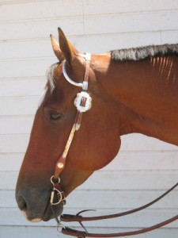  Riding, it is said, is the simple art of keeping a horse between you and the ground!  More resources for children from sermons4kids.com
PowerPoint | Many images are suggested by the reading. Google images for:  - Horse and bridle  - Sailing ship  - Tamed animal  - Forest fire  - Deadly poison
Bible Study   | Read through James chapter 3 then pose these questions to your study group:  - What famous speeches can you think of that have had an influence on history?  - What made them influential? The content? The context? The speaker? The style of delivery?  - “We need to tell the truth but not all truth needs to be told.” Can you think of times when it is best not to say something even though it is true?  - What’s the best thing to do if you feel hurt by someone’s comments?  - What’s the best thing to do if you think you have hurt someone by your own comments?  - If a person has taken a Bible reading in your church for the first time and stumbled over the words, what could you say that would be an encouragement?  - Is our church fellowship an encouraging environment to bring people into? What can we do to make it more encouraging?

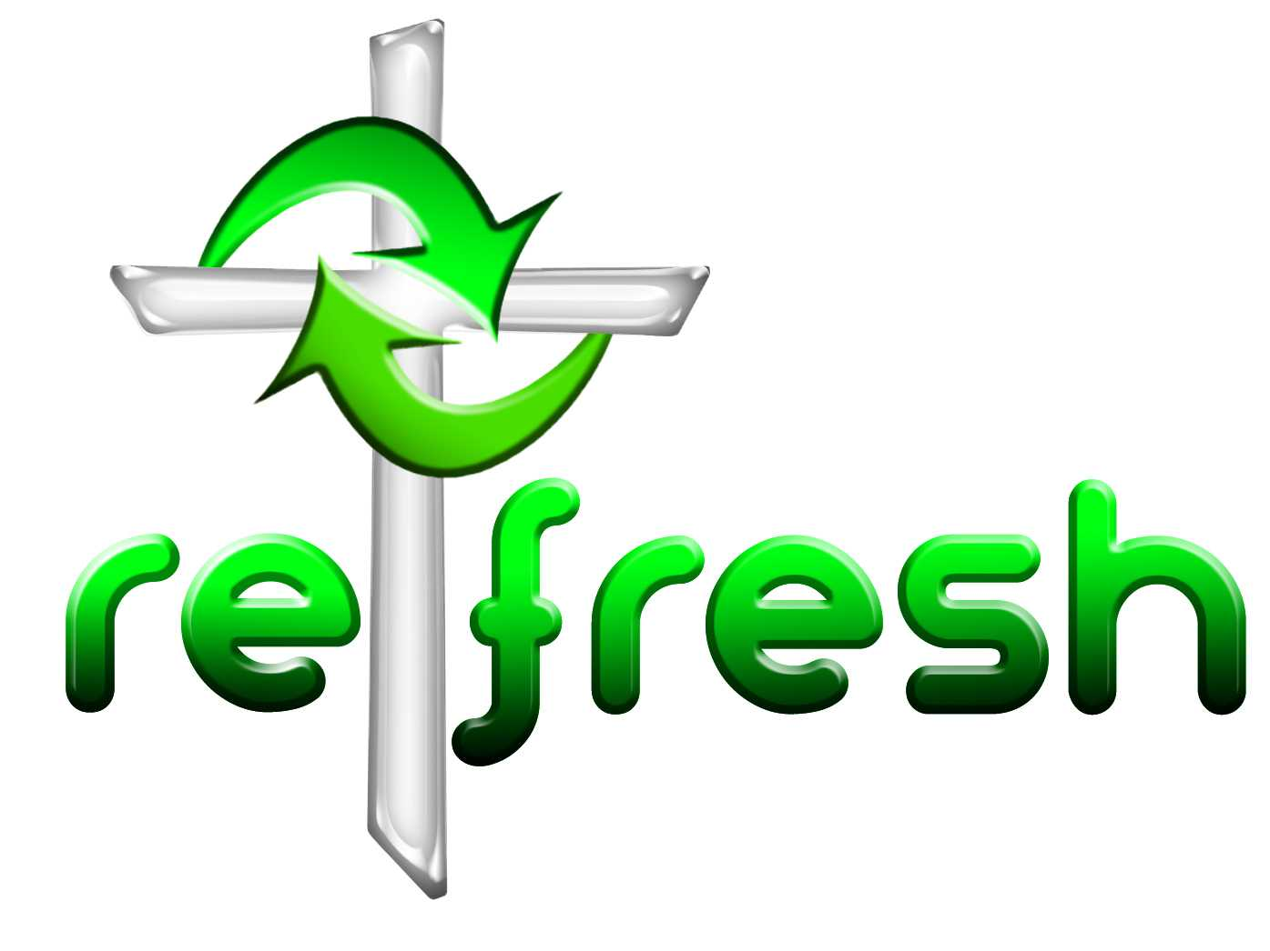
© 10 minutes on a Tuesday is a Refresh Resource. Unless otherwise acknowledged all material is prepared by Andrew Gamman. While every effort has been made to acknowledge source material, if you believe unacknowledged work has been quoted, contact the email address below to request that it be acknowledged or removed. Material included here may be freely used and reproduced for the immediate purpose of worship. Permission must be sought to republish in any form, or to reproduce for commercial gain. If you wish to share the content with others you may do so by linking through the NZ Methodist website. For more information on this and other resources, contact andrew@missionresourcing.org.nz or 09 525 4179 (w)


Mission Resourcing: Inspiring and resourcing our communities for a journey with Christ that enriches lives and relationships

