
Sunday 19 June 2011

Community
Year A - Trinity - 40A

The Mission of the Methodist Church of New Zealand | Our Church’s mission in Aotearoa / New Zealand is to reflect and proclaim the transforming love of God as revealed in Jesus Christ and declared in the Scriptures. We are empowered by the Holy Spirit to serve God in the world. The Treaty of Waitangi is the covenant establishing our nation on the basis of a power-sharing partnership and will guide how we undertake mission.
Links | Ctrl+Click on the links below to go directly to the text you require  Readings  Introduction  Broader preparation  Creativity  Preaching thoughts  Illustrations  Music  Prayers  Children  PowerPoint
Readings  Ctrl+Click to follow links | Genesis 1.1-2.4a The first Genesis account of creation, beginning with light on  day one and ending with humans in day six. On day seven God rested.  Psalm 8 A psalm by David in praise of the Lord, who is ruler and whose name is  wonderful.  2 Corinthians 13.11-13 Paul signs off his letter to the Corinthians with a final  greeting and a Trinitarian blessing.  Matthew 28.16-20 Jesus commissions his disciples to go to the people of all  nations to make disciples, baptise them in the name of the Father, Son and Holy  Spirit and teach them his commandments.  Disability Awareness Sunday  The third Sunday in June is celebrated as Disability Awareness Sunday. The  Christian Ministries for the Disabled Trust has a downloadable booklet full of ideas to include in your service.
Introduction / Summary | Embracing the mystery  Today is Trinity Sunday and I must admit that I have spent most of my ministry career trying to duck out of the way of having the Trinity as a preaching topic. It’s just not straight-forward.  So, it is important to avoid giving the impression that there is an easy way to understand the Trinity. All the easy approaches point away from God, not toward him. While we can easily understand that ice, water and steam are three different forms of H2O, this doesn’t help to explain the nature of God. It certainly doesn’t fit with the biblical picture of God the Son praying to God the Father. Any system that seeks to understand the persons of the Trinity as God wearing different hats is a form of ‘modalism’, which the Christian tradition has always rejected.  However, we can’t help it. We want to put God in a box; in a neat package that we can get a handle on. But God is too big for that. If he could be tied down, he just wouldn’t be God. The church, of course, has sought to define exactly what God is like. From the third century, believing in a God of “one substance” and “three persons” has been a test of Christian orthodoxy. But really that doesn’t help us too much because we are left to puzzle over what the word “person” means in this context and what “substance” means.  What we are left with is a profound mystery - and this is a very good thing. The three persons in one God represented by the term “Trinity” defy our ability to tie God down. God is transcendent, and this is just what draws us to him. It is part of the glorious wonder of God that, to us, he is incomprehensible. It is a mystery to be enthusiastically embraced!
Broader / Personal  Preparation | The Shack  After not being able to find a publisher, Christian author William P Young self-published this novel in 2007. It went on to be a best-selling US paperback with over 12 million copies sold. Like Alice Sebold’s Lovely Bones the plot revolves around a child murder. Unlike Lovely Bones the book’s main character, the father of the murdered child, gets to talk with the Trinitarian God about all that is troubling him.  Now, if the idea of God the Father taking the form of an Afro-American woman and the Holy Spirit manifesting himself as an Asian woman is going to upset you you’d better avoid this book. However, it’s a novel not a theology book, and read this way it has some profound and delightful things to say. One of the enduring pictures that the reader is left with is of the loving relationship between the persons of the Trinity.  While the book has received more than its share of nit-picking criticism from other Christian authors, Eugene Peterson writes, "this book has the potential to do for our generation what John Bunyan's Pilgrim's Progress did for his."
Creativity /  Visual Aids     | Three different hats  Bring along three different hats to represent three different roles you might have. Now try to have a conversation with yourself wearing a different hat for each role you are playing.  Role 1: Father (or Mother)  Role 2: Son (or Daughter)  Role 3: Friend  Choose a topic to start your conversation with yourself: How’s the homework going? What’s for dinner? or What are you going to do today?… and try to have your conversation.  Why is this a tricky conversation to have?  Some people have the idea that God wears different hats. The hats solution is also a form of modalism.  The idea of roles as the explanation for the Trinity sometimes surfaces in the suggestion that there is one God, who in the First Testament appears as Father, in the New Testament as Son and in the present age as Spirit. Father, Son and Spirit are appearances only. They are not who God is.  The trouble with this and similar ideas is that in the end God has not been revealed. What has been revealed are appearances (or modes) but the real God remains behind these, hidden and unknown.  The Christian claim, however, is that in Jesus Christ, God has been revealed. Hence the Trinity. God really is Father, Son and Holy Spirit.
Preaching thoughts and Questions        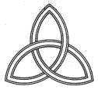    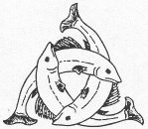  Ctrl+Click to follow link | The Trinity shows God in relationship  Today is Trinity Sunday. It is actually the only Sunday in the year that the lectionary brings our focus more on a doctrine of the church than on a particular scriptural passage. However, the Holy Trinity is a doctrine that is picked up by all our Bible readings today so we do remain anchored in scripture.  Well, you may think, you’d rather leave theology to the scholars and just try and live as a good Christian. But the truth is that we all have developed our own theological systems. Theology is just our thinking about God. We all think about God, so we each have our own theology. Because our beliefs affect the way we live, it is good to examine them from time to time… Which brings us back to the Trinity.  Now “Trinity” is not a word that we find in the Bible. We do however read in the Bible that God exists as Father, Son and Holy Spirit. The Creed of Nicea in 325 established the doctrine of the Trinity as the orthodox Christian belief about God. On the right is the traditional Christian visual symbol to express this. (Can you project this or reproduce it in your newsletter? You may want to also include the symbols of the Trinity in the left margin. The website below will give you a brief explanation of each.) God is three “persons”: Father, Son and Holy Spirit, but one in “essence”. Yes, there is something rather paradoxical and beyond our reach about that statement and this is part of the mystery of God.  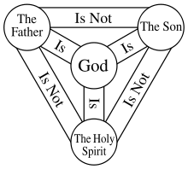  If we find it hard to define what it is to be human, it is not surprising that we meet with difficulties in explaining God. What we can understand is that the Father, Son and Holy Spirit are in a dynamic loving relationship. We see this three way relationship in action at the baptism of Jesus when the Spirit descended on the Son and the voice of the Father proclaimed, "You are my own dear Son, and I am pleased with you." (Mark 1.11)  Hear the Trinity call us into community  In our reading from the Psalms today David asks God, "Why do you care about us humans? Why are you concerned for us weaklings?" Then he reflects, “You made us a little lower than you yourself, and you have crowned us with glory and honour.” (Psalm 8.4-5) Then, in today’s reading from Genesis, the writer says that God created humans and “they will be like us.” (Genesis 1.27) Just as God is God-in-relationship, we are called to be in relationship. We are called into relationship with God and with one another. This call is the essence of salvation. Through the Spirit we become drawn into the dynamic love relationship that exists in the Trinitarian God and participate in the life of God. We become family: children of God and brothers and sisters with one another. The new community that is formed is the demonstration of God’s salvation.  This is what the church is all about. The church is essentially relationship rather than institution. When we hear the word “church” we should not be thinking first of all of buildings and clergy. This is important because for many in the twenty first century “institution” is seen as a negative word. Of course we need some structure, but it’s all a matter of where we put our emphasis. How institutional is our church? We get some idea by looking at our church budget. Relationship and community are concerned with words like justice and mercy and mission and fellowship and worship. Institution is concerned with words like buildings and structures and hierarchy.  In conclusion, we get it wrong when we think of our faith as a personal matter; only between God and me. The life of God is seen and experienced in community. This gives us cause to rethink what we say about the church. Church is not something just go to on Sunday. The church is the community that draws us into the life of the Trinitarian God. Because of this the church is God’s hope for the world. Can you hear the call of the Trinity drawing us into community?
Illustrations / Stories | Who do people say that I am?  Jesus asked them, “What do people say about the Son of man?”  The disciples answered, "Some people say you are John the Baptist or maybe Elijah or Jeremiah or some other prophet."  Then Jesus asked them, "But who do you say I am?"  Peter answered and said, “You are the same perfect in Godhead and also perfect in manhood; truly God and truly man, of a reasonable soul and body; consubstantial with the Father according to the Godhead, and consubstantial with us according to the Manhood; in all things like unto us, without sin; begotten before all ages of the Father according to the Godhead, and in these latter days, for us and for our salvation, born of the Virgin Mary, the Mother of God, according to the Manhood; one and the same Christ, Son, Lord, only begotten, to be acknowledged in two natures, inconfusedly, unchangeably, indivisibly, inseparably; the distinction of natures being by no means taken away by the union, but rather the property of each nature being preserved, and concurring in one Person and one Subsistence, not parted or divided into two persons, but one and the same Son, and only begotten God, the Word, the Lord Jesus Christ.”  And Jesus said, “What?”  (The words put into Peter’s mouth come from the Chalcedonian creed of 451. Generation X and Ys should get this immediately, others may have to be reminded that it is a little tongue-in-cheek)  Mother Church  In the literature of the early Christians, the church is often depicted as mother. The image of Mother Church picks up the idea of community and relationship. Through the church we are birthed into a family.
Music  AA: Alleluia Aotearoa  CMP: Complete Mission Praise  HIOS: Hope is our Song  FFS: Faith Forever Singing  MHB: Methodist Hymn Book  H&P: Hymns and Psalms  S1: The Source  S2: The Source 2  S3: The Source 3  SIS: Scripture in Song  WHV: With heart and Voice  WOV: With One Voice | Hymns & Songs  Father I thank you SIS 269  Father we adore you SIS 174; CMP 139  Father we love you SIS 451; CMP 142; S1 103  For the beauty of the earth MHB 35; WOV 77; H&P 333; CMP 152  Give to our God immortal praise WOV 43; H&P 22; CMP 171  God be in around above me HIOS 36  Great ring of light AA 57  Holy, holy, holy MHB 36; WOV 65; H&P 7; CMP 237; S1 177  I sing the grace HIOS 68  Lead us heavenly Father, lead us MHB 611; WOV 492; H&P 68; CMP 400;  S1 311  Maker of mystery FFS 47  May the grace of Christ our Saviour WOV 373; H&P 762  May the grace of our Lord Jesus Christ SIS 247  Meekness and majesty CMP 465; S1 353  There is a redeemer SIS 644; CMP 673; S1 492  We believe in God the Father SIS 654; CMP 720; S1 541  We give immortal praise MHB 40, WOV 38  You servants of God MHB 426; WOV 144; H&P 278; CMP 784; S2 1074
Prayers  Ctrl+Click to  follow link | A winter call to worship  Come: now is the time to worship!  Rejoice!  Outside it’s bleak and cold  here in the house of God  is warmth of human company,  shared memories,  united hopes  Outside winter is battering on our rooftop:  but the architects, the planners the builders and the labourers  have done their job well,  and we are warm and snug  Outside is a world we will go back out to soon,  warmed and encouraged  by reminders of God’s grace in the lives of those we love  The rest of today and the week, the month and the year lie ahead still:  maybe with warmth, maybe with cold and difficulties  But we are now and here: here and now is the time to worship…  We can listen to rain on the roof:  or we can listen for the mercies of God  We can remember places we missed God’s mark  or we can reach out anew for overflowing love  We can think how cold it is  when we move from the fire at the centre of God’s heart  Or we can decide to come closer,  to choose love,  to say and do and think and live  the ways that Jesus showed us.  We could have stayed home:  Toasty and roasty, insulated isolated, warmed and woollied  But we came to be warmed inside  Oh yes: it‘s cold outside:  and here and now is the time to worship!  © Alan K Webster (used with permission)  Collect  Father God,  you have created all things  and through Christ revealed your salvation  in all the world.  Give us a vision of your glory  and by your Holy Spirit fill us with life and love  that we may praise and serve you  through Jesus Christ our Lord,  who is alive and reigns with you,  in the unity of the Holy Spirit,  one God, for ever and ever. Amen.  © The Methodist Worship Book (Peterborough, England: Methodist Publishing House, 1999)  Nicene Creed  We believe in one God, the Father, the Almighty,  maker of heaven and earth,  and all that is seen and unseen.  We believe in one Lord, Jesus Christ,  the only Son of God, eternally begotten of the Father,  God from God, Light from Light,  true God from true God,  begotten, not made, one in Being with the Father.  Through him all things were made.  For us men and for our salvation  he came down from heaven:  by the power of the Holy Spirit  he was born of the Virgin Mary,  and became man.  For our sake he was crucified under Pontius Pilate;  he suffered, died, and was buried.  On the third day he rose again  in fulfillment of the Scriptures;  he ascended into heaven  and is seated at the right hand of the Father.  He will come again in glory  to judge the living and the dead,  and His kingdom will have no end.  We believe in the Holy Spirit,  the Lord, the giver of life,  who proceeds from the Father and the Son.  With the Father and the Son  he is worshiped and glorified.  He has spoken through the Prophets.  We believe in one holy catholic and apostolic Church.  We acknowledge one baptism for the forgiveness of sins.  We look for the resurrection of the dead,  and the life of the world to come.  Amen.  Psalm 8  O Lord, our Lord, your majestic name fills the earth!  Your glory is higher than the heavens.  You have taught children and infants  to tell of your strength,  silencing your enemies  and all who oppose you.  When I look at the night sky and see the work of your fingers—  the moon and the stars you set in place—  what are mere mortals that you should think about them,  human beings that you should care for them?  Yet you made them only a little lower than God  and crowned them with glory and honour.  You gave them charge of everything you made,  putting all things under their authority—  the flocks and the herds  and all the wild animals,  the birds in the sky, the fish in the sea,  and everything that swims the ocean currents.  O Lord, our Lord, your majestic name fills the earth!  New Living Translation (NLT) copyright© 1996, 2004, 2007 by Tyndale House Foundation  Benedictions  The grace of the Lord Jesus Christ  the love of God  and the fellowship of the Holy Spirit  are with you now  and will be evermore.  The peace of God which passes all understanding,  keep your hearts and minds  in the knowledge and love of God,  and of his Son Jesus Christ, our Lord;  and the blessing of God almighty,  the Father, the Son and the Holy Spirit,  be upon you and remain with you always. Amen.  More prayers written in an Australian context by Moira Laidlaw.
Children  Ctrl+Click to  follow link   | Unfortunately, there are any number of explanations of the Trinity that have been written for children:  The Trinity is like an apple - skin, flesh and pips  The Trinity is like an egg - fried, boiled and scrambled  The Trinity is like water - frozen, liquid and steam  The Trinity is like your dad – to you he is dad, to your grandad he is son, and  to your mum he is husband  The thing that most of them, including all of the above, have in common is that they lead children ‘down the garden path’ and leave them with an unhelpful and incorrect view of God. Some adults never escape from these pictures. Better to talk about a mystery. Children like a mystery, and here is a mystery so great that no-one can solve it!  Shooting rubber bands at the stars 1  Bring a bag of rubber bands and show the children how to shoot them off their thumbs. Get them to shoot them straight up in the air. (You don’t want them to shoot at one another!) See who can go the highest. Can anyone get theirs to touch the ceiling?  What if we went outside and tried to shoot the rubber bands at the sun? How do you think you would do? They might seem to go high when we shoot rubber bands inside, but if we try to get one to reach the stars it will fall a long way short.  This is a bit like talking about God. We can try to understand God, but all the things we think and say about him fall far short of what God is really like.  According to the Bible God is three persons: Father, Son and Holy Spirit. Jesus is God-with-us, the Father is God-above-us and the Holy Spirit is God-in-us. 2  Jesus shows us what God is like. So the best way we can understand God is to know about Jesus and what he did. He said “If you have seen me you have seen the Father.” (John 14.9)  1 Shooting rubberbands at the stars is the title of the 1988 debut album of Edie Brickell & New Bohemians.  2 This description of the Trinity comes from Brian K Smith, Who made God? And other tricky questions (available  from Kereru Publishing).
PowerPoint  Ctrl+Click to  follow links | The Holy Trinity Church in Amblecote, England has a website with a page dedicated to symbols for the Holy Trinity.  This ancient orthodox icon of the Holy Trinity should be good to generate some discussion.

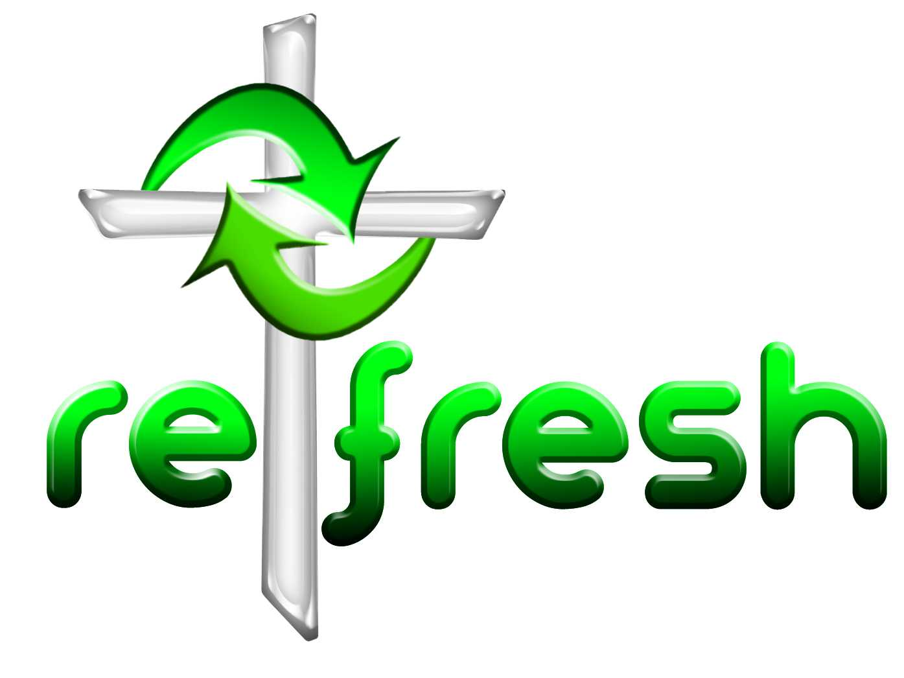
© 10 minutes on a Tuesday is a Refresh Resource. Unless otherwise acknowledged all material is prepared by Andrew Gamman. While every effort has been made to acknowledge source material, if you believe unacknowledged work has been quoted, contact the email address below to request that it be acknowledged or removed. Material included here may be freely used and reproduced for the immediate purpose of worship. Permission must be sought to republish in any form, or to reproduce for commercial gain. If you wish to share the content with others you may do so by linking through the NZ Methodist website. For more information on this and other resources, contact andrew@missionresourcing.org.nz or 09 525 4179 (w)


Mission Resourcing: Inspiring and resourcing our communities for a journey with Christ that enriches lives and relationships

