
Sunday 30 May 2010

Trinity Sunday
Year C – Trinity - 40C

The Mission of the Methodist Church of New Zealand | Our Church’s mission in Aotearoa / New Zealand is to reflect and proclaim the transforming love of God as revealed in Jesus Christ and declared in the Scriptures. We are empowered by the Holy Spirit to serve God in the world. The Treaty of Waitangi is the covenant establishing our nation on the basis of a power-sharing partnership and will guide how we undertake mission.
Links | Ctrl+Click on the links below to go directly to the text you require  Readings  Introduction  Broader Preparation  Creativity  Preaching thoughts  Illustrations  Music  Nicene creed  Children  PowerPoint
Readings  Ctrl+Click to follow links | Psalm 8 This Psalm celebrates the Creator God who “is mindful of us” as an important part of creation.  Proverbs 8:1-4, 22-31 An interesting passage that personifies “Wisdom” and has hints of John 1 where Jesus is described as the Word, involved in creation.  Romans 5:1-5 A Trinitarian passage that describes Jesus’ role in putting us right with God, and God pouring love into our hearts by the Holy Spirit.  John 16:12-15 In these few verses we catch a glimpse of the Trinity, especially in verse 15.
Introduction / Summary | The concept of Trinity is problematic for many people and for many different reasons. Some argue that it is not biblical, while others feel it does not describe the God we have come to know. For many it is too masculine while for others it lies at the heart of our worship and tradition: “In the name of the Father, and of the Son…” However, we cannot avoid dealing with the theme as it is an important part of who we are, and some leadership from the pulpit is important, even if it is to affirm the mystery of God and the journey of unfolding faith.
Broader Preparation | If you have time, take some coloured pens/pencils and “draw God.” What does your drawing tell you? What does it say about your understanding of Trinity? Which part of the Trinity is most clearly represented in what you have drawn?  How do I feel about that ancient refrain: “In the name of the Father, and of the Son, and of the Holy Spirit. Amen.” What do these feelings tell me about my experience of Trinity?
Creativity /  Visual Aids  Ctrl+Click to follow link | Use the Nicene Creed (below) to affirm our “traditional” faith, and then go on to explore the mystery of God in a brief meditation that invites people to reflect on what it means for God to hide from us (Isaiah 45:15). Something like…  That creed describes what we believe, but how can we really know what God is like, when God hides from us. Who can even begin to describe the indescribable, imagine the unimaginable? Who can offer insight to an invisible Creator, or define the mystery of an eternal, spiritual being? Who can understand the presence of the Spirit in every believer’s life, or reveal the full truth of the Incarnation, as God became flesh? We believe without understanding. We hope without certainty. We hold onto a God who cannot be grasped and follow a God who cannot be seen. We are people of faith and without faith, who believe without yet believing. We are a people of certainty who believe in a God of mystery. So be it.
Preaching thoughts and Questions | When we are confronted with suffering we often ask the question, “Why?” Answers are often hard to come by, and there are some things we may never understand. Perhaps the doctrine of the Trinity and the nature of God is one of those things. When we look around the church we see a huge variety of understandings of who God is. Clearly there is no one clear, indisputable truth in this regard. We have to settle with God being a mystery, something that God may have deliberately chosen to have happen: “I am a God who hides Himself.” (Isaiah 45:15). In a strange way, mystery is at the heart of faith. When we discover a truth we gain knowledge, but when we live with something that cannot be proved or even fully defined we are left with, “I have seen enough to believe…” Like Peter and John at the resurrection we see and believe but do not understand (John 20:8,9).  Mystery also invites us into relationship with God rather than entering into some clearly defined religion. In the same way that we get to know our partners, or children, we never fully “know” them. They are a mystery. There is more to discover, more to love, more to learn to accept. And there are things we will never understand. But we learn to trust them, enjoy them – the relationship we have is more important than what we know or don’t understand, about them.  Both these elements remind us that mystery is good. It invites us deeper despite our limited understanding. It turns dogma to faith and religion to unfolding relationship. In the end I can only bring as much of myself as I can to as much of God as I understand. God is one, God is three, God is neither one nor three… who knows? Let the mystery unfold and draw us deeper…  Trinity Sunday gives the opportunity for preachers to approach the theme of who God is in different ways:  - One could try and explain the nature of God as One-in-Three and Three-in-One using images like water (ice, liquid, steam) or eggs (shell, white and yolk) to describe a unity expressed in different ways.  - Or unpack the roles of God as Creator, Redeemer and Sustainer – celebrating each of the ways in which God is involved in the world.  - There is also the opportunity to describe God’s nature as Father, Mother, Child to begin exploring the feminine heart of God, or God’s heart for family.  - And there is the pastoral sermon that encourages people on their spiritual journey: God beyond us (Creator), God beside us (Jesus), God within us (Spirit).  The over riding theme of unity in the Godhead is worth emphasising in a world, and church, often divided. The Trinity stands for community, belonging, togetherness. It reminds us that we too should strive for these qualities: “May they be one, just as you and I are one.” (John 17:11). “God is love” is the simple expression of Trinity.
Illustrations /  Stories  Ctrl+Click to follow link | A picture of God  A little girl was drawing a picture. When asked by mum what she was drawing she relied it was a picture of God. “But no-one knows what God looks like,” said mum. “They will when I’ve finished,” replied the girl.  The egg image from the children’s talk (below).
Music  AA: Alleluia Aotearoa  MHB: Methodist Hymn Book  H&P: Hymns and Psalms  WHV: With heart and Voice  WOV: With One Voice  CMP: Complete Mission Praise  S1: The Source  S2: The Source 2  S3: The Source 3 | Hymns  Come you people, come adore Him (WOV 5)  Father in heaven (WOV 399; H&P 3)  Father, in whom we live (MHB 39; WOV 51; H&P 4)  Father most holy (H&P 5)  Hail! Holy, holy, holy Lord! (MHB 37; H&P 6)  Holy, holy, holy, Lord God Almighty (MHB 36; H&P 7)  Praise God from whom all blessings flow (WOV 573)  We give immortal praise (MHB 40; WOV 38; H&P 18)  With gladness we worship (MHB 11; H&P 19)  Great ring of light (AA 57)  Jesus, come to our hearts (AA 78)  O threefold God of tender unity (AA 110)  Songs  Father [Creator] we adore You (CMP 139)  Sing glory to God the Father (S3 1504)  We believe in God the Father (S1 541)
The Nicene  Creed | We believe in one God,  the Father, the Almighty  maker of heaven and earth,  of all that is seen and unseen.  We believe in one Lord, Jesus Christ,  the only Son of God,  eternally begotten of the Father,  God from God, Light from Light,  true God from true God,  begotten, not made,  one in Being with the Father.  Through him all things were made.  For us men and for our salvation  he came down from heaven  by the power of the Holy Spirit  he was born of the Virgin Mary, and became man.  For our sake he was crucified under Pontius Pilate;  he suffered, died, and was buried.  On the third day he rose again  in fulfillment of the Scriptures;  he ascended into heaven  and is seated at the right hand of the Father.  He will come again in glory to judge the living and the dead,  and his kingdom will have no end.  We believe in the Holy Spirit, the Lord, the giver of Life,  who proceeds from the Father and the Son.  With the Father and the Son he is worshiped and glorified.  He has spoken through the Prophets.  We believe in one holy catholic and apostolic Church.  We acknowledge one baptism for the forgiveness of sins.  We look for the resurrection of the dead,  and the life of the world to come.  Amen.
Children | Briefly, tell the story of the little girl drawing a picture of God (above) and explain that God is a mystery that we will never fully understand, but that we have some things we do know.  Hold up an egg. “What is this?” “What are the three different parts of the egg?” Shell, yolk and white… Explain how God is something like the egg, but that we “know” God in three different ways: Creator, Son, Spirit. All 3 are needed for God to be God (like all 3 elements are needed for the egg to be the egg) but that we can still identify with a part of God. We talk to Jesus when we pray, we say the Lord’s Prayer to “the Father.” (You could break open the egg and separate the yolk to illustrate this.) God is one in three and three in one…
PowerPoint  A celtic triquetra or Trinity Knot   | Water (or eggs - if you use the children’s talk) or an abstract “mystery” background would be easiest to work with.  Triangles would get “busy” but may be possible,  as would the Celtic Trinity knot, or triquetra (example left).

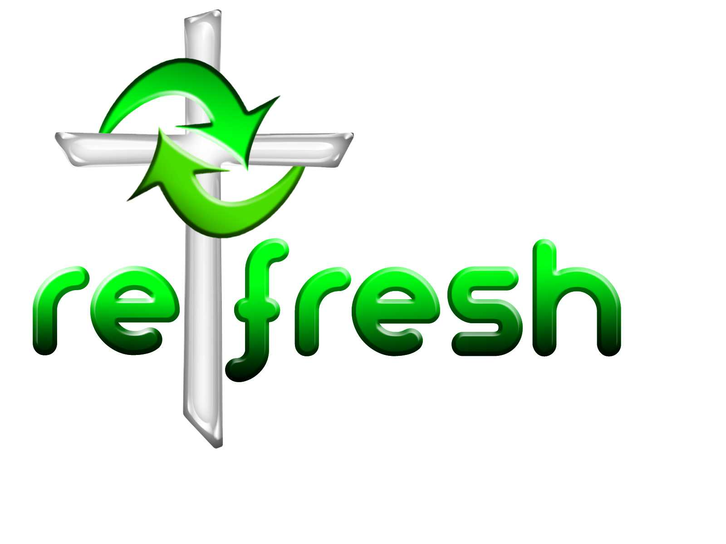
© 10 minutes on a Tuesday is a Refresh Resource. Unless otherwise acknowledged all material in this edition was prepared by Andre le Roux. While every effort has been made to acknowledge source material, if you believe unacknowledged work has been quoted, contact the email address below to request that it be acknowledged or removed. Material included here may be freely used and reproduced for the immediate purpose of worship. Permission must be sought to republish in any form, or to reproduce for commercial gain. If you wish to share the content with others you may do so by linking through the NZ Methodist website. For more information on this and other resources, contact andrew@missionresourcing.org.nz or 09 525 4179 (w)



Mission Resourcing: Inspiring and resourcing our communities for a journey with Christ that enriches lives and relationships

