
Sunday 27 June 2010

Freedom
Year C - Pentecost 5 – 45C

The Mission of the Methodist Church of New Zealand | Our Church’s mission in Aotearoa / New Zealand is to reflect and proclaim the transforming love of God as revealed in Jesus Christ and declared in the Scriptures. We are empowered by the Holy Spirit to serve God in the world. The Treaty of Waitangi is the covenant establishing our nation on the basis of a power-sharing partnership and will guide how we undertake mission.
Links | Ctrl+Click on the links below to go directly to the text you require  Readings  Introduction  Broader Preparation  Creativity  Preaching thoughts  Illustrations  Music  Prayers  Children  PowerPoint
Readings  Ctrl+Click to follow links | 2 Kings 2:1-2, 6-14: Three times Elisha refuses to leave Elijah, finally he received his master’s powers as Elijah is taken up to heaven.  Psalm 77:1-2, 11-20: The Psalmist cries out to God, expressing the frustration of God’s seeming absence (vv3-10) only to find faith again through remembering all the good things God has done. An amazing “journey” Psalm that should, in my opinion, include verses 3-10 for it to carry its full meaning.  Galatians 5:1, 13-25: Freedom is found in Christ, expressed through love, directed by the Spirit and strengthened by the “fruit of the Spirit.” (Now there is a classic four point sermon!)  Luke 9:51-62: Jesus is clear about His purpose – to reach Jerusalem, and He calls other would be followers to be clear about discipleship too.
Introduction / Summary | So many people define freedom as the ability to do what we please. However, we may find the opposite is true: that we are only free when we limit ourselves to those things that create or build life. The way of the gospel links personal freedom with values that ensure the good of all. “For to be free is not merely to cast off one's chains, but to live in a way that respects and enhances the freedom of others.” (Nelson Mandela). Or, to use Paul’s words, “It is for freedom that Christ has set us free.” (Gal 5:1) Freedom is both a means and an end.
Broader / Personal Preparation | If you are feeling tired or frustrated at the moment, take some time with Psalm 77. Allow verses 1-5 to express something of your struggle. Feel them, even own them.  When you are ready, move on to verses 6-10. What questions do you have?  Then, allow yourself to remember what God has done for you in the past (verses 11,12). Take time here. Be grateful. Celebrate the little things.  The Psalm ends with a celebration of God’s power. If possible, write down a short “celebration” Psalm of your own – just celebrating the goodness or greatness of God. Allow this to be your guide as you continue to prepare for the service.
Creativity /  Visual Aids | Appropriate to your worship situation, create a 'path' with brown paper (or newsprint painted brown). If this is impractical or not possible, consider a swathe of brown cloth (or several cloths of different shades of brown) draped from the cross or worship table to the floor in front, to symbolize that 'path'. You could add some footprints and the words, "Follow me". (This path could be used by the volunteer in the sermon, should you use those ideas.)
Preaching thoughts and Questions | People are struggling with life circumstances, financial debt, physical or emotional pain, even spiritual meaninglessness. People long for freedom! Deep down we know that freedom is one of life’s best ingredients – to be free from past hurts, present struggle, future fears…  Jesus’ ministry was filled with acts of setting people free: free from the limitations of illness and disability (healing miracles); free from past lifestyles or actions that brought guilt or dishonour (Zacchaeus, woman caught in adultery); free from stifling religious practice (Nicodemus); free from sin and death. But Jesus also embodied freedom in Himself. He is “free” to go to Jerusalem because it expresses who He is and what He stands for.  How do I find this kind of freedom? A healthy expression of life that is good for me and those around me?  1. Freedom is found letting go, not in accumulating things (Lk 9:57,58)  Much of our struggle to find freedom is caught up in emotional/spiritual issues. We tend to hold onto the things that burden us. (Get a volunteer to come forward and give them some rocks to hold, representing emotional baggage – Anger, bitterness, cynisism, resentment…) These things imprison us. We know it, but we can’t let them go. So, we try to replace them with other things that might cheer us up. We carry our rocks off to the mall for retail therapy (now hand the person a waffle maker to go with their rocks), or the bank for a loan to go on holiday (Holiday brochures and banking loan details), or we try to lose ourselves in another reality (wine bottle). We even think that having children may finally give us the life we are looking for (child’s toy). (Now ask the person to give you a hug!) These things do not set us free – anything but. Our hands are so full we cannot receive and we cannot give. We cannot be free when we carry so many burdens. We need to learn to let go.  2. Freedom comes from choosing to follow (Lk 9:59,60)  So often we think that freedom MUST involve choices. I am only free when I am “free to choose.” If there are no alternatives, and I am forced to do one thing, then I have lost my freedom. This may often be true, but not always. The best way to walk through the bush is to stick to the path: you are free to enjoy your surroundings because you are secure in where you are going. Security gives rise to freedom. Martin Luther King Jnr, Gandhi, Mother Teresa and others have been free to fulfill their dreams and purpose because they had no choice: they had to be true to themselves. It’s about taking a stand! Many people would agree that if their lives were characterised by the Fruit of the Spirit (Gal 5:22,23) they would be happy, fulfilled people. However, taking the steps to make those qualities a reality in their lives is another matter altogether: It requires a “this is what I want” decisiveness and commitment. (Talk this through as an illustration if you don’t have a guitar: Give your volunteer a loose guitar string and ask them to “play it.” Obviously this is impossible. Now give them the guitar and ask them to play it: just a sound will do.) The only way for a guitar string to work is if it is tied down on both ends and brought to the right tension. So too with us: We are free to play the music of our lives when we are tied down to what is good and right for us.  3. Freedom comes from looking forward, not in looking back (Lk 9:61,62)  (Get your volunteer back up front and ask them to “balance” along a path – a ribbon or line in the front of the church or down the isle. This should go reasonably well – don’t be too picky about performance. Then ask them to “balance” back along the line while looking backwards, over their shoulder – a much more difficult task!)  There is value in looking back. God often calls us to “remember” and remembrance is at the centre of our celebration of communion. The Psalmist is only free to move from despair to praise with, “I will remember the deeds of the LORD…” (Psalm 77:10-15). But it is one thing to remember and another thing to cling to the past – to keep looking back. We can live our resentments or we can live our forgiveness. We can be held by our fear or captured by our hope. We can find fault with others around us or we can celebrate their goodness. In doing so we not only set them free, but find freedom for oursleves too. We let go of the past and embrace the future – the potential of the other and the opportunity to change.
Illustrations / Stories | The use of a volunteer to give visual impact is included in the italic notes above.  Examples of how some parameters may appear to limit our choices but can actually create freedom:  The freedom given to explore the beauty of the bush by a path leading the way.  The freedom to play sport created by the sidelines of the court or field.  The freedom to play the piano because the strings are tied down to the correct tension to create the various notes.  In The Lord of the Rings we see how the ring becomes more of a burden to Frodo as the film progresses. The things we hold onto can possess us and rob us of our freedom – even good things can become obsessions.
Music  AA: Alleluia Aotearoa  MHB: Methodist Hymn Book  H&P: Hymns and Psalms  WHV: With heart and Voice  WOV: With One Voice  CMP: Complete Mission Praise  S1: The Source  S2: The Source 2  S3: The Source 3 | Hymns  A charge to keep I have (MHB 578; WOV 487; H&P 785)  Be thou my vision (MHB 632; WOV 455; H&P 378)  I heard the voice of Jesus say (MHB154; WOV 500; H&P 136)  Jesus calls us o’er the tumult (MHB 157; WOV 505; H&P 141)  Make me a captive Lord (MHB 596; WOV 528; H&P 714)  O Jesus I have promised to serve you to the end (MHB 526; WOV 514; H&P 704; S1 391)  O thou who camest from above (MHB 386; WOV 486; H&P 745)  There’s a light upon the mountain (MHB 256; WOV 207; H&P 246)  Where the Spirit is there’s freedom  Christ is our peace (AA 16)  God of our every day (AA 52)  Take my gifts and let me love you (AA 127)  Faith is in the following (WHV 28)  Fill our sails wind of God (WHV 23)  Songs  From heaven you came helpless babe (CMP 162; S1 114)  I, the Lord of sea and sky (CMP 857; S1 246)  Jesus take me as I am (CMP 382; S1 297)  Teach me to dance to the beat of your heart (CMP 936; S1 469)  This is my desire (CMP 1013; S1 515)  This little light of mine, I’m gonna let it shine  When the music fades (CMP 1016; S1 576)
Prayers | Passing It On  Though it may seem to us that evil spreads like a virus,  though it may feel naïve to resist it,  we choose to believe that your spirit’s fruit  can satisfy a world that hungers for healing.  And so:  Wherever hatred and suspicion divide people and fragment communities,  we will pass on love.  Wherever sorrow and cynicism leave the dark stain of despair,  we will pass on joy.  Wherever violence and abuse shatter lives and destroy the earth,  we will pass on peace.  Wherever expediency and the quest for quick fixes create confusion and need,  we will pass on patience.  Wherever heartlessness and selfishness cause loneliness and exclusion,  we will pass on kindness.  Wherever evil and darkness steal away hope and integrity,  we will pass on goodness.  Wherever aggression and coercion remove freedom and playfulness,  we will pass on gentleness.  Wherever self-interest and shallowness undermine relationships and stability,  we will pass on faithfulness.  Wherever lawlessness and carelessness generate chaos and fear,  we will pass on self-control.  Though it may take our best energy  and our most enduring commitment,  We pray for the courage and the faith  to answer your call,  to resist whatever devils we may face,  and to pass on your abundant life.  In Jesus’ Name  Amen.  John van de Laar © 2010 sacredise.com (used with permission)
Children | Encourage the older children to memorise the 9 “fruit of the Spirit” during the week.  You could tell the story of a family going camping. Just as they arrive, it starts to rain. They hurriedly put up the tent, but are all a little wet and cold by the time they finish and it soon begins to get dark. They can’t start a fire, and don’t want to use their new stove inside the tent until they have tested it outside first. It is has been a long day so they to spread out our sleeping bags, and tell stories into the night, snacking on some old guide biscuits… One by one they fall asleep until… Drip. Drip. Drip. The tent is leaking! Not much sleep – avoiding drips and bumps in the ground.  Eventually, the sun begins to peak into the windows of the tent. Time to get up and get some coffee and hot chocolate to warm up – but the matches are wet! Not a great start to the day! Everyone is a little grumpy. What should have been fun is turning out to be really yuck! Mum slips and falls in the mud on her way to the toilet. Dad can’t catch any fish for lunch! Then the rain starts again! Eventually someone says: "Let's pack up and go home. I've had all the fun I can stand!" Everyone agrees and soon the wet tent is in the trailer and the family are on their way.  One day, Jesus was walking along a road with some of his disciples when one of them said to him, "Lord, I will follow you wherever you go." Jesus turned to him and said, "Foxes have holes, and birds of the air have nests; but the Son of Man has nowhere to lay his head." Jesus was trying to make his disciples understand that it wouldn't always be easy to follow him. There would be some rough times. Well, some of Jesus' followers were willing to follow Jesus as long as it was easy, but when things got hard, they decided it was time to go pack up and go home! Sometimes it won't be easy. People may make fun of you. Some people will hate you. Will we follow him when the going is rough, or will we pack up and go home?  Dear Jesus, you have called us to follow you. Help us to follow, even when the going gets rough. Amen.
PowerPoint | Pictures of pathways could work well for this Sunday.

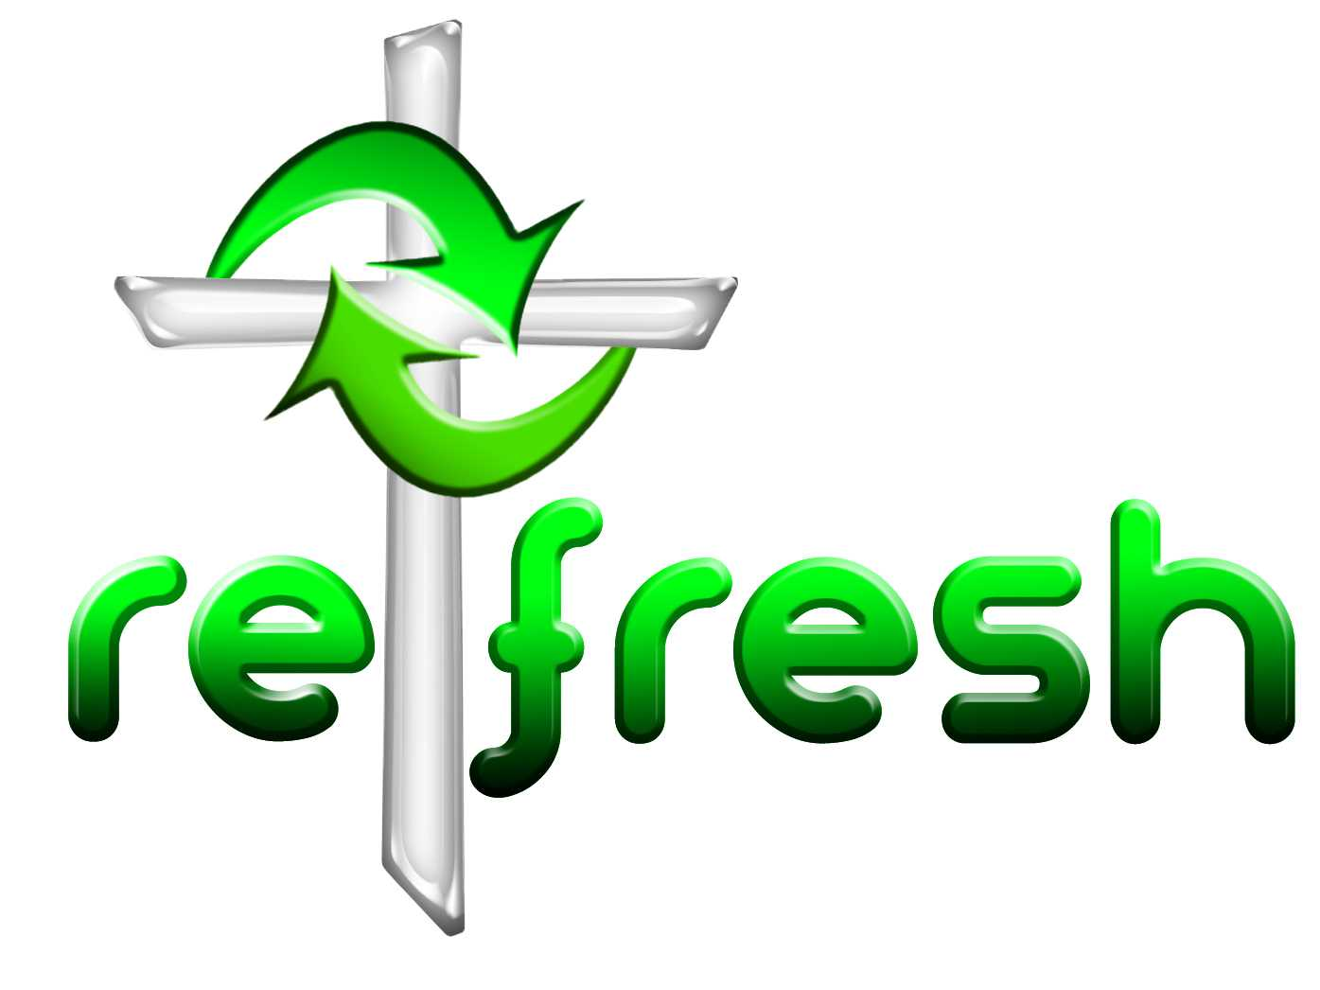
© 10 minutes on a Tuesday is a Refresh Resource. Unless otherwise acknowledged all material in this edition was prepared by Andre le Roux. While every effort has been made to acknowledge source material, if you believe unacknowledged work has been quoted, contact the email address below to request that it be acknowledged or removed. Material included here may be freely used and reproduced for the immediate purpose of worship. Permission must be sought to republish in any form, or to reproduce for commercial gain. If you wish to share the content with others you may do so by linking through the NZ Methodist website. For more information on this and other resources, contact andrew@missionresourcing.org.nz or 09 525 4179 (w)



Mission Resourcing: Inspiring and resourcing our communities for a journey with Christ that enriches lives and relationships

