
Sunday 20 June 2010

Hope
Year C - Pentecost 4 – 44C

The Mission of the Methodist Church of New Zealand | Our Church’s mission in Aotearoa / New Zealand is to reflect and proclaim the transforming love of God as revealed in Jesus Christ and declared in the Scriptures. We are empowered by the Holy Spirit to serve God in the world. The Treaty of Waitangi is the covenant establishing our nation on the basis of a power-sharing partnership and will guide how we undertake mission.
Links | Ctrl+Click on the links below to go directly to the text you require  Readings  Introduction  Broader Preparation  Creativity  Preaching thoughts  Illustrations  Music  Prayers  Children  PowerPoint
Readings  Ctrl+Click to follow links | 1 Kings 19:1-4, (5-7), 8-15a: Elijah experiences God, not in the spectacular events of wind, earthquake and fire, but in the still small voice of silence.  Psalm 42 & 43: Psalm 42 begins with an expression of longing for God, “As the deer pants for the water,” while Psalm 43 ends with a call to “put your hope in God.”  Galatians 3:23-29: We no longer live by law but as God’s children through faith in Christ.  Luke 8:26-39: The healing of Legion, the demon possessed man, and the fear of the people who witness the miracle.
Introduction / Summary | This week’s resource has a very personal feel to it. I have chosen to write from my own search for hope in an attempt to get behind some of the questions that my cancer has provoked over the past few weeks. For many of us, hope is associated with a positive outcome: I hope to win the lotto; I hope she says “yes”; I hope God heals me… But what happens when what we hope for does not happen? What does hope mean then?
Broader Preparation | If I were sitting with someone who was diagnosed with an incurable disease, what would I offer them in terms of hope? What feelings do I have as I consider my response? What does this say about my understanding of hope?
Creativity /  Visual Aids | Give each person a playing card as they enter church. Have a wonderful looking cake up front. Early in the service explain to the people that you will be drawing a card to find the winner of the cake. However, near the end of the service, instead of drawing one card, lift the whole pack. “We all win! We’ll share the cake.” Explain that the purpose of the cards and the cake was to highlight that part of worship is about community, about being together, about supporting each other. Hope is found when God’s people live together in healing love.  If you use the WASGIJ hope image you may want to give people a jigsaw puzzle piece to take home to remind them of the service.
Preaching thoughts and Questions | In writing about hope, I need to begin on a personal note. Many of you know that I have been diagnosed with a rare cancer that has not responded to treatment. Medically, “there is no hope.” What does this mean for me as a Christian? From a faith perspective, is hope now only about a miraculous healing?  So, I would like to offer some random thoughts on hope, based on the lectionary readings for today. They arise out of growing belief that hope does not depend on outcomes or circumstances, but on a fundamental state of being – one that carries us through the valley of the shadow of death, holds us in times of despair and challenges us into new ways of living when everything else seems uncertain. Hope is, after all, right up there with faith and love as one of the great qualities of life (1 Cor 13:13).  In many ways I see faith and hope as a seamless garment woven into the fabric of love. Faith is the seedbed of Hope and Hope is the energy of Faith, and over all these things is love. They all feed each other. Hope is not about “one day things might get better”. Hope is about the certainty that God is with us, and will travel with us through anything we face. It is not about outcomes but about presence and process.  The trouble is that this presence of God often seems illusive. Like Elijah, I have told God how much I have done for Him and the church (1 Kings 19:10). I have begged for a miracle, searching for God in the earthquake, wind and fire of a spectacular turn around that would prove to the world that God is real. As yet God has not been in these things. It is interesting that one could translate verse 12, the “still small voice” as a “small voice of silence.” What I got was silence. And it is in this silence that I search for hope because I believe that God is “about to pass by” (v11).  “The candle is a symbol of protest. It says to the darkness, “I beg to differ.” Hope protests against the darkness. Like the demoniac in Luke 8, we are surrounded by a “legion” of life destroying elements: negativity, destructives, disease… the list goes on. But we also live with our own inner pain and turmoil – the demons that haunt us. They keep us chained to our doubts and fears and drive us into lonely places. We wish for things to be different. We hope that, like the demoniac, we will be healed, “sitting at Jesus feet, dressed and in our right mind” (v35): “My chains fell off, my heart was free…” But when they don’t fall off? When we cannot break that habit, end that relationship, deal with that addiction, conquer that cancer… What then? Where is hope? Where is God? If hope does not depend on outcomes, on the removal of the demons, what does it mean to hope?  Interestingly, the Galatians reading begins with the image of being held prisoner by the law. I wonder if we are prisoners to the law of cause and effect. “If there is a God, then I will be healed…” There is my hope. But Paul goes on to write about faith in Christ setting us free: “You are all children of God through faith in Christ Jesus” (v26). Hope is about who we are, people with whom God chooses to share life. I have a divine presence that accompanies me along the road. The Creator surrounds me, the Spirit embodies me. God is there, whatever the circumstance. Hope means that I am held, even in the silence, by a “love that will not let me go.” This divine presence is bigger than our circumstances, it provides a starting point to face the struggles that surround us. The “serenity prayer” (below) captures something of this sentiment. And John Wesley, from his death bed, summed it up in 1791 when he uttered those famous last words "The best of all is God is with us." Hope is found in presence, not in outcomes.  Hope is also nurtured by community. People expressing healing love can carry those who struggle through difficult times, even when the outcomes that they are hoping for do not arise. The sad part of the story of the demoniac is the way the people treat him: Chained, rejected, isolated. And when he is healed, they are overcome with fear, even asking Jesus to leave the area! However, where people get alongside those who suffer, giving prayerful attention to their needs, allowing emotions to be expressed and “demons” to be explored, something shifts. Burdens become lighter. They become as Christ to us. Their presence says to the darkness, “I beg to differ.” Once again, we find hope being nurtured, not by outcomes, but by presence, by being loved.  This should not come as a surprise to us. Love has always been at the centre of the gospel and of God’s way. To be loved is to have hope. We can have the outcomes we desire, but without love we may well remain broken and lost.  Finally, on a practical level, hope may be built on little things… That birthday celebration coming up, or resisting temptation for the day, or that moment. Hope comes when we realize that we got through that one circumstance, or achieved that small outcome. We may have a long way to go, but each step we take builds on the next. We say to the darkness, “I beg to differ.”
Illustrations /  Stories  Ctrl+Click to follow link | The “Footprints in the sand” poem expresses how God carries us, but could also be used to encourage us to do the same for one another – to carry one another.  An alternative anonymous “footprints” poem is included right at the end of this resource – a possibility for some tongue in cheek humour that could illustrate the importance of doing something about our situation. Sometimes we sit back and wait for God to do it all – we use our hope / faith as an excuse for laziness… (Some people may not like this because of how special the original footprints poem is to them.)  The candle is a symbol of protest. It says to the darkness, “I beg to differ.”  WASGIJ HOPE  Recently I wrote the following words as part of my journey with cancer and my search for hope. Feel free to use or adapt them as an illustration of hope.  I admit that at the moment I am a little addicted to the WASGIJ puzzles - where you don't get the picture to build (copy), but where the picture given on the box is a clue to what the completed puzzle will look like. I find it therapeutic and relaxing, and, as you will read, it seems to free my head for thinking while keeping me occupied...  There were some things that struck me about puzzles, WASGIJs and hope - the kind of hope that does not depend on outcomes but on the process of trying to find my way through this cancer:  The first thing is that I realised that I have a certain way of approaching puzzles that sometimes doesn't work...  Like many people, I start with the border first so that the parameters are set. I think that I have done this well so far. I am searching for hope inside the parameters of my cancer and my faith - I still have those two things in my hands and will continue to hold them together, whatever the news, prognosis or outcome. The one speaks to the other and my life is now lived out in their interaction, one way or another, like it or not.  I also realised that I avoid the hard bits - the parts where there are no obvious clues... When I unpacked the puzzle I am doing now I almost put it back in the box immediately. The pieces were dark and "smudgy" with very few obvious lines etc. Once I had done the border there seemed to be no obvious place to start. It looked too hard, so why not just do another one? How easily I try and avoid the "too hard" basket...  But what struck me most were these three things: my "WASGIJ hope":  With my last puzzle I was convinced that at least 3 pieces were missing. In the end I found them all. Just because we cannot find what we are looking for, doesn't mean it doesn't exist! Hope is believing that the missing piece/s will be found.  The other part of my WASGIJ hope is that I so often find a piece that I am NOT looking for. While searching for one piece, my eyes fall on another and I know immediately where that piece goes. It comes as a surprise, a serendipity... I believe that the hope I am looking for may still surprise me by turning up where I may not be looking for it.  Lastly, WASGIJs don't show you what the picture looks like - it emerges as you build. So too with me right now. I do not know what hope means when the outcomes look so bleak medically, nor do I know how to define hope outside of a physical healing that prolongs my life. But I believe that a picture of hope will emerge and that it will have a depth and a divine quality that I would not be able to find by myself - with God's help it will emerge within me.  What all this gives me is the ability to step back and let things happen, AND step forward to engage with the unfolding picture that is my life at the moment.  Still held in Healing Love... and WASGIJ hope?  Andre
Music  AA: Alleluia Aotearoa  MHB: Methodist Hymn Book  H&P: Hymns and Psalms  SIS: Scripture in Song  WHV: With heart and Voice  WOV: With One Voice  CMP: Complete Mission Praise  S1: The Source  S2: The Source 2  S3: The Source 3 | Hymns  And can it be (MHB 371; WOV 138; H&P 216)  Blessed assurance (MHB 422; H&P 668)  For the might of thine arm (MHB 715; WOV 535 H7P 435)  I will sing the wondrous story (MHB 380; WOV 173; H&P 223)  Longing for light (Christ be our light) (S3 1409)  O love that will not let me go (MHB 448; WOV 525; H&P 658)  Our God our help in ages past (MHB 878; WOV 46; H&P 358)  From the apple in the garden (AA 42)  God of our every day (AA 52)  The spring has come (AA 140)  We do not hope to ease our minds (AA 147)  In this world of darkness (WHV 25)  Songs  Above all powers (S2 611)  As the deer pants for the water (CMP 37; S1 27)  Brother, sister let me serve you (SIS 256; AA 8)  Give thanks to the Lord (Forever God is faithful) (S2 688)  Give thanks with a grateful heart (CMP 170; S1 118)  I the Lord of sea and sky (CMP 857; S1 246)  Make me a chaneel of your peace (CMP 456)  Tell my people I love them (AA 132; CMP 630)
Prayers | God grant me the serenity  to accept the things I cannot change;  courage to change the things I can;  and wisdom to know the difference.  Living one day at a time;  Enjoying one moment at a time;  Accepting hardships as the pathway to peace;  Taking, as He did, this sinful world as it is,  not as I would have it;  Trusting that He will make all things right  if I surrender to His Will;  That I may be reasonably happy in this life  and supremely happy with Him forever.  Amen.  --Reinhold Niebuhr
Children | Invite the children to write down (or draw a picture) of something that they are hoping for. These could be shared with the congregation after a story of hope, or some reflections on our Christmas present hopes… As Christmas approaches (Still a whole half year away! How sad is that!) we might make a list of some of the things we hope for – the toys we would really like. Sometimes we get what we hope for, but sometimes we don’t. Often though we really enjoy what we do get, and we always enjoy the excitement of unwrapping the presents together with our families or friends. There is something special about Christmas and presents, but without the people to share it with it would be pretty boring wouldn’t it?
PowerPoint | A single candle burning against a dark background.


© 10 minutes on a Tuesday is a Refresh Resource. Unless otherwise acknowledged all material in this edition was prepared by Andre le Roux. While every effort has been made to acknowledge source material, if you believe unacknowledged work has been quoted, contact the email address below to request that it be acknowledged or removed. Material included here may be freely used and reproduced for the immediate purpose of worship. Permission must be sought to republish in any form, or to reproduce for commercial gain. If you wish to share the content with others you may do so by linking through the NZ Methodist website. For more information on this and other resources, contact andrew@missionresourcing.org.nz or 09 525 4179 (w)



Mission Resourcing: Inspiring and resourcing our communities for a journey with Christ that enriches lives and relationships

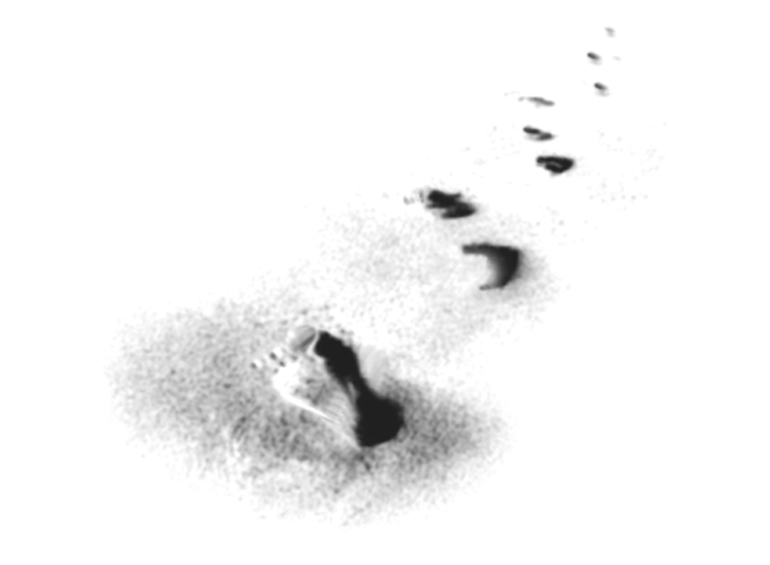
One night I had a wondrous dream.
One set of footprints there was seen,
the footprints of my precious Lord,
but mine were not along the shore.
But then some stranger prints appeared
and I asked the Lord, "What have we here?
Those prints are large and round and neat,
but, Lord, they are too large for feet."
"My child," he said in sober tones,
"For miles I carried you alone.
I challenged you to walk in faith,
but you refused and made me wait."
"You disobeyed, you would not grow.
The walk of faith you would not know.
So I got tired, I got fed up,
and there I dropped you on your butt."
"Because in life there comes a time
when one must fight and one must climb,
when one must rise and take a stand
or leave one’s butt prints in the sand."

