
Friday 2 April 2010

Dying: Sacrificing our Sin
Year C - Good Friday - 29C

The Mission of the Methodist Church of New Zealand | Our Church’s mission in Aotearoa / New Zealand is to reflect and proclaim the transforming love of God as revealed in Jesus Christ and declared in the Scriptures. We are empowered by the Holy Spirit to serve God in the world. The Treaty of Waitangi is the covenant establishing our nation on the basis of a power-sharing partnership and will guide how we undertake mission.
Links | Ctrl+Click on the links below to go directly to the text you require  Readings  Introduction  Broader preparation  Creativity  Preaching thoughts  Illustrations  Music  Prayers  Children  Closing  PowerPoint
Readings  Ctrl+Click to follow links | Isaiah 52:13-53:12 The suffering servant of Isaiah is highlighted in this passage that turns our concept of power and greatness on its head.  Psalm 22 The Psalm that Jesus quotes from the cross carries many of the themes from Isaiah’s suffering servant.  Hebrews 10:16-25 or 4:14-16, 5:7-9 Both these readings encourage confidence because of who Jesus was and what He stood for.  John 18:1-19:42 John’s account of the trial and death of Jesus.
Introduction / Summary | Good Friday is a day to feel suffering, experience death. It is a time when silence and stillness can dominate. So often we leave emotion out of our services, but here we bring our feelings – regret, awe, repentance. “Sometimes, it causes me to tremble, tremble, tremble. Were you there when they crucified my Lord.”
Broader Preparation | Perhaps time reflecting on the question, “Why did Jesus have to die?” may be a good way to prepare ourselves for leading worship on Good Friday. The question invites us to think deeply about the theology of the cross, but it also calls us to consider our human nature – what we do when we are confronted by perfect love.
Creativity /  Visual Aids | Strip the church of everything possible for this service. Ideally all that is left is the cross at the front of the church. This ‘empty church’ reminds us that everything we have is a result of the Good Friday death of Jesus. Leading the majority of the service from the back of the church can enhance this: The congregation hears the words, but all they see is the cross.  Banging 2 pieces of wood together 3 times as a ‘hammering’ sound, followed by the words “My God, my God why have you forsaken me” could work effectively to mark the start of the service, announce the gospel reading, call for silence etc. Be careful not to overdo it though – 3 or 4 times in the service should be enough.  People are given a flower petal as they enter church and are asked to hold it throughout the service. Hopefully they will wilt/become less attractive during the service – a good image of how sin can slowly change us: Not always an obvious breakdown of morals etc, but a subtle loss of life, day by day.  Keep 1 minute silence in memory of Jesus, who died for us.  This may be a bit risky, but it helps us confront our sinfulness or our part in the death of Christ: People are handed a galvanised nail as they enter church. Towards the end of the service these nails are collected in boxes (preferably by some of the bigger, more ‘intimidating’ men of the church). As people drop their nails into the box they say, “Crucify Him!” The boxes are brought forward and placed at the foot of the cross. A voice from ‘off stage’ says, “God, forgive them. They don’t know what they are doing.”
Preaching thoughts and Questions | Sin is not a concept we speak of easily these days – but it is real. Our sin is that which breaks down good life and relationships. It is seen in the destruction of the environment and the breakdown of society. It’s symptoms of violence and poverty are proof of its existence. Sin needs to be dealt with!  The cross is God’s answer to sin. On the cross Jesus absorbs our violence, undermines our hatred with love, overturns our betrayals with forgiveness… The cross represents Jesus’ refusal to allow anything but love to determine His actions. No matter what humanity throws at Him, no matter how unfounded the accusations against Him or manipulated the shouts of “Crucify Him,” Jesus continues to show unconditional love: “God, forgive them… they do not now what they are doing.” Stubborn sin is met with unmoving love. Human darkness is broken by the flickering light of unending grace. Christ is willing to be sacrificed to reveal the full extent of our depravity – we kill the one who showed nothing but love. If we, as human beings, are willing to do that, then there is nothing that we will not do. Christ dies not only to deal with our sin, but to reveal the full extent of our sin. Our sin is that deep. It must be dealt with!  So, what to do? We face up to the fact that sin is not some medieval concept. We are sinners and our sin is destructive. We offer those sins to God, asking for forgiveness, but also for help to change. Turning destructive behaviours into life giving habits is not easy. It is almost as if we need to sacrifice our sin – to willingly give it up and allow it to be put to death. Good Friday is God’s call to change – to follow the example of Jesus and make love our way of life. The cross is God’s “Enough!” – it is time to bring this to an end. “Take up your cross and follow me.” Follow me into forgiveness, into mercy, into surrender, into generosity. “Turn away from your sins and believe the good news.”  If you have used the petals, the following thoughts may be useful:  Like the petal in your hand, death often comes slowly. Christ’s death comes slowly, in a sense He was always dying, not only with sudden hammer blows or piercing spear to His side – but also like the creeping darkness at the end of the day, a difficult journey of increasing disease or suffering… The moment those petals were picked from the plant they started to die. For Jesus, the moment He set foot on this earth, He began His journey to the cross.  We think of sin as the hammer blows that destroy life, but it is also true that sin is a creeping darkness or a growing suffering that erodes our lives and relationships. It is the very slowness of the dis-ease that disarms us – we think we can deal with it later, that ‘it is not too bad for now.’ But decay happens slowly, and before we know it we are too far down the road to turn back, or too set in our ways to change. Often it is the ‘little by little’ sins that are the most destructive.
Illustrations /  Stories  Ctrl+Click to  follow link | In 2003 in the Utah Mountains, Aron Ralston was trapped by a fallen boulder that pinned his hand to the rock beside him. After 4 days, increasingly dehydrated and desperate, he tries to cut off his hand, but cannot cut through the bone of his wrist. After 6 days, he breaks his arm, cuts off his hand and walks out for help. (Later, it took 13 people 4 days to remove the hand.) Aron’s choice was to lose the hand or lose his life. He had to go through the pain of severing his hand to save himself. So too with some of the behaviours (sins) of our lives – painful to remove, but essential if we are to live.  You can view his story here: http://www.youtube.com/watch?v=60DuKWyzd3E
Music  AA: Alleluia Aotearoa  MHB: Methodist Hymn Book  H&P: Hymns and Psalms  WOV: With One Voice  CMP: Complete Mission Praise  S1: The Source  S2: The Source 2  S3: The Source 3 | Music  The ‘old classics’ are often useful on Good Friday: Pie Jesu, Panus Angelicus  Hymns  Beneath the cross of Jesus (MHB 197; H&P 165)  O sacred head once wounded (MHB 202; WOV 255; H7P 176)  How deep the Father’s love for us (CMP 988; S1 185)  When I survey the wondrous cross (MHB 182; WOV 258; H&P 180)  I cannot tell why He whom angels worship (MHB 809; H&P 238)  There is a green hill far away (MHB 180; WOV 266; H&P 178)  Great ring of light (AA 57)  O Christ, who by a cross (AA 105)  Teach us, O loving heart of Christ (AA 130)  Songs  Were you there when they crucified my Lord? (CMP 745)  From Heaven You came, helpless Babe (CMP 162; S1 114)  Jesus Christ, I think upon Your sacrifice (S1 274)  Above all powers (S2 611)
Prayers  Ctrl+Click to  follow link | A Meditation on the Cross of Jesus  From www.liturgy.co.nz - scroll down
Children | This is a difficult day for a children’s talk if you want to build up a sense of the cross. Perhaps it is the one day when there is no ‘children’s time.’
Closing  Ctrl+Click to  follow link | You may want to close with this “poem” from the Christian Musical, The Witness. The final line leaves us hanging – there is no benediction, Christ has died, grace is hidden, we can only prepare Him for His burial…  (scroll down to…)  They took Him down,  His poor dead body,  And prepared Him for His burial….
PowerPoint | There are many great pictures of crosses available. Remember to keep them simple, with good spaces for the words of the hymns and songs.

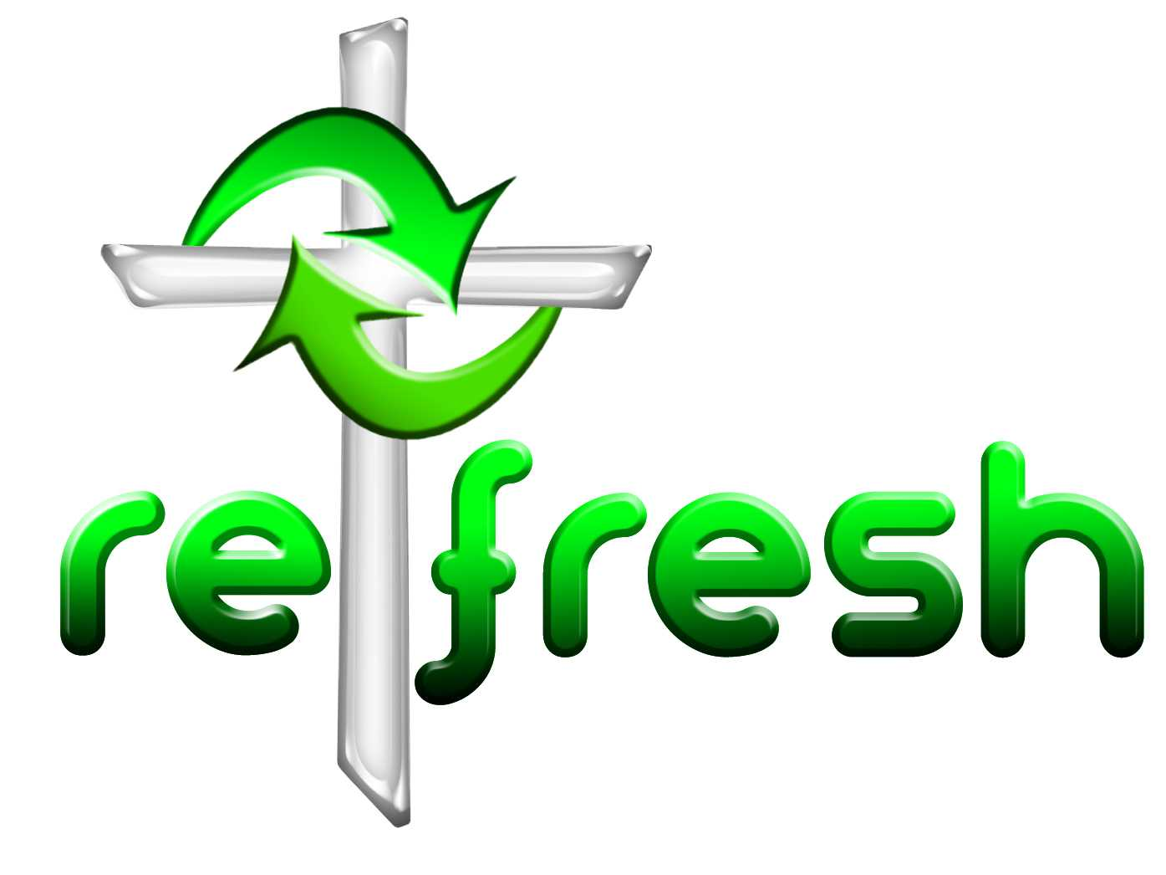
© 10 minutes on a Tuesday is a Refresh Resource. Unless otherwise acknowledged all material in this edition was prepared by Andre le Roux. While every effort has been made to acknowledge source material, if you believe unacknowledged work has been quoted, contact the email address below to request that it be acknowledged or removed. Material included here may be freely used and reproduced for the immediate purpose of worship. Permission must be sought to republish in any form, or to reproduce for commercial gain. If you wish to share the content with others you may do so by linking through the NZ Methodist website. For more information on this and other resources, contact andrew@missionresourcing.org.nz or 09 525 4179 (w)



Mission Resourcing: Inspiring and resourcing our communities for a journey with Christ that enriches lives and relationships

