
Sunday 11 April 2010

The Spirit of Confusion
Year C - Easter 2 - 32C

The Mission of the Methodist Church of New Zealand | Our Church’s mission in Aotearoa / New Zealand is to reflect and proclaim the transforming love of God as revealed in Jesus Christ and declared in the Scriptures. We are empowered by the Holy Spirit to serve God in the world. The Treaty of Waitangi is the covenant establishing our nation on the basis of a power-sharing partnership and will guide how we undertake mission.
Links | Ctrl+Click on the links below to go directly to the text you require  Readings  Introduction  Broader Preparation  Creativity  Preaching thoughts  Illustrations  Music  Prayers  Children  PowerPoint
Readings  Ctrl+Click to follow links | Psalm 150 This Psalm calls us to make a noise in celebration of what God has done! “Let everything that has breath praise the Lord.”  Revelation 1:4-8 Twice Christ is referred to as the one ‘who is, and was, and is to come,’ – to Him be glory and power forever!  Acts 2:1-12; 5:27-32 At Pentecost, the gift of tongues helped all those present to understand the message that Peter proclaimed. Later, Peter points to the Holy Spirit as God’s gift to those who obey Christ (Acts 5:32).  John 20:19-31 Jesus appears to the disciples, but Thomas cannot believe until he sees Jesus for himself. His confusion is turned to faith when he receives a special visit from the Risen Lord.
Introduction / Summary | This week begins a new series preparing us for Pentecost. We prepare for Christmas with Advent, and Easter through Lent, but for some reason we don’t spend time preparing for the coming of the Spirit at Pentecost. However, over the next 6 weeks we will explore the nature of the Spirit based on the lectionary readings and the Acts 2 reading. This week we begin with the Spirit of confusion.  “Amazed and confused, they asked…” (Acts 2:12) All of us have times when we are confused. The appearance of Jesus in the upper room would have overturned everything the disciples thought was ‘normal.’ The experience of Pentecost would have done the same. God is shaking things up, we try to put things back in order. Confusion can be a sign that we need to rearrange our worldview.
Broader Preparation | What are the things that you find difficult about faith? Is there an area of your faith that needs to be explored further, to be stretched into new understandings? What questions do you live with?
Creativity /  Visual Aids | Get people to move to the opposite side of the church to where they are sitting now, “Just for the children’s talk…” or “Just for the reading…” After the talk, or reading, ask people how they feel about their new place. Offer then the opportunity to return to their original seats or remain where they are. How did they feel about that offer?
Preaching thoughts and Questions | We all hate being confused. Confusion can be frightening when it involves others: ‘What’s happening with our marriage?’ and unsettling when it challenges our faith: ‘Where are you, God? I need you!’ But confusion can also be an element of grace – a sign that we are being stretched or challenged: At school, the maths confused us for a while until we ‘got it.’  In the upper room the natural order of things was reversed – the dead had come back to life. No wonder Thomas was confused and needed proof of the Risen Christ. He hears, but he cannot believe (v25). We seem to believe what we see, we long for proof: “If only… then I would be sure.” Uncertainty, doubt and confusion do not sit well with us. Yet it is the discomfort that challenges us to find a way forward, the dis-ease that forces us to look for a solution. Confusion can be a springboard to faith. “I do believe, help my unbelief.”  It seems as if there is a tension here. At Pentecost God shakes things up, and then, as the book of Acts unfolds, we notice that the church keeps trying to bring order to the confusion. God is unsettling things so that we will move to new understandings and ways of living. But we struggle to live with that which is unsettled or open ended, so we attempt to define and prescribe and legalize… Perhaps we try to keep things too tidy, too well defined. Perhaps we need to let God shake us up, unsettle us, stretch us - create some healthy confusion! It may not be comfortable, but it may give us a new understanding of “My Lord and my God.” (John 20:28).  So confusion can be an element of grace – a way in which God expresses love for us. The gift of the Spirit at Pentecost creates confusion: ‘Amazed and confused, they asked each other, “What does this mean?”’ (Acts 2:12). The question calls to be answered, and the answer leads people closer to God and God’s grace.  Are we willing to let God challenge our comfort zones? Are we willing to struggle with new understandings of who God is and what God expects of us? Will we be willing to give up old ways of thinking for new understandings and expressions of faith? ‘Lord, comfort the unsettled and unsettle the comfortable.’  On a pastoral note, it is worth pointing out that Jesus does not respond to Thomas’ doubt with judgment but with grace. In fact, Thomas receives a special visit from Christ, special attention. Our doubts are not obstacles to grace but pathways God can use to help us move to a new level. Like Thomas we need to be honest about our doubts, but also be ready to receive the challenge of Jesus: ‘Stop your doubting and believe.’ (Jn 20:27)  Interestingly, the readings for the week focus on praise, not on doubt. Even Thomas ends in a place of praise: “My Lord and my God!” Perhaps that is the message after all. We can allow our confusion to push us away from God into doubt and uncertainty, or we can use it to grow new understandings while we continue to live in the confidence that God’s Spirit is within us, leading us to new expressions of faith.
Illustrations / Stories | Comfort zones – where people sit in church, the type of music we prefer, the people we surround ourselves with – all these things are important to us. We don’t like change, but sometimes changing places or doing things differently brings new insights and expressions of life. God wants to move us into new ways of being, and sometimes that means unsettling us from our comfort zones.  2 catholic nuns run out of petrol on rural road. Finding a nearby farm they manage to get some petrol, but only find an old potty to carry it in. As they are emptying the yellow fuel from the potty to the tank a passerby stops and says, “Sisters, I’m not sure that I believe everything you do, but I really do admire your faith!”  In Blaise Pascal’s essay, Why I am a Christian, he writes of the source of his doubt and confusion: “We see too much to deny and too little to be sure.”
Music  AA: Alleluia Aotearoa  MHB: Methodist Hymn Book  H&P: Hymns and Psalms  WOV: With One Voice  CMP: Complete Mission Praise  S1: The Source  S2: The Source 2  S3: The Source 3 | Hymns  Alleluia, alleluia, give thanks to the risen Lord (WOV 674;CMP 30)  Have faith in God my heart (WOV 552)  Have faith in God my heart – alternative words on the next page…  When our confidence in God is shaken (WOV 492)  We limit not the truth of God (WOV 335)  Breathe on me breath of God (MHB 300; WOV 320)  Give me the faith which can remove (MHB 390; WOV 479)  Will your anchor hold in the storms of life (MHB 634; CMP 770)  From the waiting comes the sign (AA 43)  Great and deep the Spirit’s purpose (AA 55)  Loving Spirit (AA 94)  Songs  Blessed be the Lord, God, Almighty (Revelation 1) (CMP 135; S1 96)  Open the eyes of my heart, Lord (S2 926)  Be still for the presence of the Lord, the Holy One is here (CMP 50; S1 47)  Spirit of the Living God (CMP 613; S1 462)  Come Holy Spirit live your life in me
Prayers  Ctrl+Click to follow links | A General Prayer of Thanksgiving from laughingbird.net  A Blessing to close that comes from the Methodist General Board of Discipleship website (scroll down to the bottom of the page).
Children | Tell the story of the resurrection appearance in an energetic and child friendly way – how scared the disciples must have been – the doors were locked but here was Jesus! He should be in the tomb! Is this a ghost!? Go on to describe Thomas and how he couldn’t believe, and how Jesus gives him a special visit so that he could believe. During the talk highlight Jesus words (used 3 times): ‘Peace be with you.’ You may want to conclude by getting the children and the congregation to ‘share the peace’ – to greet one another with a hug or a handshake and the words, ‘The peace of the Lord be with you,’ and the reply, ‘And also with you.’  Lord Jesus, sometimes we are like Thomas. We have our doubts, we don’t know what to believe. Thank you that during those times you still love us and want the best for us. So, help us to be honest with you and tell you how we feel, and ask you for what we need – just like Thomas did. Amen.
PowerPoint | Abstract backgrounds may work best this week – not too complicated so that the text is still clearly visible.

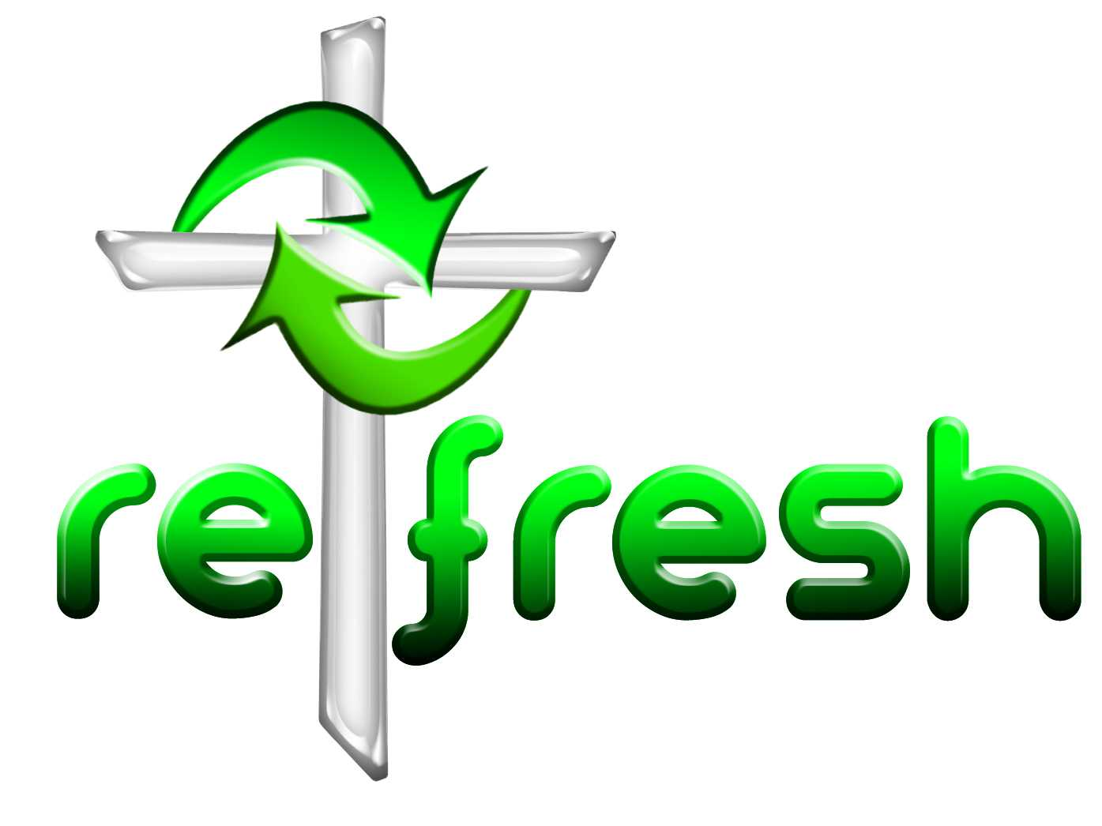
© 10 minutes on a Tuesday is a Refresh Resource. Unless otherwise acknowledged all material in this edition was prepared by Andre le Roux. While every effort has been made to acknowledge source material, if you believe unacknowledged work has been quoted, contact the email address below to request that it be acknowledged or removed. Material included here may be freely used and reproduced for the immediate purpose of worship. Permission must be sought to republish in any form, or to reproduce for commercial gain. If you wish to share the content with others you may do so by linking through the NZ Methodist website. For more information on this and other resources, contact andrew@missionresourcing.org.nz or 09 525 4179 (w)



Mission Resourcing: Inspiring and resourcing our communities for a journey with Christ that enriches lives and relationships
Have faith in God my heart
Trust and be unafraid
God will fulfill in every part
Each promise He has made.

Have faith in God my mind
Though often doubts occur
Trust Him who, with a wiser plan,
Will hold the future sure

Have faith in God my soul
For nothing can remove
The love, which from all time began,
And will enduring prove

Lord Jesus make me whole
Let grace my life fulfill
Take all I have and all I am
And use me for Your will.
Adapted by Andre le Roux from Bryn Austin Rees’s Hymn

