METHODIST MISSION AND ECUMENICAL NEWSLETTER - March 2022

In this Season of Lent we remember the love made manifest in the birth, life, and death of Jesus of Nazareth. In his healing acts and radical teachings we recall the words he spoke to call forth love, care and respect for one another. We are grateful for this assurance of love amidst human betrayal, care amidst hatred, respect amidst oppression.
SOLOMON ISLANDS: the COVID pandemic deepens its impact
The Covid situation in the Solomon Islands arising from an outbreak in January has caused serious concern. The NZ Herald reports there are now cases in the thousands, and more than 100 deaths (that are recorded); with Honiara’s hospital overwhelmed.
Vaccination rates are very low (various reports indicate less than 1-in-5 are fully vaccinated). At the current rate of vaccination, it is estimated that 80% coverage would not be achieved until 2027. There is a low number of trained vaccinators in more remote regions.
A late-January article from The Guardian (UK) provides a perspective on the impact of COVID in the Islands: https://www.theguardian.com/world/2022/feb/22/people-are-dying-on-the-floor-healthcare-workers-tell-of-covid-devastation-in-solomon-islands
MME is working with CWS to explore a partnership in the Solomon Islands to provide specific assistance for supporting the vaccination programme. Already the donations offered through MME to Sasamuqa Hospital, with the cost of fuel for the hospital boat, has supported the work of the vaccination programme. There are about 300 positive cases in Choiseul but no deaths so far.
UKRAINE: world-wide ecumenical prayer and concern
We urge all member churches and all people of good will around the world to join us in prayer for peace for the people of Ukraine and the region.
– Rev. Prof. Dr Ioan Sauca, Acting General Secretary of the World Council of Churches
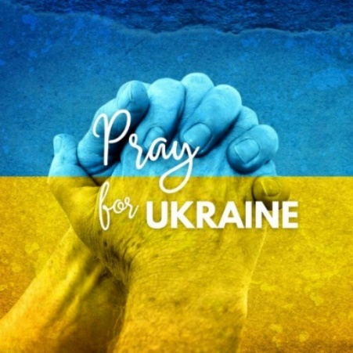
An international and ecumenical call has been made for prayer and assistance following the arising of war in Ukraine. The resulting in a significant refugee crisis. CWS have launched an appeal, to support the work of partners in the ACT Alliance.
An international service of prayer was held on Ash Wednesday. The service of prayers and chants, Lenten reflections and personal testimonies was jointly organized by various Christian world communions including the Lutheran World Federation, the World Communion of Reformed Churches, the World Methodist Council, the Mennonite World Conference, the Conference of European Churches and the Anglican Communion.
A pall of ashes covers Ukraine. The claim of God calls humanity into responsibility: Where is your brother, Cain? We want to shout this claim into the hearts and minds of those responsible for all this violence.
— Rev. Anne Burghardt, General Secretary of the Lutheran World Federation
An edited video of excerpts for the service can be watched through this link: https://www.lutheranworld.org/news/pall-ashes-covers-ukraine-christians-join-prayer-peace
Despite what is happening in Ukraine, I still believe that the international community can make a difference as we collectively work for peace in the region
– Bishop Ivan Abrahams, General Secretary of the World Methodist Council.
United Methodist Bishop Eduard Khegay, who is responsible for Eurasia, recently posted this reflection:
PRESENCE
Imagine an infant born in the Kiev subway and his exhausted mother seeking shelter from grenades.
Christ weeps next to them.
Imagine a lonely grandmother and her grandson in Luhansk who can't sleep because of explosions and sirens.
Christ weeps at their side.
Imagine a Russian and a Ukrainian soldier looking at each other through the sight of a machine gun.
Christ weeps at their side.
Imagine the drivers queuing up at the Ukrainian-Polish border for three nights.
Christ weeps next to them.
Imagine that friends on Facebook are willing to "denazify" each other with their comments.
Christ weeps at their side.
Imagine the explosions near your house and the wounded in the east and west, in the south and north of Ukraine.
Christ weeps at their side.
Imagine hundreds of thousands of refugees from Ukraine in Europe and Russia.
Christ weeps at their side.
Imagine the coffins with 18-year-old boys who have just started life and their grieving others.
Christ weeps at their side.
Imagine if you were hugging all these people.
Christ embraces them with You.
Jesus calls us to be peacemakers, both in terms of preventing bloodshed, and building constructive links with God, ourselves, and other people. The British Methodist and United Reformed Churches produced a report titled Peacemaking: A Christian Vocation which explores a Christian perspective on peace and conflict in the context of new challenges.
An electronic copy can be accessed here: https://www.jointpublicissues.org.uk/wp-content/uploads/2020/10/Peacemaking-Report.pdf
MISSION AND ECUMENICAL BOARD
Methodist Church of New Zealand
Te Hāhi Weteriana o Aotearoa
[Acting] Director: Rev. Tony Franklin-Ross
Postal: 20a Georgina Street, Freemans Bay, Auckland 1011
Phone: 021-481 816 (Mobile)
E-mail: mm-e@methodist.org.nz
www.methodist.org.nz/mission_and_ecumenical

